Sixth Sunday of Easter
Holy Eucharist, Rite II

10:00 am – May 10, 2026

Welcome to Christ Church
We are so happy you have chosen to come and participate in worship this morning. Your presence today strengthens the Body of Christ, not only here but throughout the world.
Land Acknowledgment
Christ Church acknowledges that we gather on the traditional homeland of the Puyallup Tribe. The Puyallup people have lived on and stewarded these lands since the beginning of time, and continue to do so today. We honor and give thanks for the land itself and the life of all the indigenous peoples of this area.
New to Christ Church?
Welcome to Christ Episcopal Church of Puyallup. Wherever you are on your spiritual journey, you are welcome here! We invite you to sign our guestbook, visit our website (www.episcopallup.com) or connect with one of the clergy.
Questions?
Please ask. The ushers (one of the persons who gave you a bulletin) can answer your questions or concerns. Restrooms are available in the hallway to the west of the worship space.
About our Liturgy
Worship lies at the heart of the Christian life. It is in worship that we express our theology and define our identity. We encounter God within worship and are formed and transformed as the people of God. One of the hallmarks of the Episcopal Church is its liturgical worship. Liturgy literally is “the work of the people,” and refers to the patterns, forms, words, and actions through which public worship is conducted.

Hymnal 405 – All Things, Bright and Beautiful
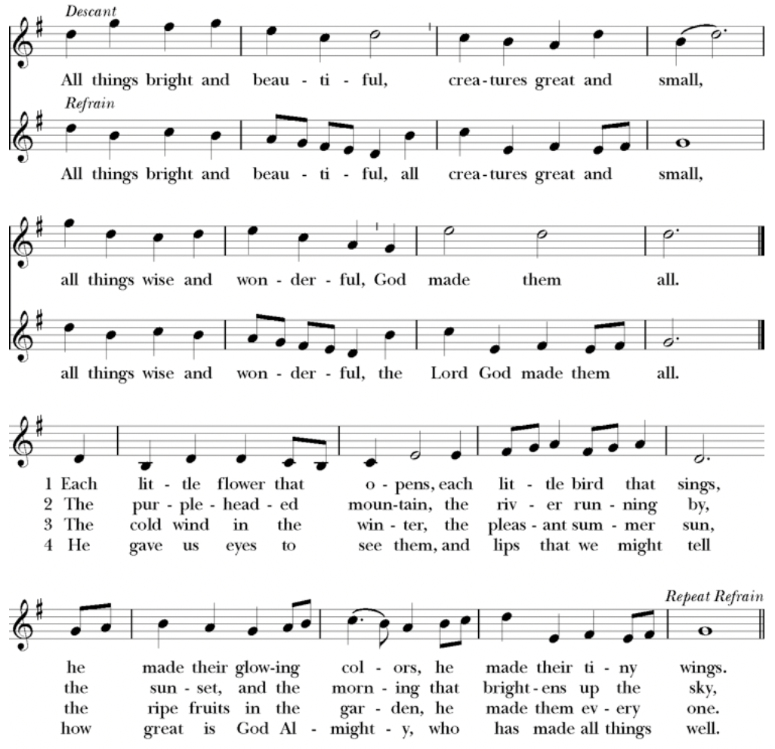

The Celebrant then says to the people

Alleluia. Christ is risen.
People The Lord is risen indeed. Alleluia.
The Celebrant may say
Almighty God, to you all hearts are open, all desires known, and from you no secrets are hid: Cleanse the thoughts of our hearts by the inspiration of your Holy Spirit, that we may perfectly love you, and worthily magnify your holy Name; through Christ our Lord. Amen.

When appointed, the following hymn or some other song of praise is sung or said, all standing

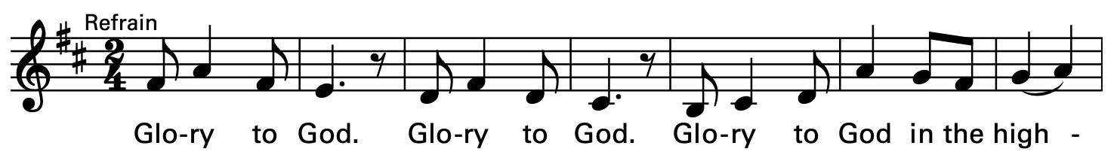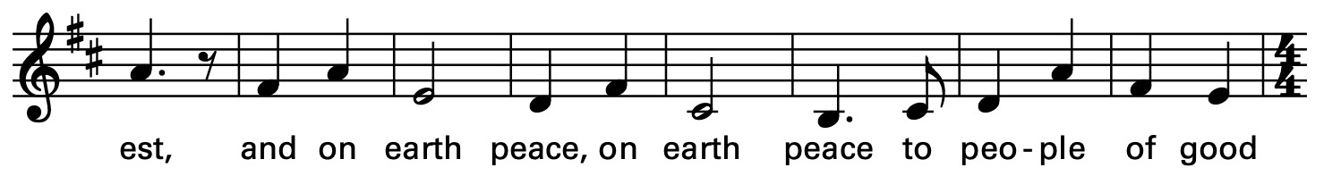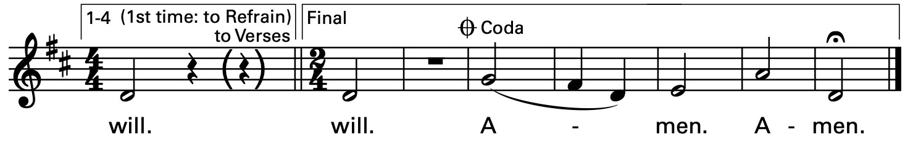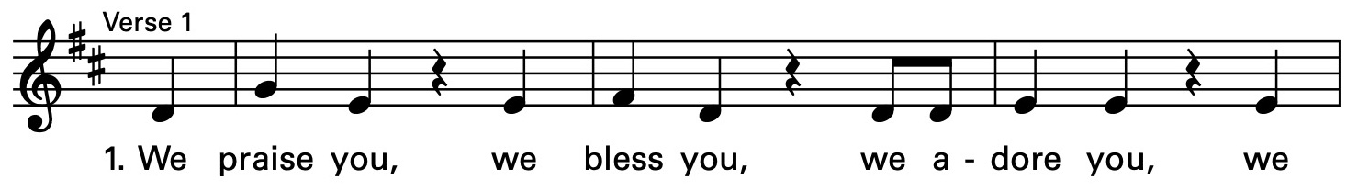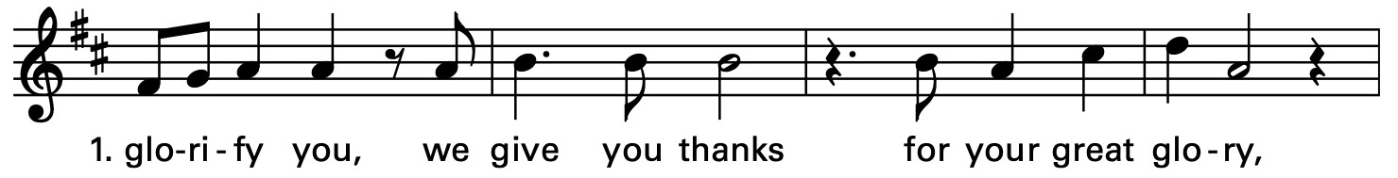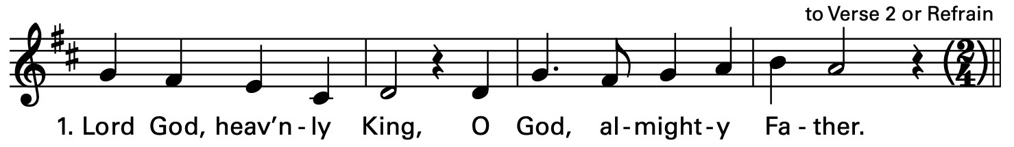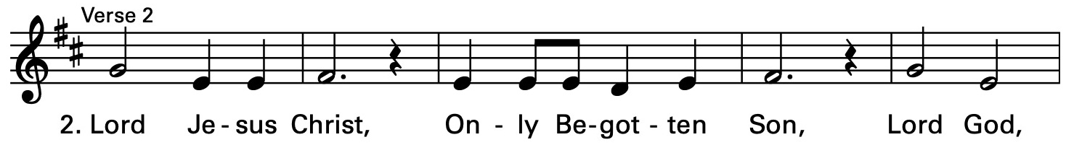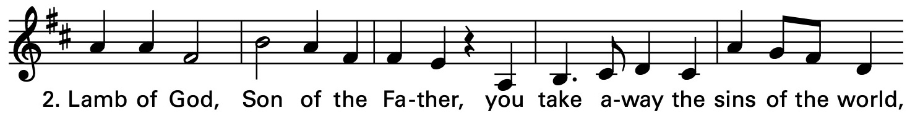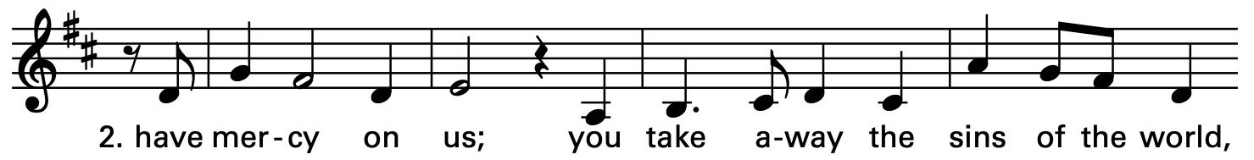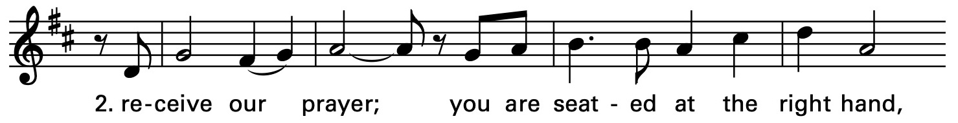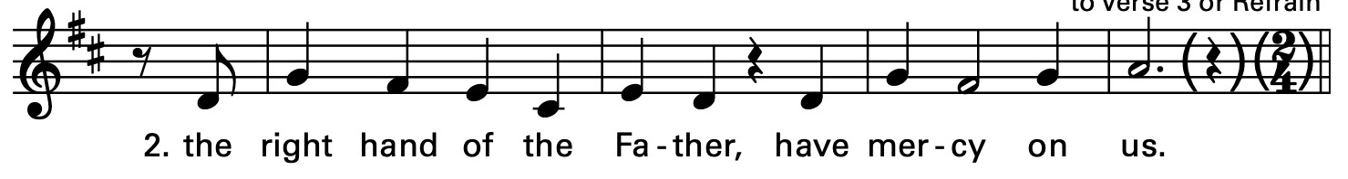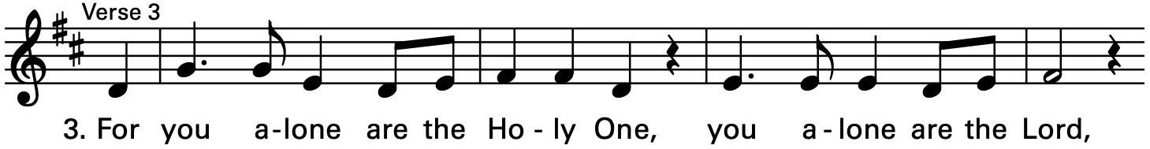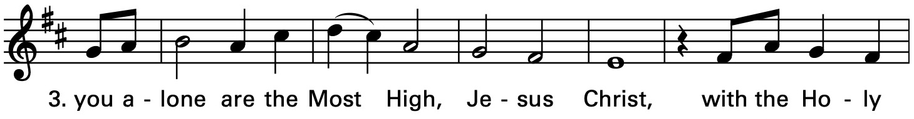

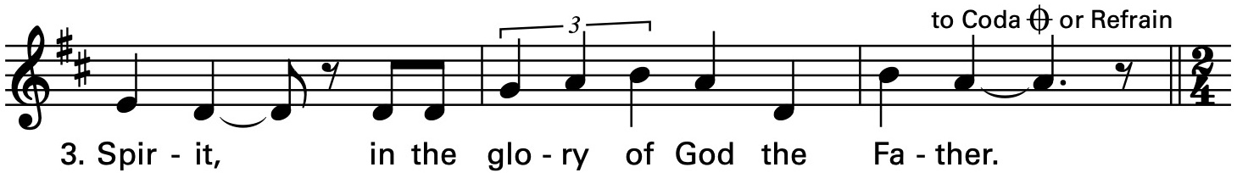

The Collect of the Day

The Celebrant says to the people
The Lord be with you.
People And also with you.
Celebrant Let us pray.
O God, you have prepared for those who love you such good things as surpass our understanding: Pour into our hearts such love towards you, that we, loving you in all things and above all things, may obtain your promises, which exceed all that we can desire; through Jesus Christ our Lord, who lives and reigns with you and the Holy Spirit, one God, for ever and ever. Amen.
The Lessons

The people sit. One or two lessons, as appointed, are read, the Reader first saying

A Reading from the Acts of the Apostles (17:22-31)

Paul stood in front of the Areopagus and said, “Athenians, I see how extremely religious you are in every way. For as I went through the city and looked carefully at the objects of your worship, I found among them an altar with the inscription, ‘To an unknown god.’ What therefore you worship as unknown, this I proclaim to you. The God who made the world and everything in it, he who is Lord of heaven and earth, does not live in shrines made by human hands, nor is he served by human hands, as though he needed anything, since he himself gives to all mortals life and breath and all things. From one ancestor he made all nations to inhabit the whole earth, and he allotted the times of their existence and the boundaries of the places where they would live, so that they would search for God and perhaps grope for him and find him—though indeed he is not far from each one of us. For ‘In him we live and move and have our being’; as even some of your own poets have said, ‘For we too are his offspring.’ Since we are God’s offspring, we ought not to think that the deity is like gold, or silver, or stone, an image formed by the art and imagination of mortals. While God has overlooked the times of human ignorance, now he commands all people everywhere to repent, because he has fixed a day on which he will have the world judged in righteousness by a man whom he has appointed, and of this he has given assurance to all by raising him from the dead.”

The Word of the Lord.
People Thanks be to God.

Silence may follow

Psalm 66:7-18

7 Bless our God, you peoples; *
make the voice of his praise to be heard;

8 Who holds our souls in life, *
and will not allow our feet to slip.

9 For you, O God, have proved us; *
you have tried us just as silver is tried.

10 You brought us into the snare; *
you laid heavy burdens upon our backs.

11 You let enemies ride over our heads;
we went through fire and water; *
but you brought us out into a place of refreshment.

12 I will enter your house with burnt-offerings
and will pay you my vows, *
which I promised with my lips
and spoke with my mouth when I was in trouble.

13 I will offer you sacrifices of fat beasts with the smoke of rams; *
I will give you oxen and goats.

14 Come and listen, all you who fear God, *
and I will tell you what he has done for me.

15 I called out to him with my mouth, *
and his praise was on my tongue.

16 If I had found evil in my heart, *
the Lord would not have heard me;

17 But in truth God has heard me; *
he has attended to the voice of my prayer.

18 Blessed be God, who has not rejected my prayer, *
nor withheld his love from me.

Silence may follow.

A Reading from the first letter of Peter (3:13-22)
Now who will harm you if you are eager to do what is good? But even if you do suffer for doing what is right, you are blessed. Do not fear what they fear, and do not be intimidated, but in your hearts sanctify Christ as Lord. Always be ready to make your defense to anyone who demands from you an accounting for the hope that is in you; yet do it with gentleness and reverence. Keep your conscience clear, so that, when you are maligned, those who abuse you for your good conduct in Christ may be put to shame. For it is better to suffer for doing good, if suffering should be God's will, than to suffer for doing evil. For Christ also suffered for sins once for all, the righteous for the unrighteous, in order to bring you to God. He was put to death in the flesh, but made alive in the spirit, in which also he went and made a proclamation to the spirits in prison, who in former times did not obey, when God waited patiently in the days of Noah, during the building of the ark, in which a few, that is, eight persons, were saved through water. And baptism, which this prefigured, now saves you-- not as a removal of dirt from the body, but as an appeal to God for a good conscience, through the resurrection of Jesus Christ, who has gone into heaven and is at the right hand of God, with angels, authorities, and powers made subject to him.
The Word of the Lord.
People Thanks be to God.
Hymnal 510– Come Holy Spirit
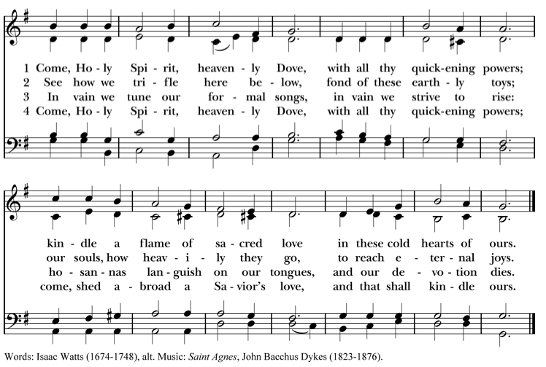
Deacon The Holy Gospel of our Lord Jesus Christ
according to John (14:15-21)
People Glory to you, Lord Christ.
Jesus said, ”If you love me, you will keep my commandments. And I will ask the Father, and he will give you another Advocate, to be with you forever. This is the Spirit of truth, whom the world cannot receive, because it neither sees him nor knows him. You know him, because he abides with you, and he will be in you. ”I will not leave you orphaned; I am coming to you. In a little while the world will no longer see me, but you will see me; because I live, you also will live. On that day you will know that I am in my Father, and you in me, and I in you. They who have my commandments and keep them are those who love me; and those who love me will be loved by my Father, and I will love them and reveal myself to them.”
After the Gospel, the Reader says
The Gospel of the Lord.
People Praise to you, Lord Christ.
The Sermon The Rev. Mike Mayor
All standing
The Nicene Creed
We believe in one God,
the Father, the Almighty,
maker of heaven and earth,
of all that is, seen and unseen.
We believe in one Lord, Jesus Christ,
the only Son of God,
eternally begotten of the Father,
God from God, Light from Light,
true God from true God,
begotten, not made,
of one Being with the Father.
Through him all things were made.
For us and for our salvation
he came down from heaven:
by the power of the Holy Spirit
he became incarnate from the Virgin Mary,
and was made man.
For our sake he was crucified under Pontius Pilate;
he suffered death and was buried.
On the third day he rose again
in accordance with the Scriptures;
he ascended into heaven
and is seated at the right hand of the Father.
He will come again in glory to judge the living and the dead,
and his kingdom will have no end.
We believe in the Holy Spirit, the Lord, the giver of life,
who proceeds from the Father and the Son.
With the Father and the Son he is worshiped and glorified.
He has spoken through the Prophets.
We believe in one holy catholic and apostolic Church.
We acknowledge one baptism for the forgiveness of sins.
We look for the resurrection of the dead,
and the life of the world to come. Amen.
The Prayers of the People – Form IV

Deacon or other leader

Let us pray for the Church and for the world.

Grant, Almighty God, that all who confess your Name may be united in your truth, live together in your love, and reveal your glory in the world.

We remember especially Sean, our Presiding Bishop; Phil, our Bishop; Mike, our priest; and Linda, our Deacon.

In our diocesan cycle of prayer we remember Christ Church, Blaine and Emmanuel, Eastsound.

Silence

Lord, in your mercy
Hear our prayer.

Guide the people of this land, and of all the nations, in the ways of justice and peace; that we may honor one another and serve the common good.

Silence

Lord, in your mercy
Hear our prayer.

Give us all a reverence for the earth as your own creation, that we may use its resources rightly in the service of others and to your honor and glory.

Silence

Lord, in your mercy
Hear our prayer.

Bless all whose lives are closely linked with ours, and grant that we may serve Christ in them, and love one another as he loves us.

In our parish cycle of prayer we remember Jeremy, Linda, Tanya, Shelly, Kay, and Dee Dee.

Silence

Lord, in your mercy
Hear our prayer.

Comfort and heal all those who suffer in body, mind, or spirit; give them courage and hope in their troubles, and bring them the joy of your salvation.

Silence

Lord, in your mercy
Hear our prayer.

We commend to your mercy all who have died, that your will for them may be fulfilled; and we pray that we may share with all your saints in your eternal kingdom.

Silence

Lord, in your mercy
Hear our prayer.

The Celebrant adds a concluding Collect.
The Peace

All stand. The Celebrant says to the people
The peace of the Lord be always with you.
People And also with you.

Then the Ministers and People may greet one another in the name of the Lord.

With One Voice 760– For the Fruit of All Creation

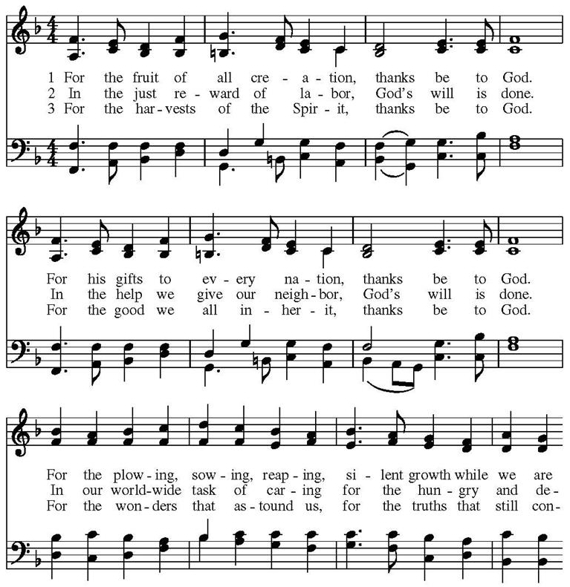

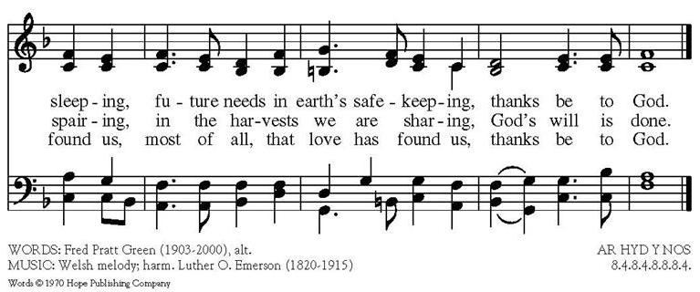
Doxology

The Great Thanksgiving – Eucharistic Prayer D
The people remain standing.
The Celebrant, whether bishop or priest, faces them and sings or says
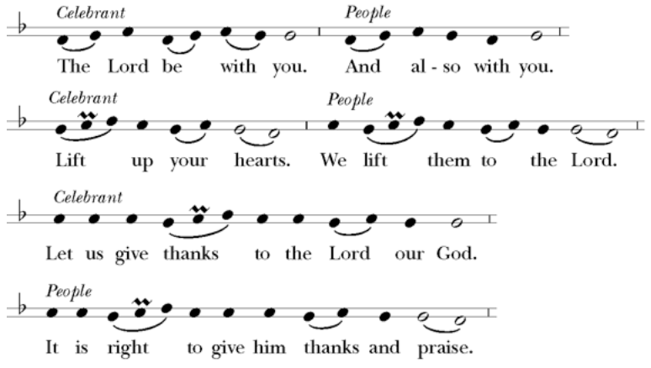

Then, facing the Holy Table, the Celebrant proceeds
It is truly right to glorify you, Father, and to give you thanks; for you alone are God, living and true, dwelling in light inaccessible from before time and for ever.
Fountain of life and source of all goodness, you made all things and fill them with your blessing; you created them to rejoice in the splendor of your radiance.
Countless throngs of angels stand before you to serve you night and day; and, beholding the glory of your presence, they offer you unceasing praise. Joining with them, and giving voice to every creature under heaven, we acclaim you, and glorify your Name, as we sing (say),

Celebrant and People
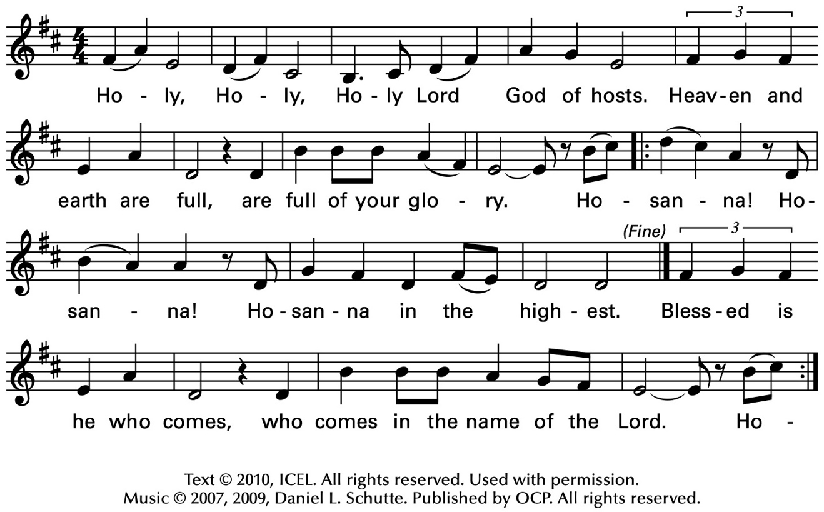
The Celebrant continues
We acclaim you, holy Lord, glorious in power. Your mighty works reveal your wisdom and love. You formed us in your own image, giving the whole world into our care, so that, in obedience to you, our Creator, we might rule and serve all your creatures. When our disobedience took us far from you, you did not abandon us to the power of death. In your mercy you came to our help, so that in seeking you we might find you. Again and again you called us into covenant with you, and through the prophets you taught us to hope for salvation.
Father, you loved the world so much that in the fullness of time you sent your only Son to be our Savior. Incarnate by the Holy Spirit, born of the Virgin Mary, he lived as one of us, yet without sin. To the poor he proclaimed the good news of salvation; to prisoners, freedom; to the sorrowful, joy. To fulfill your purpose he gave himself up to death; and, rising from the grave, destroyed death, and made the whole creation new.
And, that we might live no longer for ourselves, but for him who died and rose for us, he sent the Holy Spirit, his own first gift for those who believe, to complete his work in the world, and to bring to fulfillment the sanctification of all.
At the following words concerning the bread, the Celebrant is to hold it, or lay a hand upon it; and at the words concerning the cup, to hold or place a hand upon the cup and any other vessel containing wine to be consecrated.

When the hour had come for him to be glorified by you, his heavenly Father, having loved his own who were in the world, he loved them to the end; at supper with them he took bread, and when he had given thanks to you, he broke it, and gave it to his disciples, and said, "Take, eat: This is my Body, which is given for you. Do this for the remembrance of me."

After supper he took the cup of wine; and when he had given thanks, he gave it to them, and said, "Drink this, all of you: This is my Blood of the new Covenant, which is shed for you and for many for the forgiveness of sins. Whenever you drink it, do this for the remembrance of me."

Father, we now celebrate this memorial of our redemption. Recalling Christ's death and his descent among the dead, proclaiming his resurrection and ascension to your right hand, awaiting his coming in glory; and offering to you, from the gifts you have given us, this bread and this cup, we praise you and we bless you.

Celebrant and People

We praise you,
we bless you,
we give thanks to you,
and we pray to you, Lord our God.

The Celebrant continues

Lord, we pray that in your goodness and mercy your Holy Spirit may descend upon us, and upon these gifts, sanctifying them and showing them to be holy gifts for your holy people, the bread of life and the cup of salvation, the Body and Blood of your Son Jesus Christ.

Grant that all who share this bread and cup may become one body and one spirit, a living sacrifice in Christ, to the praise of your Name.

Remember, Lord, your one holy catholic and apostolic Church, redeemed by the blood of your Christ. Reveal its unity, guard its faith, and preserve it in peace.

And grant that we may find our inheritance with the Blessed Virgin Mary, with patriarchs, prophets, apostles, and martyrs, and all the saints who have found favor with you in ages past. We praise you in union with them and give you glory through your Son Jesus Christ our Lord.

Through Christ, and with Christ, and in Christ, all honor and glory are yours, Almighty God and Father, in the unity of the Holy Spirit, for ever and ever.

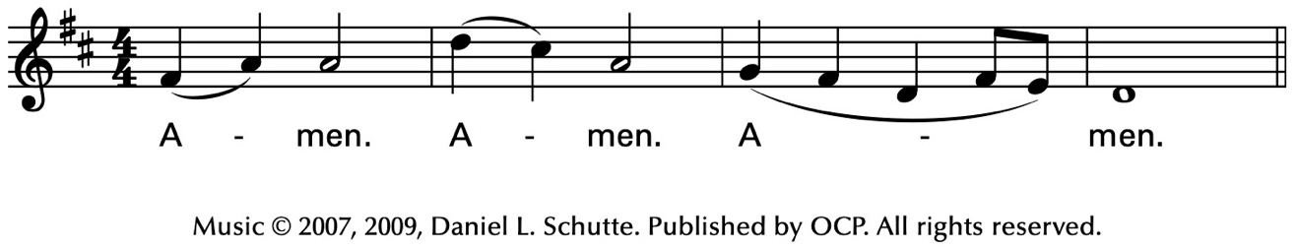
Celebrant
As our Savior Christ
has taught us,
we now pray,

People and Celebrant
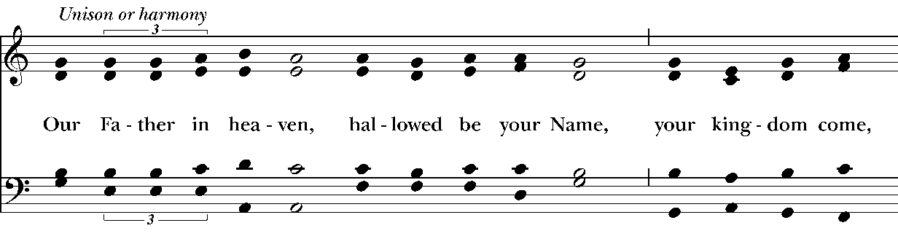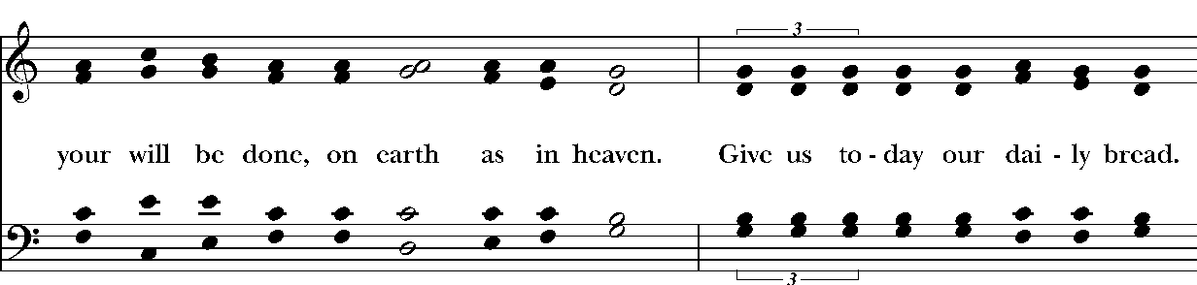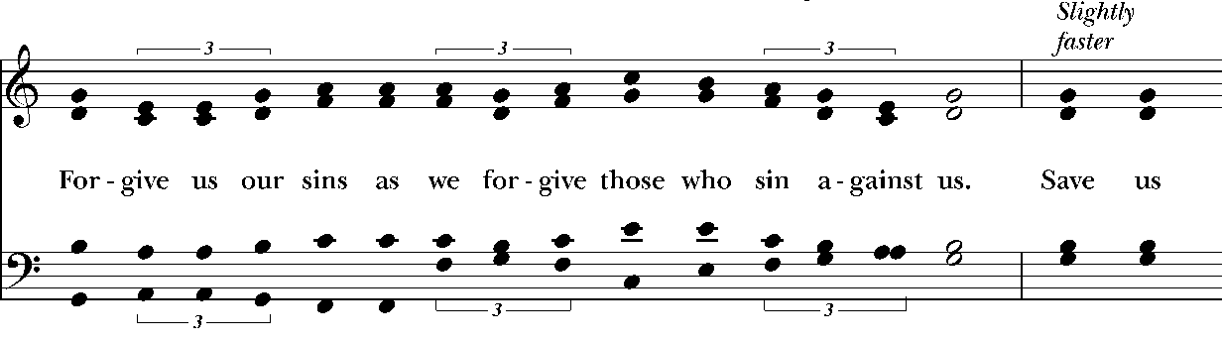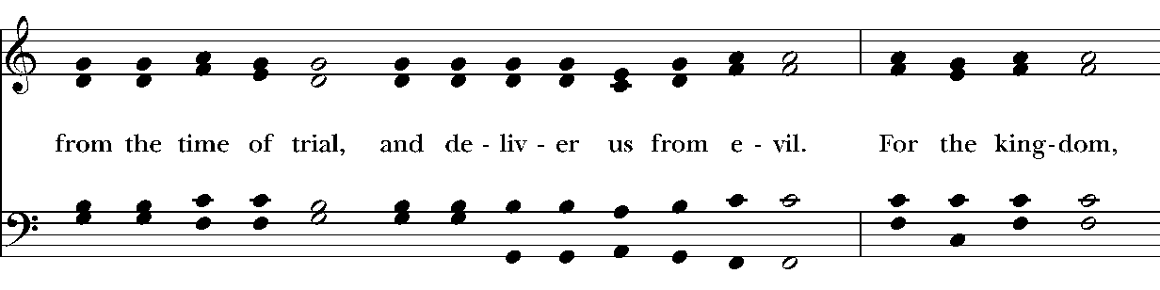
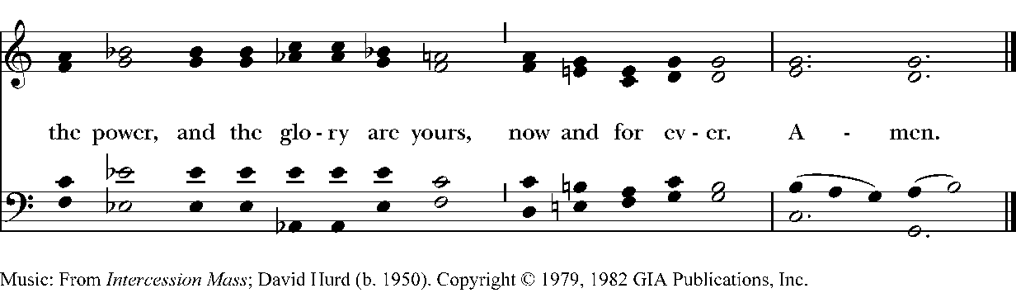
The Breaking of the Bread

The Celebrant breaks the consecrated Bread.

A period of silence is kept.

Then may be sung or said

Celebrant

People
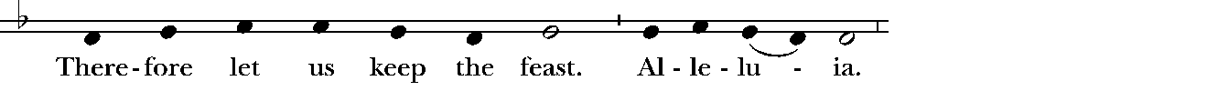
Music: Ambrosian chant; adapt. Mason Martens (1933-1991)

Facing the people, the Celebrant says the following Invitation

The Gifts of God for the People of God.
and may add Take them in remembrance that Christ died for
you, and feed on him in your hearts by faith,
with thanksgiving.

The Bread and Wine are given to the communicants with these words

The Body of Christ, the bread of heaven. [Amen.]
The Blood of Christ, the cup of salvation. [Amen.]

Hymnal 325– Let Us Break Bread
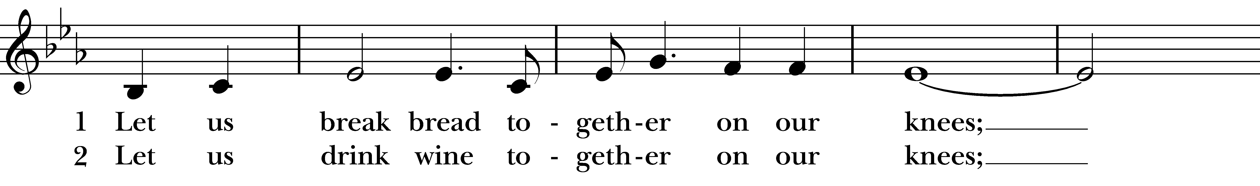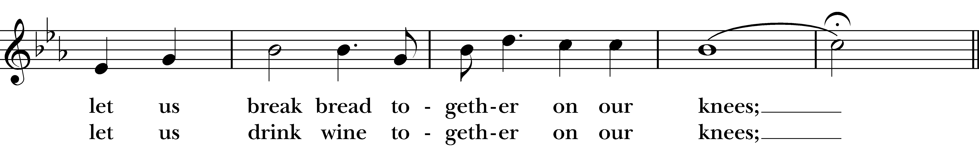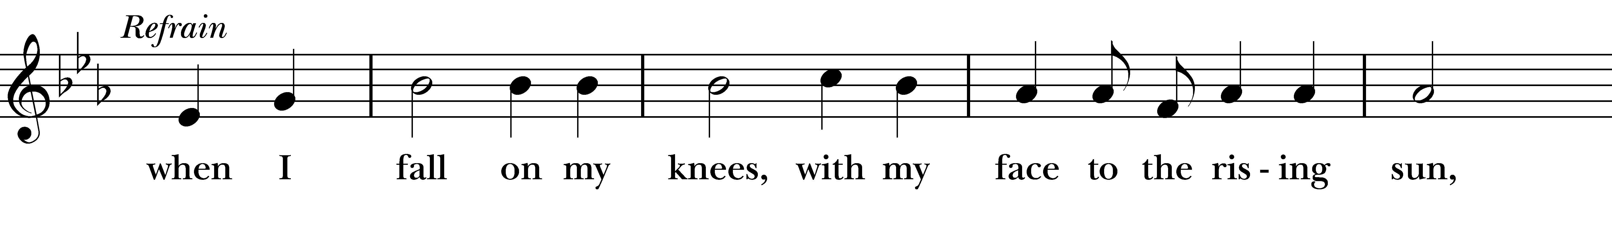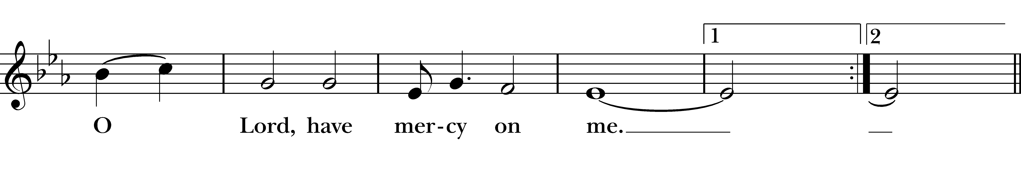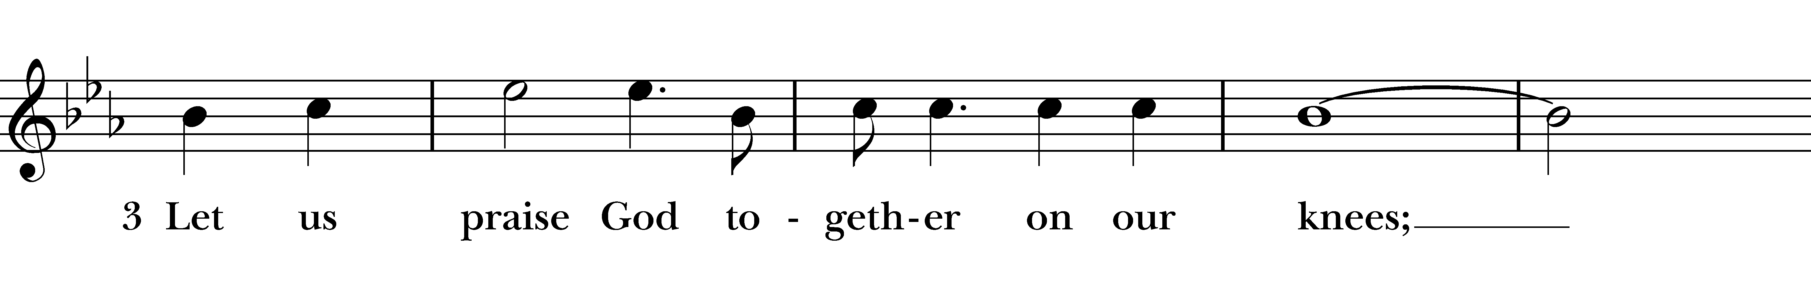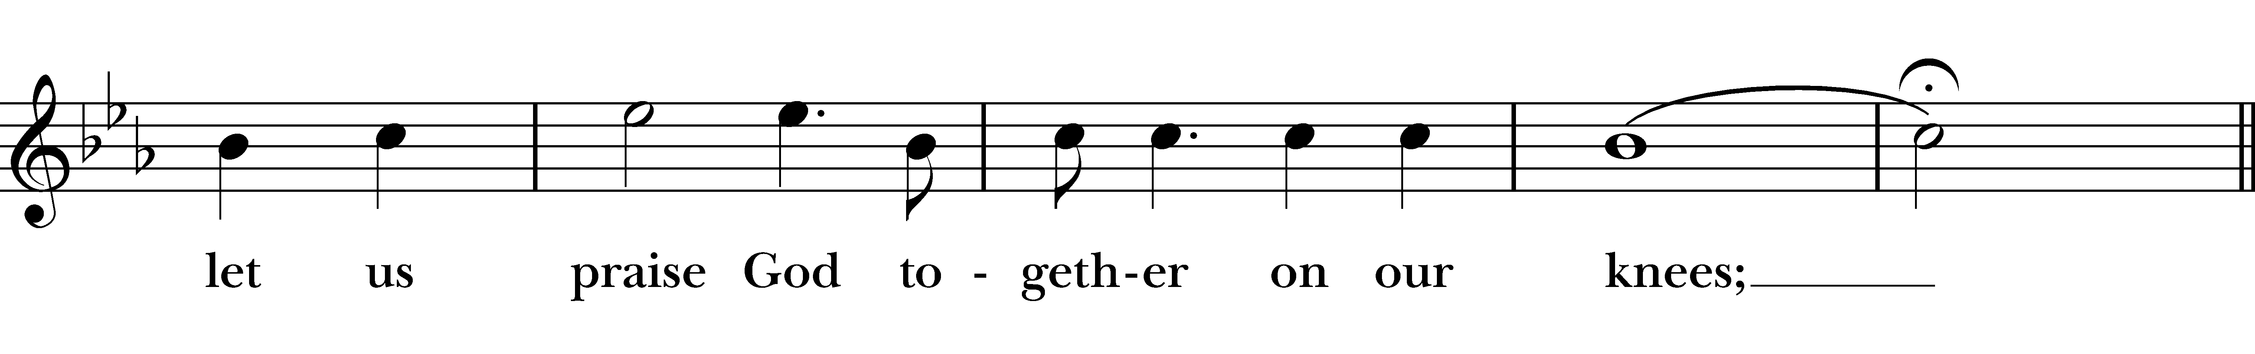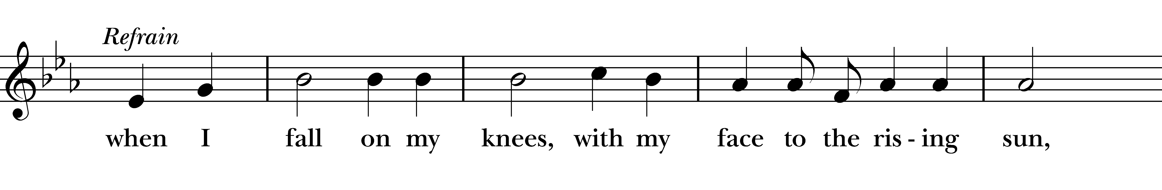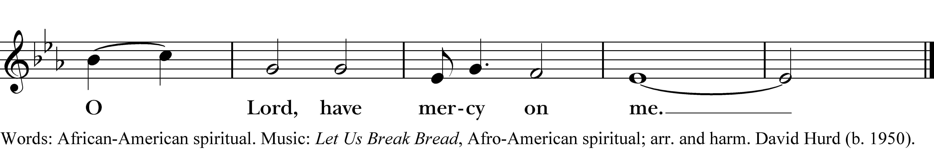
After communion the Celebrant says
Let us pray.

Celebrant and People
Eternal God, heavenly Father,
you have graciously accepted us as living members
of your Son our Savior Jesus Christ,
and you have fed us with spiritual food
in the Sacrament of his Body and Blood.
Send us now into the world in peace,
and grant us strength and courage
to love and serve you
with gladness and singleness of heart;
through Christ our Lord. Amen.
The Bishop when present, or the Priest, may bless the people.
Hymnal 705– As Those of Old Their First Fruits Brought
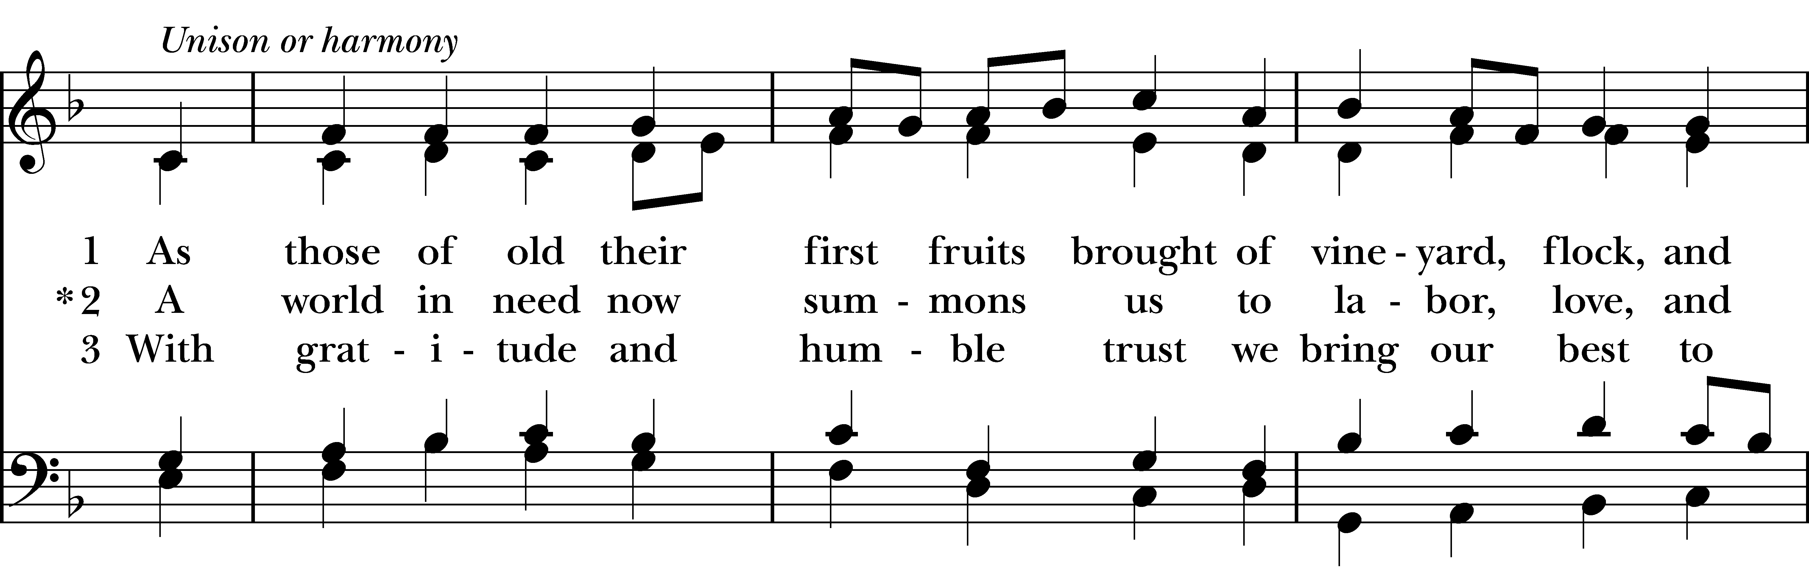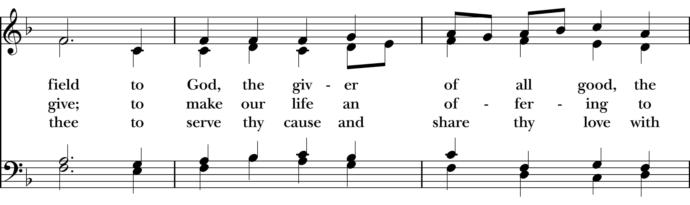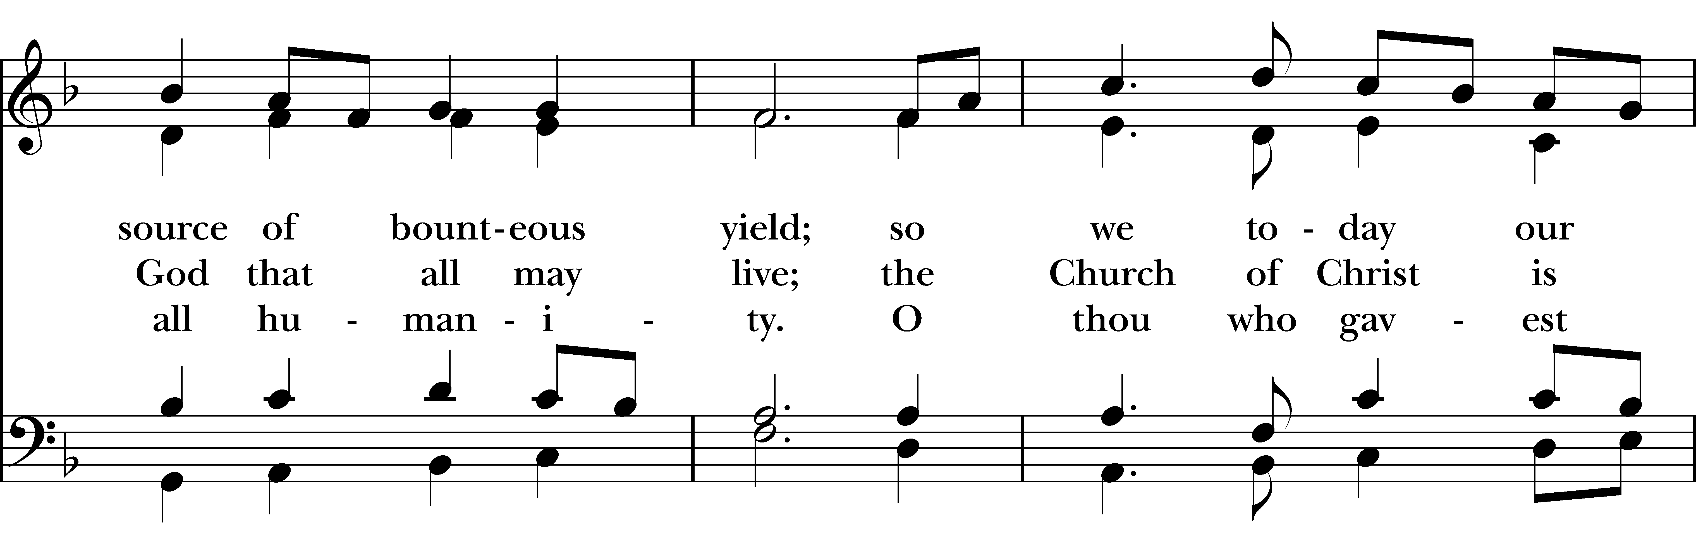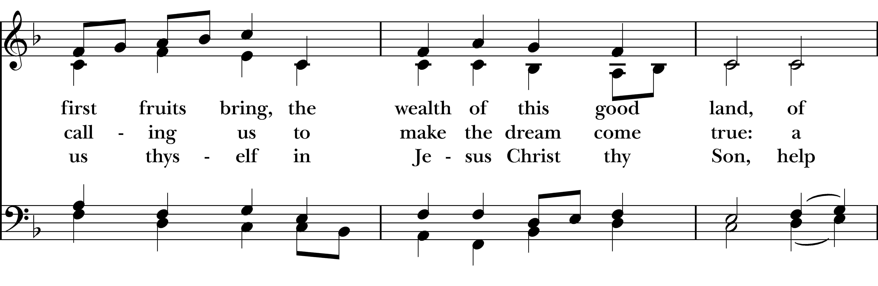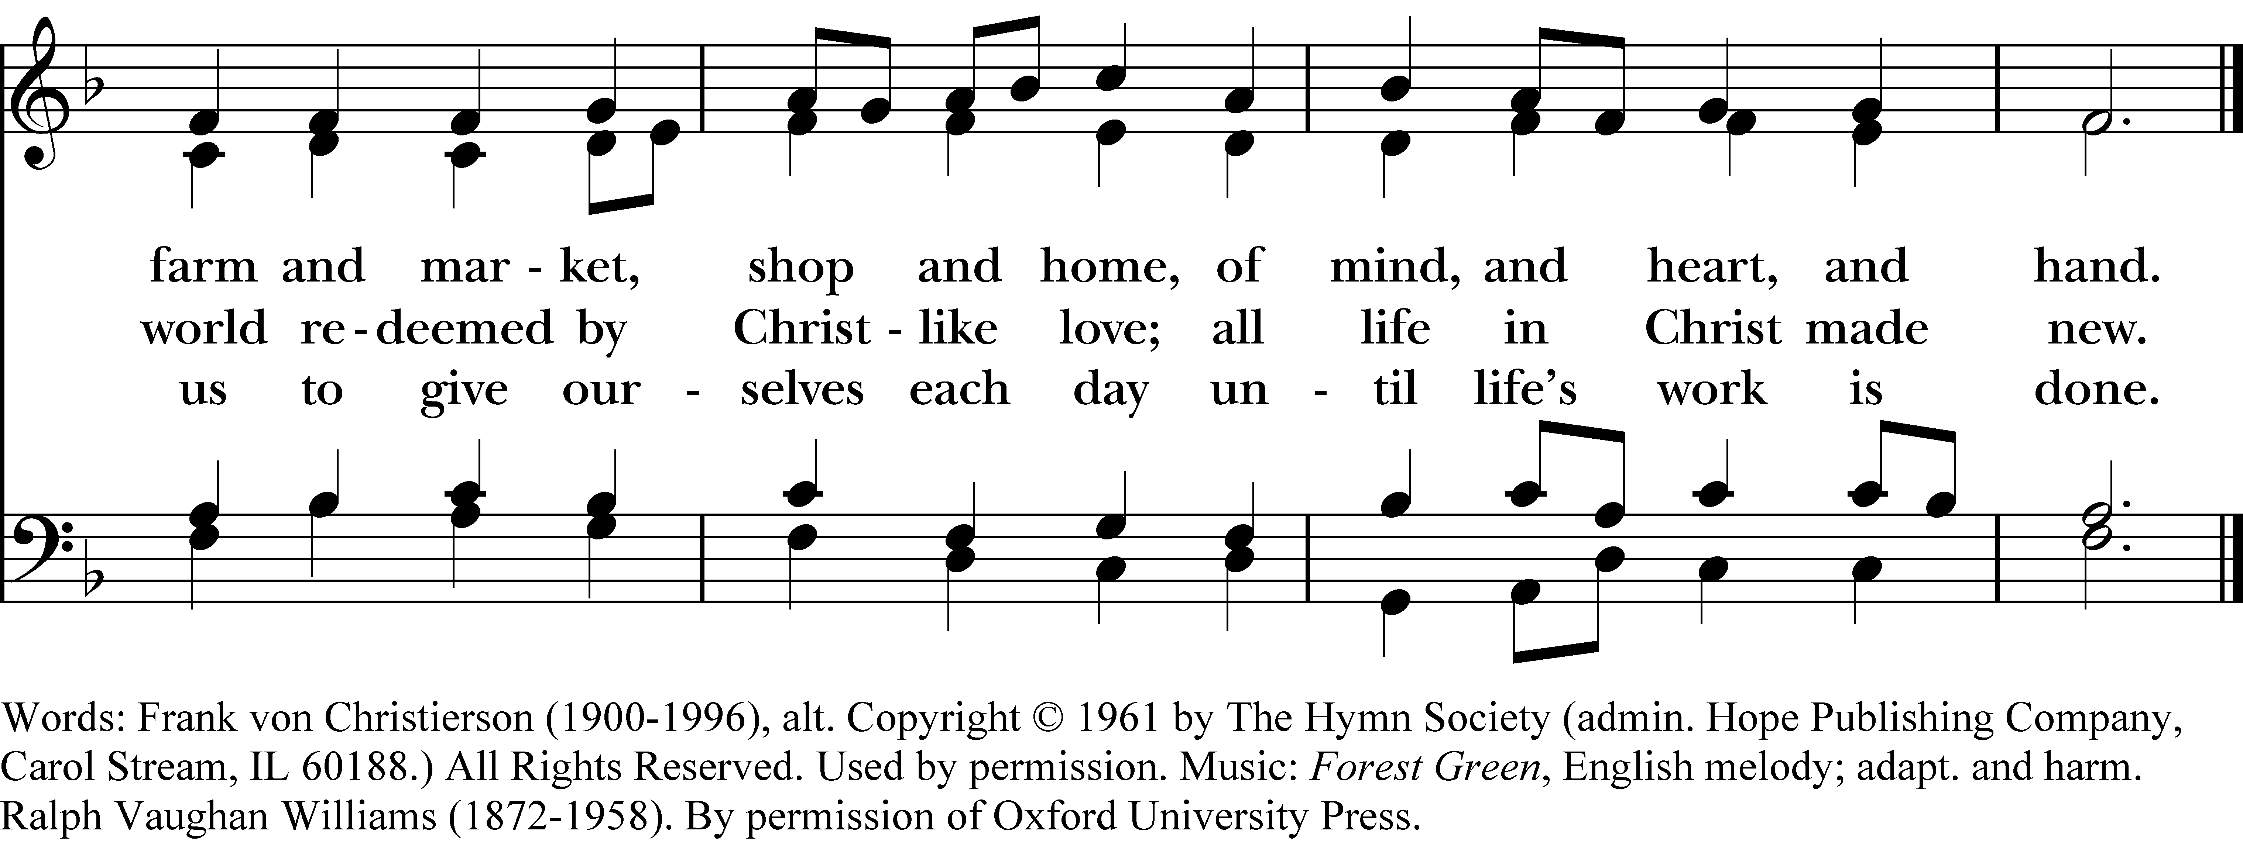

Deacon Go in peace to love and serve the Lord. Alleluia. Alleluia.
People Thanks be to God. Alleluia. Alleluia.
Postlude

Announcements
Flowers for this Sunday
The flowers for this Sunday, May 10, 2026 are given by Peggy Wheeler to the Glory of God, and in celebration of Mother’s Day, Daughter’s Hillary’s birthday and WSU graduation!!
Fellowship Book Group
Please join us for fellowship and lively discussion. We start with fellowship at 6:00 pm and discussion starts at 6:30 pm. We’d love to have you join us. The next meeting will be on our usual meeting day, (4th Monday of the month) April 27, 2026 via zoom.
The Zoom link and passcode are:
Meeting ID: 82826550583
Passcode: 121698
May will be "The Heaven & Earth Grocery Store", by James McBride. (Available for order at various used bookstores, Audible, or possibly at your local library)
In 1972, when workers in Pottstown, Pennsylvania, were digging the foundations for a new housing development, the last thing they expected to uncover was a human skeleton. Who the skeleton was and how it got buried there were just two of the long-held secrets that had been kept for decades by the residents of Chicken Hill, the dilapidated neighborhood where immigrant Jews and African Americans lived side by side, sharing ambitions and sorrows.
We are providing the title of the book chosen for the next month, so readers will have time to get on library wait lists or plan for any ordering backlog. The book for June will be "How to Read a Book", by Monica Wood.
Questions? Speak with any of the following: Shelly Fairbanks, DeeDee Fournier, Jen Killion, Melinda Jackson
Soup Kitchen
Susan Myers and Deacon Linda
Thank you to the volunteers for providing the food: Susan M. for providing soup; Rick B. for serving; Susan M. for assisting in the kitchen; Steve A. for bringing fruit, Calvin S. and Rick B. for serving food; Patti M. and Lynn S. for serving at the Hospitality Table.
This week's totals:
People served: 13 Toiletries given out: 13
Bus passes given out: 7 Socks given away: 8
How many picked up mail: 5
We need volunteers to provide soup, fruit, bread or dessert for the month of May. Please sign up on the Soup Kitchen form on the Communications Board in the parish hall.
Food donations can be bought on Sunday mornings or on Wednesdays before 10:00 am. Just mark them “Soup Kitchen”.
May is the last month for the Soup Kitchen. Don’t mis your opportunity to contribute something to the Soup Kitchen.
Lunches To Go will open outside on the sidewalk in front of the church on Wednesday, June 3.
Puyallup Food Bank Donations
We have Spring in full swing now. We have selected the following items for the month of May:

- Shelf-stable Goods
- Nutritional Foods
- Paper Products
- Special Treats

Monies to donate can be added to the collection plate, or can be mailed to the Church. Please mark your donations "Food Bank".
Thank you in advance for your support and generosity. It is greatly appreciated!
Maria Haack, Vestry Liaison for Outreach
Lunches To Go
Lunches To Go is a very successful Christ Church outreach ministry to the poor, homeless or those in need. We pack sack lunches and give them out along with pop and water. We will be starting on June 3 and continuing through the end of September.
We are in need of food items for Lunches To Go. Items needed for Lunches to Go - Protein bars, fruit cups, pudding cups, Ding Dongs or individually wrapped cupcakes, Twinkies, Individual small bags of chips, sandwich size Ziploc baggies, napkins, cans of Coke, Sprite, and bottles of water. When we pack lunches, we prepare 24 sack lunches each week. Monetary donations to St. Laurence Ministry are also welcomed. Please mark your check in the lower left-hand side "Lunches To Go." Please bring your donations of food items to the stage in the parish hall.
If you would like to volunteer this summer, and sit under the canopy, and hand out lunches, your help would be greatly appreciated. Three volunteers are needed each week. There will be chairs for the volunteers to sit in. The duties are very simple, and this is a great way to volunteer and help others.
The Sign-Up Forms for Lunches to Go are on a clipboard on the board holder on the stage. The times would be any Wednesday from 10:00 am to 1:15 pm.
Thank you for providing food items or donations for the Lunches to Go ministry. Please contact Deacon Linda for more details or to volunteer.
"Immigrant" Justice Prayer Walk- Saturday, May 15 @ 12:00 pm - 6:00 pm | Seattle
You are invited you to participate in the second annual "Immigrant" Justice Prayer Walk on Saturday, May 16th.
We will begin in prayer at St. Luke’s in Ballard and walk 2.5 miles, stopping at Commodore Park for a Coast Salish water ceremony and finishing at Daybreak Star for food and cultural sharing. The diocese is honored to be an event sponsor and part of the organizing coalition of indigenous, environmental, and other community-centered groups.
There will be van transportation between stops for any who needs a ride, and interpretation, security, and de-escalation will be provided throughout. All are welcome and feel free to join for any part!
Canon Carla Robinson
Back by Popular Demand - Let's Talk About God
After multiple requests, last summer's program: Let's Talk About God, will be returning Sunday, June 7, following the 10 am service.
On the first and third Sundays of the month during the summer and early fall, join a casual but hopefully informative coffee hour chat with Fr. Mike and each other. Two tables will be set aside during coffee hour to let people have a chance to talk about matters of faith in a relaxed and informal setting while enjoying coffee, treats, and fellowship. Look for the Let's Talk About God signs on those tables.
Puyallup Food Bank Thank You
Dear Christ Church,
Thank you for your generous gift of $600.00 received on April 20, 2026. We are deeply grateful for your compassion and support. Your kindness comes at a meaningful time for the families we serve, and it truly makes a difference.
Through your kindness and the incredible community donations received through events like our Spring Fair Food Drive that brought in nearly 19,000 pounds of food, parents, kids and seniors in our community receive the nourishment they need.
Every day we see firsthand how powerful generosity can be. Your support reminds our neighbors in need that they are not forgotten.
Thank you for standing with us in our mission to fight hunger and nourish lives. We are profoundly grateful for your heart and your partnership.
With sincere appreciation and warmest thanks,
Shawn Manley,
Puyallup Food Bank CEO

Sermon Notes

Sermon Notes
Today’s Ministers of Worship

Celebrant: The Rev. Mike Mayor
Deacon: The Rev. Linda Potter
Lectors: Sue Golden, Carla Golden
Acolyte: Tristen Schilling
Eucharistic Minister: Jeremy Duplissey
Livestream Coordinator: Bonnie Quintana
Nursery Attendants: Barry O’Brien
Melinda Jackson
Pianist: Vicki Melton
Greeters: Carla Golden, DeeDee Fournier, Helen Godwin, Christine Scholer, Tiffany Richards,
Barb Johnsey
Usher: Maria Haack
Closer: Melinda Jackson
Altar Guild: Christine Scholer, Jean Irey
Music permission through OneLicense #A-706918


Scan to give online. All payments are processed through Paypal.

Christ Episcopal Church
A congregation of the Episcopal Diocese of Olympia
Bishop – The Rt. Rev. Philip N. LaBelle
Rector – The Rev. Mike Mayor
Vestry
Sr. Warden – Shelly Fairbanks
Jr. Warden for Property – Jeremy Duplissey
Jr. Warden for Communication – Barry O’Brien
Treasurer – Melinda Jackson
Clerk – Tanya Elder
Member – Steve Angelo
Member – Roddi Barton
Member – Maria Haack
Member – Susan Myers
Member – Dave Steere
Member – Rolin Stone
210 5th St. SW | Puyallup, WA | 98371
253-848-2323 | office@episcopallup.com
www.episcopallup.com

