Fifth Sunday of Easter
Holy Eucharist, Rite II

10:00 am – May 3, 2026

Welcome to Christ Church
We are so happy you have chosen to come and participate in worship this morning. Your presence today strengthens the Body of Christ, not only here but throughout the world.
Land Acknowledgment
Christ Church acknowledges that we gather on the traditional homeland of the Puyallup Tribe. The Puyallup people have lived on and stewarded these lands since the beginning of time, and continue to do so today. We honor and give thanks for the land itself and the life of all the indigenous peoples of this area.
New to Christ Church?
Welcome to Christ Episcopal Church of Puyallup. Wherever you are on your spiritual journey, you are welcome here! We invite you to sign our guestbook, visit our website (www.episcopallup.com) or connect with one of the clergy.
Questions?
Please ask. The ushers (one of the persons who gave you a bulletin) can answer your questions or concerns. Restrooms are available in the hallway to the west of the worship space.
About our Liturgy
Worship lies at the heart of the Christian life. It is in worship that we express our theology and define our identity. We encounter God within worship and are formed and transformed as the people of God. One of the hallmarks of the Episcopal Church is its liturgical worship. Liturgy literally is “the work of the people,” and refers to the patterns, forms, words, and actions through which public worship is conducted.

Hymnal 390 – Praise to the Lord, the Almighty, the King of creation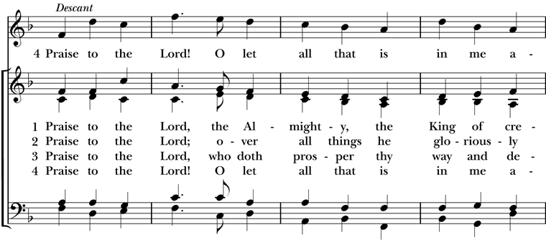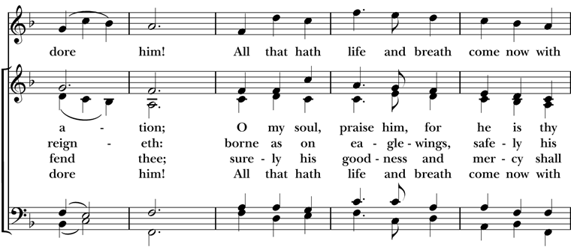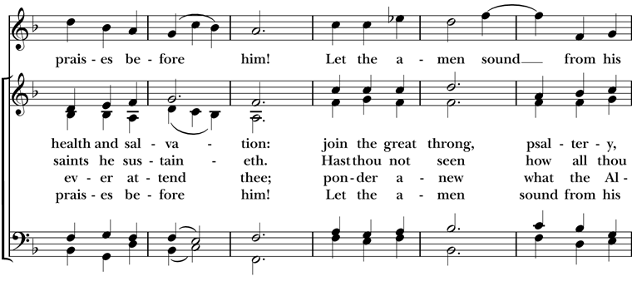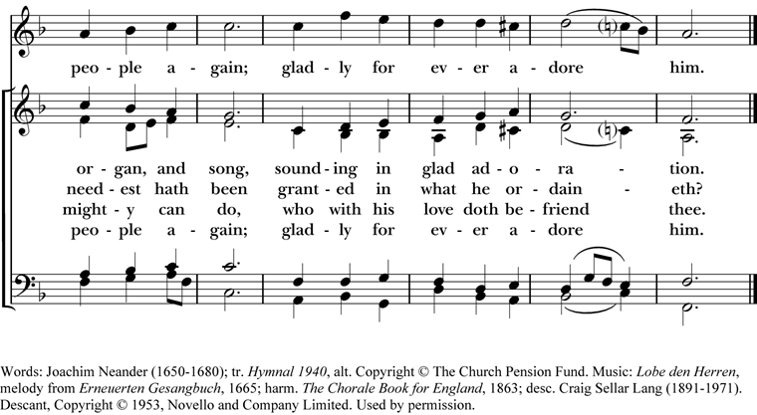

The Celebrant then says to the people

Alleluia. Christ is risen.
People The Lord is risen indeed. Alleluia.
The Celebrant may say
Almighty God, to you all hearts are open, all desires known, and from you no secrets are hid: Cleanse the thoughts of our hearts by the inspiration of your Holy Spirit, that we may perfectly love you, and worthily magnify your holy Name; through Christ our Lord. Amen.

When appointed, the following hymn or some other song of praise is sung or said, all standing

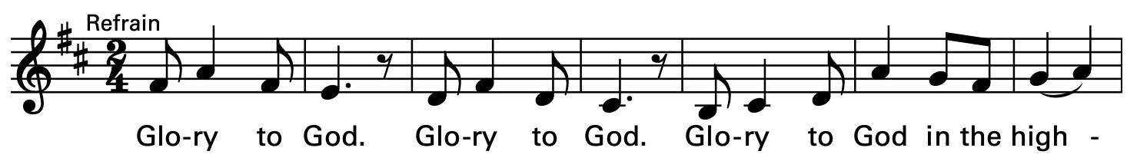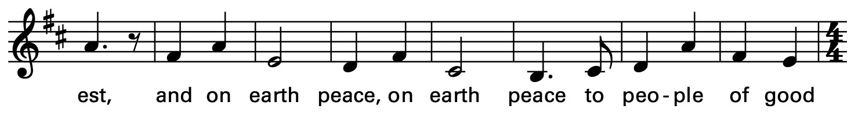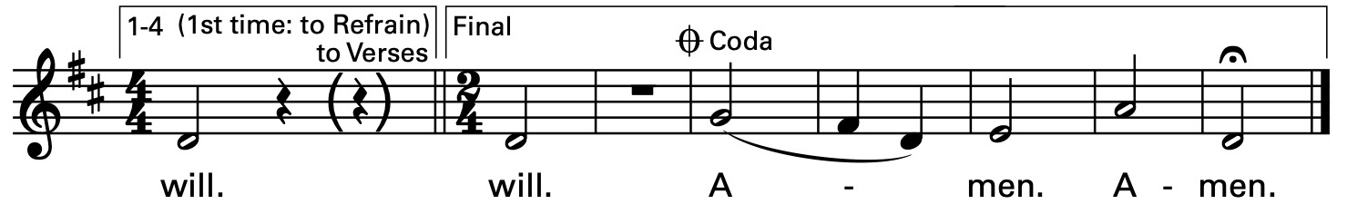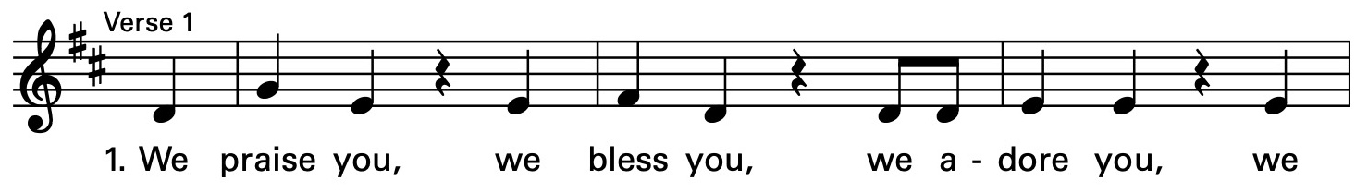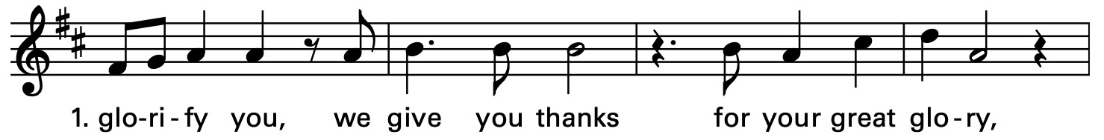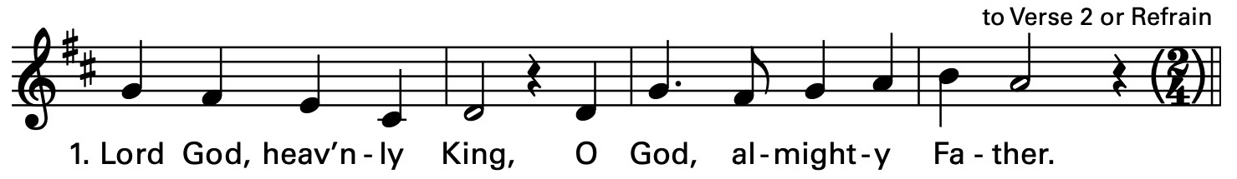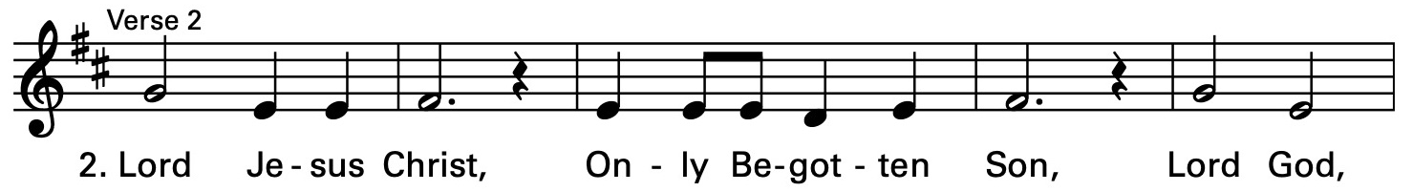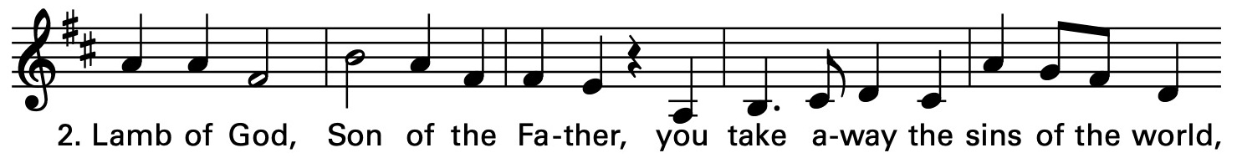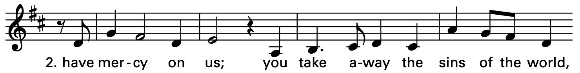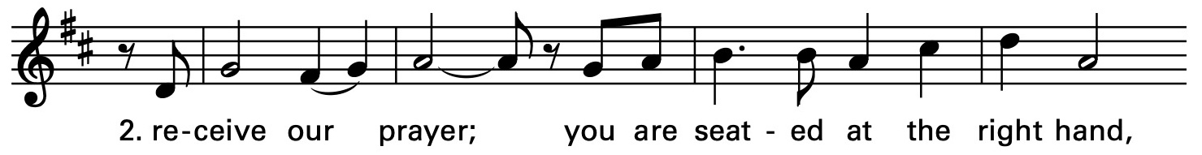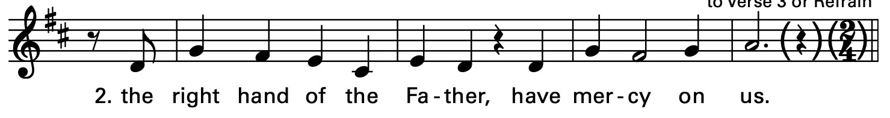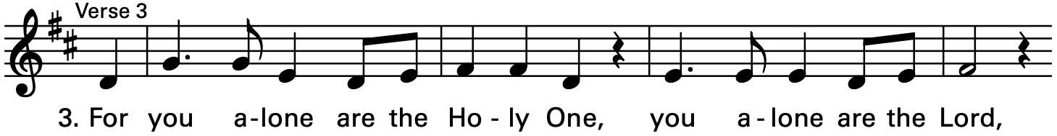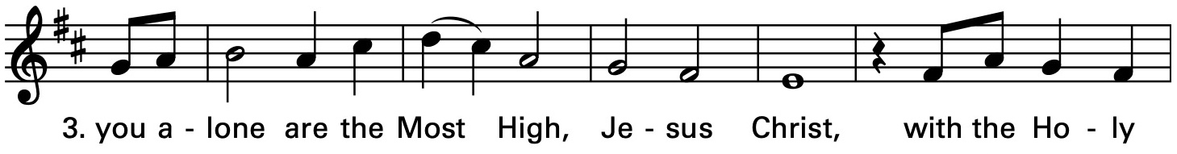

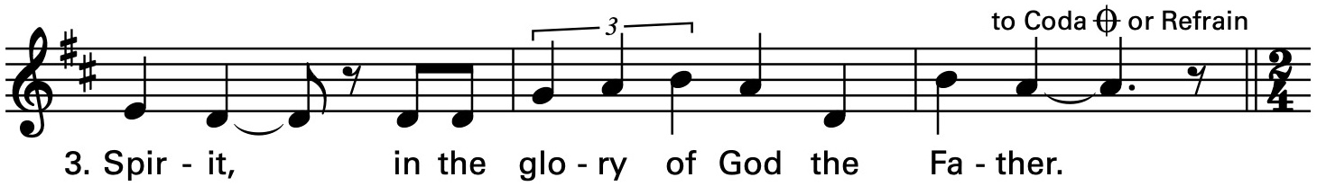

The Collect of the Day

The Celebrant says to the people
The Lord be with you.
People And also with you.
Celebrant Let us pray.
Almighty God, whom truly to know is everlasting life: Grant us so perfectly to know your Son Jesus Christ to be the way, the truth, and the life, that we may steadfastly follow his steps in the way that leads to eternal life; through Jesus Christ your Son our Lord, who lives and reigns with you, in the unity of the Holy Spirit, one God, for ever and ever. Amen.
The Lessons

The people sit. One or two lessons, as appointed, are read, the Reader first saying

A Reading from the Acts of the Apostles (7:55-60)

Filled with the Holy Spirit, Stephen gazed into heaven and saw the glory of God and Jesus standing at the right hand of God. “Look,” he said, “I see the heavens opened and the Son of Man standing at the right hand of God!” But they covered their ears, and with a loud shout all rushed together against him. Then they dragged him out of the city and began to stone him; and the witnesses laid their coats at the feet of a young man named Saul. While they were stoning Stephen, he prayed, “Lord Jesus, receive my spirit.” Then he knelt down and cried out in a loud voice, “Lord, do not hold this sin against them.” When he had said this, he died.

The Word of the Lord.
People Thanks be to God.

Silence may follow

Psalm 31:1-5, 15-16

1 In you, O Lord, have I taken refuge;
let me never be put to shame; *
deliver me in your righteousness.

2 Incline your ear to me; *
make haste to deliver me.

3 Be my strong rock, a castle to keep me safe,
for you are my crag and my stronghold; *
for the sake of your Name, lead me and guide me.

4 Take me out of the net that they have secretly set for me, *
for you are my tower of strength.

5 Into your hands I commend my spirit, *
for you have redeemed me,
O Lord, O God of truth.

15 My times are in your hand; *
rescue me from the hand of my enemies,
and from those who persecute me.

16 Make your face to shine upon your servant, *
and in your loving-kindness save me.

Silence may follow.

A Reading from the first letter of Peter (2:2-10)
Like newborn infants, long for the pure, spiritual milk, so that by it you may grow into salvation— if indeed you have tasted that the Lord is good. Come to him, a living stone, though rejected by mortals yet chosen and precious in God’s sight, and like living stones, let yourselves be built into a spiritual house, to be a holy priesthood, to offer spiritual sacrifices acceptable to God through Jesus Christ. For it stands in scripture: “See, I am laying in Zion a stone, a cornerstone chosen and precious; and whoever believes in him will not be put to shame.” To you then who believe, he is precious; but for those who do not believe, “The stone that the builders rejected has become the very head of the corner”, and “A stone that makes them stumble, and a rock that makes them fall.” They stumble because they disobey the word, as they were destined to do. But you are a chosen race, a royal priesthood, a holy nation, God’s own people, in order that you may proclaim the mighty acts of him who called you out of darkness into his marvelous light. Once you were not a people, but now you are God’s people; once you had not received mercy, but now you have received mercy.
The Word of the Lord.
People Thanks be to God.
Hymnal 703– Lead us, O Father, in the paths of peace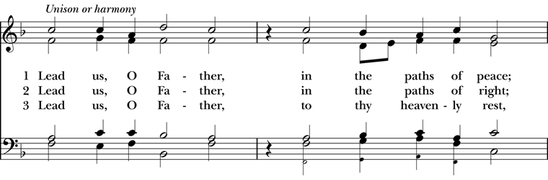
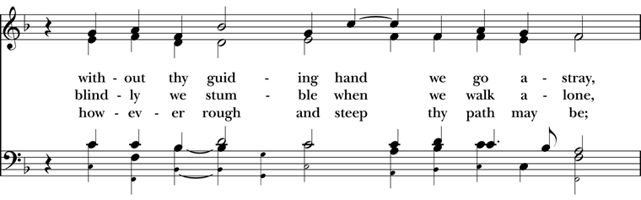
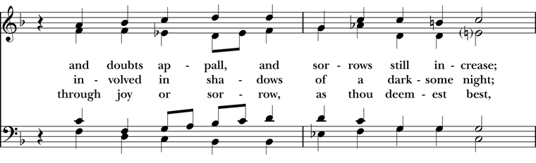

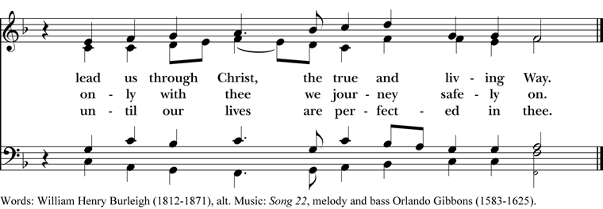
Deacon The Holy Gospel of our Lord Jesus Christ
according to John (14:1-14)
People Glory to you, Lord Christ.
Jesus said, “Do not let your hearts be troubled. Believe in God, believe also in me. In my Father’s house there are many dwelling places. If it were not so, would I have told you that I go to prepare a place for you? And if I go and prepare a place for you, I will come again and will take you to myself, so that where I am, there you may be also. And you know the way to the place where I am going.” Thomas said to him, “Lord, we do not know where you are going. How can we know the way?” Jesus said to him, “I am the way, and the truth, and the life. No one comes to the Father except through me. If you know me, you will know my Father also. From now on you do know him and have seen him.” Philip said to him, “Lord, show us the Father, and we will be satisfied.” Jesus said to him, “Have I been with you all this time, Philip, and you still do not know me? Whoever has seen me has seen the Father. How can you say, ‘Show us the Father’? Do you not believe that I am in the Father and the Father is in me? The words that I say to you I do not speak on my own; but the Father who dwells in me does his works. Believe me that I am in the Father and the Father is in me; but if you do not, then believe me because of the works themselves. Very truly, I tell you, the one who believes in me will also do the works that I do and, in fact, will do greater works than these, because I am going to the Father. I will do whatever you ask in my name, so that the Father may be glorified in the Son. If in my name you ask me for anything, I will do it.”
After the Gospel, the Reader says
The Gospel of the Lord.
People Praise to you, Lord Christ.
The Sermon The Rev. Mike Mayor
All standing
The Nicene Creed
We believe in one God,
the Father, the Almighty,
maker of heaven and earth,
of all that is, seen and unseen.
We believe in one Lord, Jesus Christ,
the only Son of God,
eternally begotten of the Father,
God from God, Light from Light,
true God from true God,
begotten, not made,
of one Being with the Father.
Through him all things were made.
For us and for our salvation
he came down from heaven:
by the power of the Holy Spirit
he became incarnate from the Virgin Mary,
and was made man.
For our sake he was crucified under Pontius Pilate;
he suffered death and was buried.
On the third day he rose again
in accordance with the Scriptures;
he ascended into heaven
and is seated at the right hand of the Father.
He will come again in glory to judge the living and the dead,
and his kingdom will have no end.
We believe in the Holy Spirit, the Lord, the giver of life,
who proceeds from the Father and the Son.
With the Father and the Son he is worshiped and glorified.
He has spoken through the Prophets.
We believe in one holy catholic and apostolic Church.
We acknowledge one baptism for the forgiveness of sins.
We look for the resurrection of the dead,
and the life of the world to come. Amen.
The Prayers of the People – Form IV

Deacon or other leader

Let us pray for the Church and for the world.

Grant, Almighty God, that all who confess your Name may be united in your truth, live together in your love, and reveal your glory in the world.

We remember especially Sean, our Presiding Bishop; Phil, our Bishop; Mike, our priest; and Linda, our Deacon.

In our diocesan cycle of prayer we remember Christ Church, Anacortes and St. Paul’s, Bellingham.

Silence

Lord, in your mercy
Hear our prayer.

Guide the people of this land, and of all the nations, in the ways of justice and peace; that we may honor one another and serve the common good.

Silence

Lord, in your mercy
Hear our prayer.

Give us all a reverence for the earth as your own creation, that we may use its resources rightly in the service of others and to your honor and glory.

Silence

Lord, in your mercy
Hear our prayer.

Bless all whose lives are closely linked with ours, and grant that we may serve Christ in them, and love one another as he loves us.

In our parish cycle of prayer we remember Coty, Bill & Auri, Brian, and Marti, Dugan, Alex, Stuart, & Peter.

Silence

Lord, in your mercy
Hear our prayer.

Comfort and heal all those who suffer in body, mind, or spirit; give them courage and hope in their troubles, and bring them the joy of your salvation.

Silence

Lord, in your mercy
Hear our prayer.

We commend to your mercy all who have died, that your will for them may be fulfilled; and we pray that we may share with all your saints in your eternal kingdom.

Silence

Lord, in your mercy
Hear our prayer.

The Celebrant adds a concluding Collect.
The Peace

All stand. The Celebrant says to the people
The peace of the Lord be always with you.
People And also with you.

Then the Ministers and People may greet one another in the name of the Lord.

Hymnal 455 – O Love of God, how strong and true

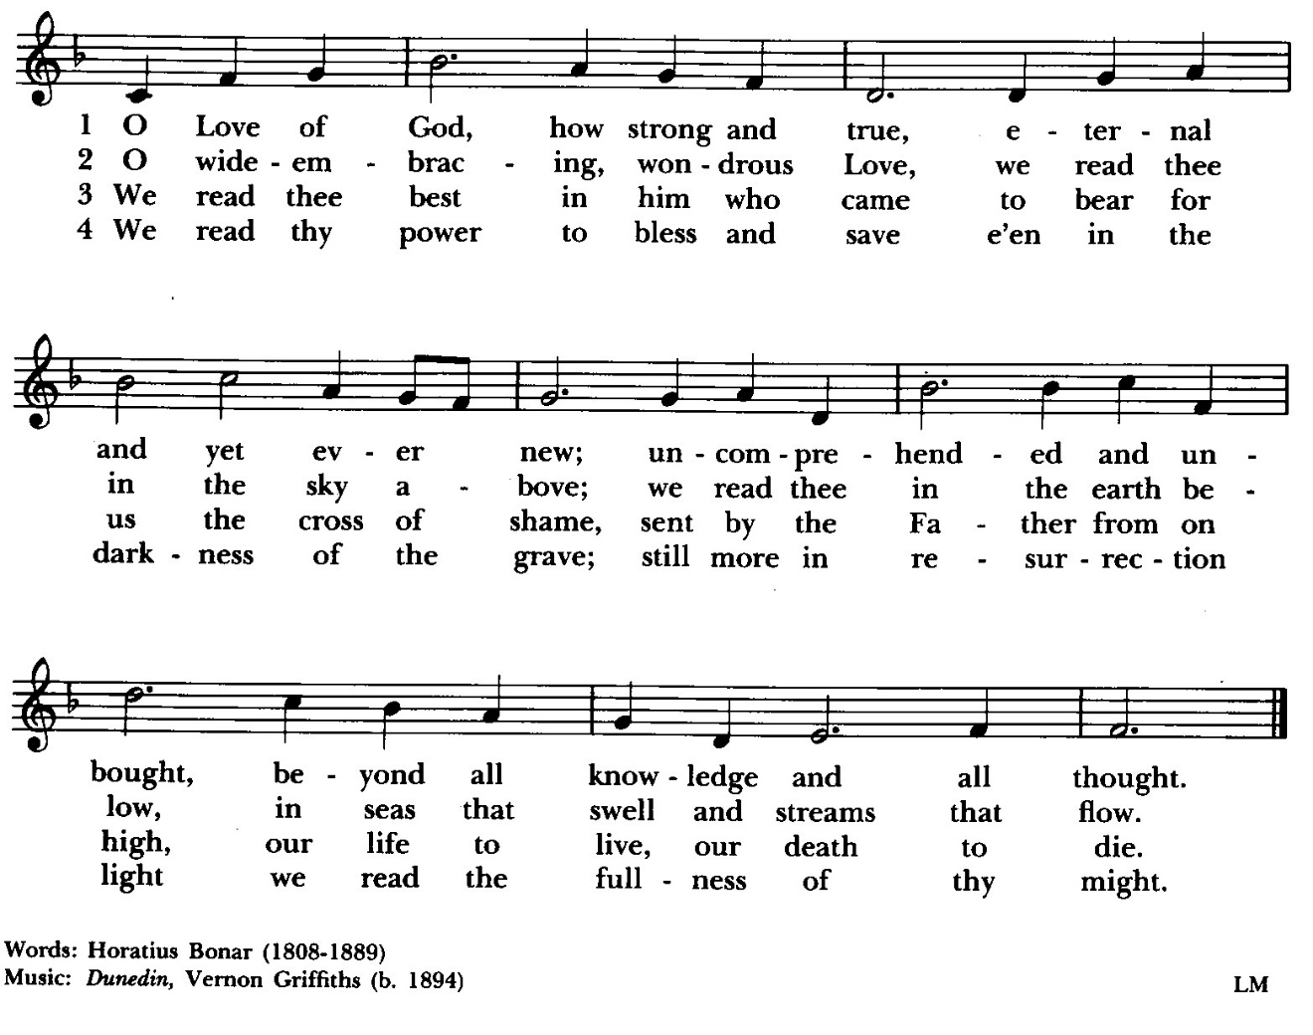

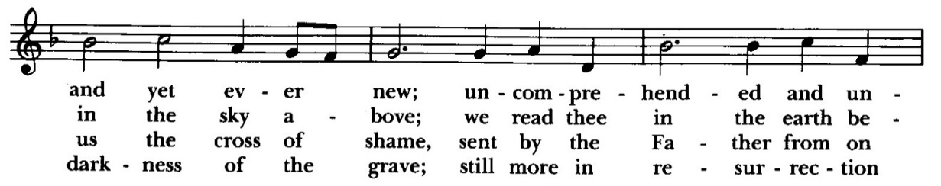
Doxology
The Great Thanksgiving – Eucharistic Prayer D
The people remain standing.
The Celebrant, whether bishop or priest, faces them and sings or says
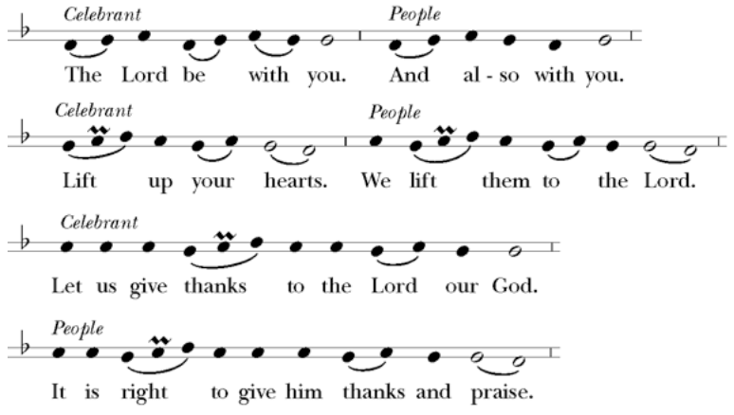

Then, facing the Holy Table, the Celebrant proceeds
It is truly right to glorify you, Father, and to give you thanks; for you alone are God, living and true, dwelling in light inaccessible from before time and for ever.
Fountain of life and source of all goodness, you made all things and fill them with your blessing; you created them to rejoice in the splendor of your radiance.
Countless throngs of angels stand before you to serve you night and day; and, beholding the glory of your presence, they offer you unceasing praise. Joining with them, and giving voice to every creature under heaven, we acclaim you, and glorify your Name, as we sing (say),

Celebrant and People
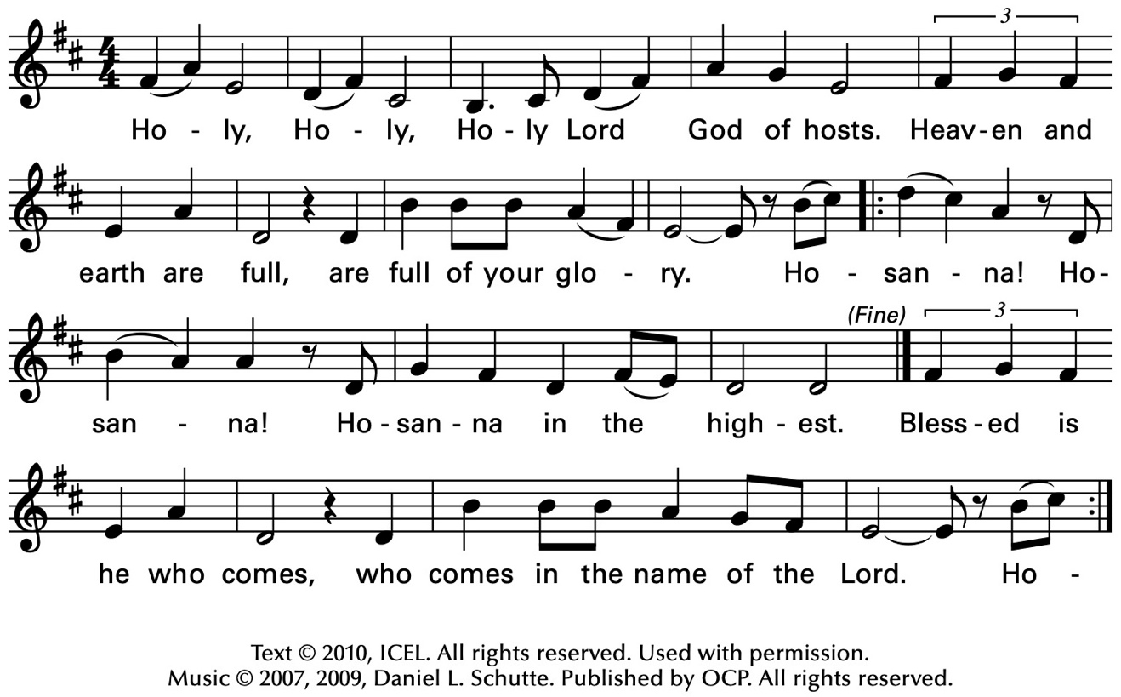
The Celebrant continues
We acclaim you, holy Lord, glorious in power. Your mighty works reveal your wisdom and love. You formed us in your own image, giving the whole world into our care, so that, in obedience to you, our Creator, we might rule and serve all your creatures. When our disobedience took us far from you, you did not abandon us to the power of death. In your mercy you came to our help, so that in seeking you we might find you. Again and again you called us into covenant with you, and through the prophets you taught us to hope for salvation.
Father, you loved the world so much that in the fullness of time you sent your only Son to be our Savior. Incarnate by the Holy Spirit, born of the Virgin Mary, he lived as one of us, yet without sin. To the poor he proclaimed the good news of salvation; to prisoners, freedom; to the sorrowful, joy. To fulfill your purpose he gave himself up to death; and, rising from the grave, destroyed death, and made the whole creation new.
And, that we might live no longer for ourselves, but for him who died and rose for us, he sent the Holy Spirit, his own first gift for those who believe, to complete his work in the world, and to bring to fulfillment the sanctification of all.
At the following words concerning the bread, the Celebrant is to hold it, or lay a hand upon it; and at the words concerning the cup, to hold or place a hand upon the cup and any other vessel containing wine to be consecrated.

When the hour had come for him to be glorified by you, his heavenly Father, having loved his own who were in the world, he loved them to the end; at supper with them he took bread, and when he had given thanks to you, he broke it, and gave it to his disciples, and said, "Take, eat: This is my Body, which is given for you. Do this for the remembrance of me."

After supper he took the cup of wine; and when he had given thanks, he gave it to them, and said, "Drink this, all of you: This is my Blood of the new Covenant, which is shed for you and for many for the forgiveness of sins. Whenever you drink it, do this for the remembrance of me."

Father, we now celebrate this memorial of our redemption. Recalling Christ's death and his descent among the dead, proclaiming his resurrection and ascension to your right hand, awaiting his coming in glory; and offering to you, from the gifts you have given us, this bread and this cup, we praise you and we bless you.

Celebrant and People

We praise you,
we bless you,
we give thanks to you,
and we pray to you, Lord our God.

The Celebrant continues

Lord, we pray that in your goodness and mercy your Holy Spirit may descend upon us, and upon these gifts, sanctifying them and showing them to be holy gifts for your holy people, the bread of life and the cup of salvation, the Body and Blood of your Son Jesus Christ.

Grant that all who share this bread and cup may become one body and one spirit, a living sacrifice in Christ, to the praise of your Name.

Remember, Lord, your one holy catholic and apostolic Church, redeemed by the blood of your Christ. Reveal its unity, guard its faith, and preserve it in peace.

And grant that we may find our inheritance with the Blessed Virgin Mary, with patriarchs, prophets, apostles, and martyrs, and all the saints who have found favor with you in ages past. We praise you in union with them and give you glory through your Son Jesus Christ our Lord.

Through Christ, and with Christ, and in Christ, all honor and glory are yours, Almighty God and Father, in the unity of the Holy Spirit, for ever and ever.

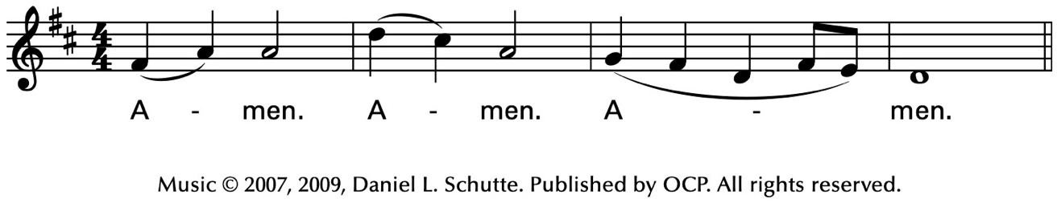
Celebrant
As our Savior Christ
has taught us,
we now pray,

People and Celebrant
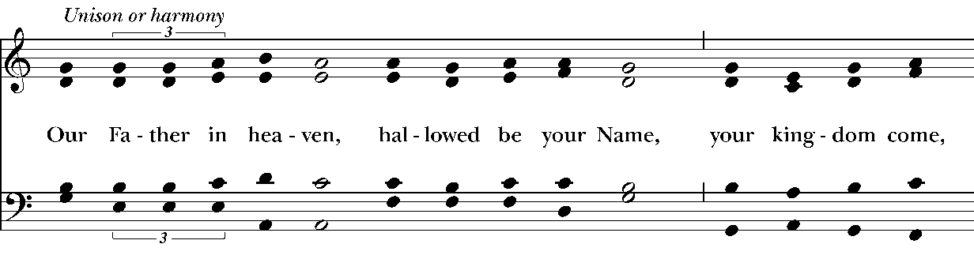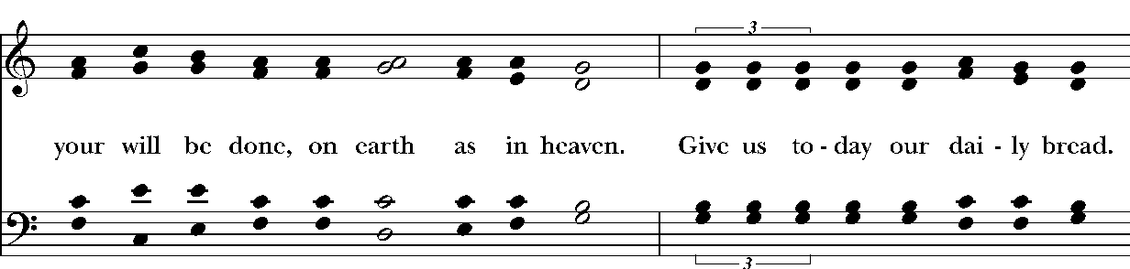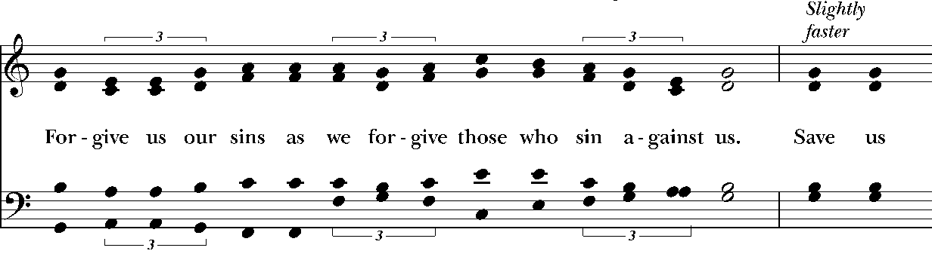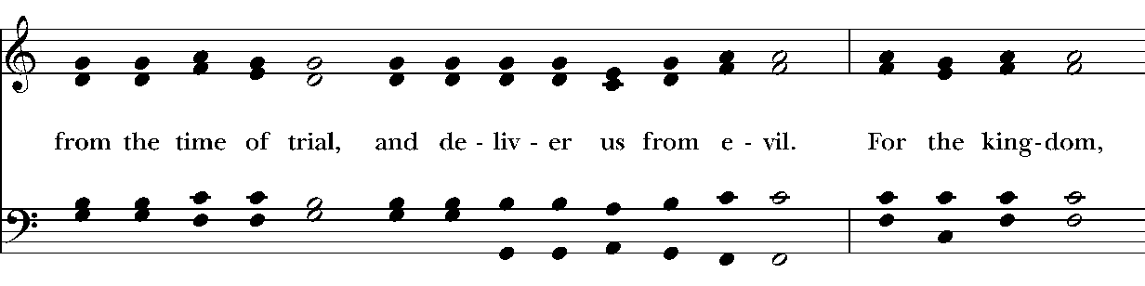
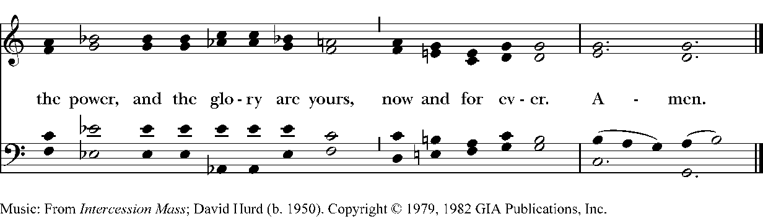
The Breaking of the Bread

The Celebrant breaks the consecrated Bread.

A period of silence is kept.

Then may be sung or said

Celebrant

People
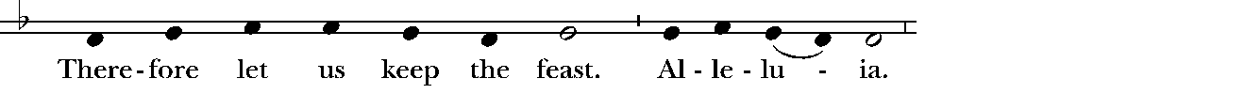
Music: Ambrosian chant; adapt. Mason Martens (1933-1991)

Facing the people, the Celebrant says the following Invitation

The Gifts of God for the People of God.
and may add Take them in remembrance that Christ died for
you, and feed on him in your hearts by faith,
with thanksgiving.

The Bread and Wine are given to the communicants with these words

The Body of Christ, the bread of heaven. [Amen.]
The Blood of Christ, the cup of salvation. [Amen.]

Hymnal 366– Holy God, we praise thy Name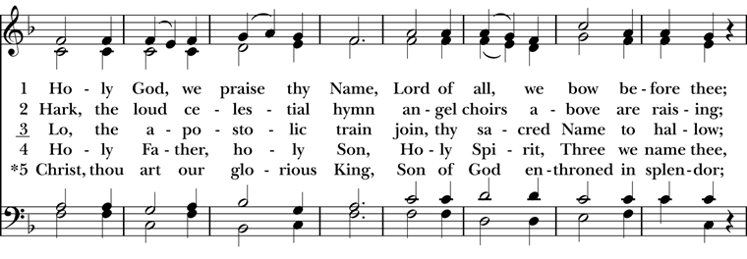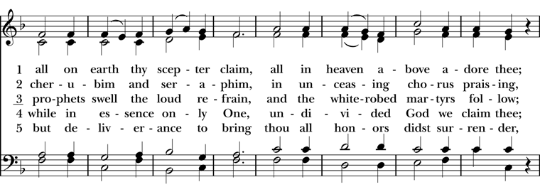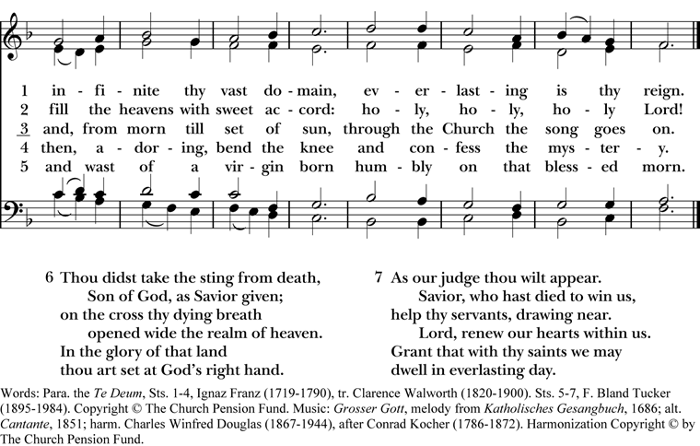
After communion the Celebrant says
Let us pray.

Celebrant and People
Eternal God, heavenly Father,
you have graciously accepted us as living members
of your Son our Savior Jesus Christ,
and you have fed us with spiritual food
in the Sacrament of his Body and Blood.
Send us now into the world in peace,
and grant us strength and courage
to love and serve you
with gladness and singleness of heart;
through Christ our Lord. Amen.
The Bishop when present, or the Priest, may bless the people.
Hymnal 518 – Christ is made the sure foundation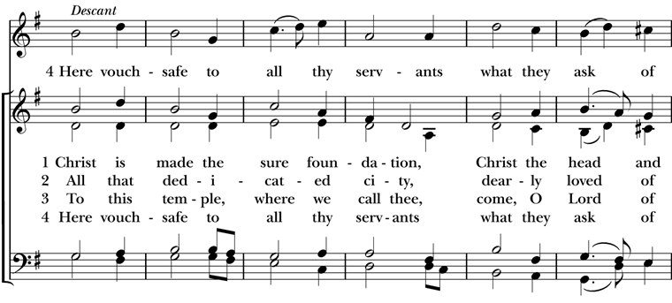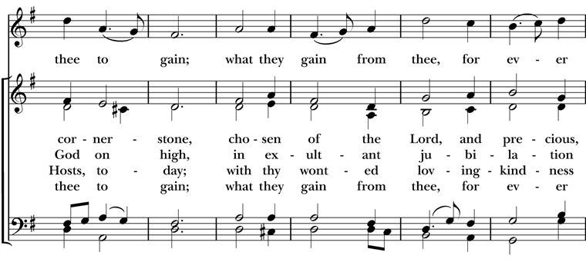
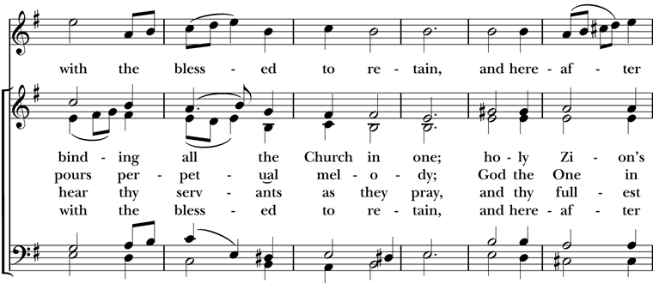
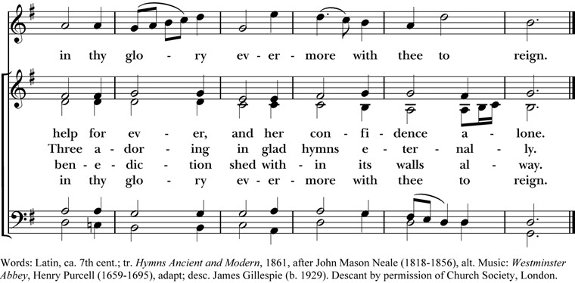

Deacon Go in peace to love and serve the Lord. Alleluia. Alleluia.
People Thanks be to God. Alleluia. Alleluia.
Postlude

Announcements
Wesley Homes Communion Service
Christ Church will be offering a service of Holy Communion this Sunday, May 3, 2026, at 1 pm at Wesley Homes at Bradley Park. Several members of our congregation are residents at Wesley Homes. All are welcome to come and participate in support of our parishioners and the residents.
Rector's Discretionary Fund
The undesignated offering on the first Sunday of the month is used to fund the Rector's discretionary account. This includes any undesignated electronic offerings that are submitted from the Thursday prior through the Wednesday following the first Sunday of the month. The Rector’s Discretionary Fund principally provides assistance to those in need in a variety of ways as well as supporting outreach efforts on occasion. Please consider giving generously.
Mother's Day
Sunday, May 10, is Mother's Day. Mother’s Day is the third most attended church day in the U.S., just behind Christmas and Easter. At Christ Church we honor all women this day. This is an opportunity to invite moms, grandmothers, someone who has been like a mother to you, family members and friends to come to church. A gift of a rose will be given to all women on Mother's Day at Christ Church.
Pre-Pentecost Work Party #2
There are many plans underway to celebrate the upcoming Feast Day of Pentecost on Sunday, May 10. The color of the day is red so please wear something red on Pentecost Sunday.
You are invited to attend Work Party #2 for Pentecost. Helen Godwin and Deacon Linda will host this Pre-Pentecost Work Party.
It will be held on Tuesday, May 5 from 10 am to 11:30 am and will be held at Helen Godwin's Hospitality Room at Argus Manor, 204 9th Avenue SE, Puyallup. At this work party we will be cutting ribbon to the right sizes and tying the pieces of ribbons to the paper. (If you know how to use a pair of scissors and to tie knots then this is the work party for you.) Bring your own coffee or beverage, otherwise coffee will be provided. Snacks will be provided for you. Please park on the street and not in the apartment complex.
Fellowship Book Group
Please join us for fellowship and lively discussion. We start with fellowship at 6:00 pm and discussion starts at 6:30 pm. We’d love to have you join us. The next meeting will be on our usual meeting day, (4th Monday of the month) April 27, 2026 via zoom.
The Zoom link and passcode are:
Meeting ID: 82826550583
Passcode: 121698
May will be "The Heaven & Earth Grocery Store", by James McBride. (Available for order at various used bookstores, Audible, or possibly at your local library)
In 1972, when workers in Pottstown, Pennsylvania, were digging the foundations for a new housing development, the last thing they expected to uncover was a human skeleton. Who the skeleton was and how it got buried there were just two of the long-held secrets that had been kept for decades by the residents of Chicken Hill, the dilapidated neighborhood where immigrant Jews and African Americans lived side by side, sharing ambitions and sorrows.
We are providing the title of the book chosen for the next month, so readers will have time to get on library wait lists or plan for any ordering backlog. The book for June will be "How to Read a Book", by Monica Wood.
Questions? Speak with any of the following: Shelly Fairbanks, DeeDee Fournier, Jen Killion, Melinda Jackson
Soup Kitchen
Susan Myers and Deacon Linda
Thank you to the volunteers for providing the food: Maria H. for providing soup and bread; Steve A. for providing fruit; Deacon Linda P. for providing dessert; Rick B. for serving; Susan M. for assisting in the kitchen; Sue G. and DeeDee F. for serving at the Hospitality Table.
This week's totals:

People served: 12
Bus passes given out: 9
How many picked up mail: 3
Toiletries given out: 12
Socks given away: 6
We need volunteers to provide soup, fruit, bread or dessert for the month of May. Please sign up on the Soup Kitchen form on the Communications Board in the parish hall.
Food donations can be bought on Sunday mornings or on Wednesdays before 10:00 am. Just mark them “Soup Kitchen”.
Items we need for the health care basket are shampoo, Conditioner, Deodorant, and shaving cream. These items are available and affordable at the Dollar Tree.
Proverbs 22:9 – Whoever has a bountiful eye will be blessed, for he shares his bread with the poor.

Puyallup Food Bank Donations
Now that Spring weather is warming up and we see new life sprouting, here are a few ideas for April's Food Bank:

- Facial Tissues, for allergies
- Diapers & Pull Ups, all sizes
- Baby Wipes
- Paper Towels
- Toilet Paper

Of course, any donation that is shelf stable is welcome. You may also make monetary donations; please mark your checks, "Food Bank".
Thank you for your support of our community.
Maria Haack, Vestry Liaison for Outreach
National Day of Prayer
The Daughters of the King will be hosting Daily Devotions and prayers at noon (1200-12:30) and early evening (5:00-5:30) on the National day of Prayer, May 7. We will meet in the parish hall. Please join us. All are welcome.
Monthly Financial Report
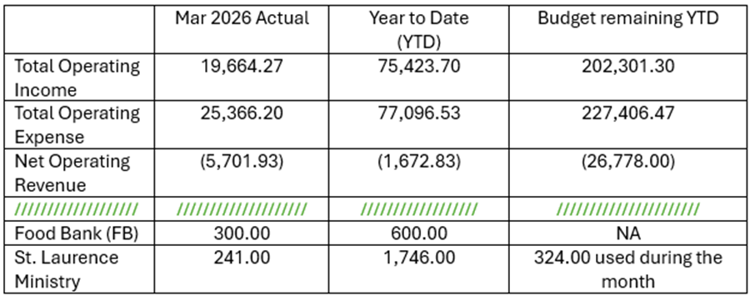
Sermon Notes

Sermon Notes

Today’s Ministers of Worship

Celebrant: The Rev. Mike Mayor
Deacon: The Rev. Linda Potter
Lectors: DeeDee Fournier, Jen Killion
Acolyte: Denise Quintana
Eucharistic Minister: David Steere
Livestream Coordinator: David Steere
Nursery Attendants: Barry O’Brien
Barb Johnsey
Pianist: Vicki Melton
Greeters: Christine Scholer, Carla Golden
Usher: Maria Haack
Closer: Barry O'Brien
Altar Guild: Sue Golden, Carla Golden, Rolin Stone
Music permission through OneLicense #A-706918


Scan to give online. All payments are processed through Paypal.

Christ Episcopal Church
A congregation of the Episcopal Diocese of Olympia
Bishop – The Rt. Rev. Philip N. LaBelle
Rector – The Rev. Mike Mayor
Vestry
Sr. Warden – Shelly Fairbanks
Jr. Warden for Property – Jeremy Duplissey
Jr. Warden for Communication – Barry O’Brien
Treasurer – Melinda Jackson
Clerk – Tanya Elder
Member – Steve Angelo
Member – Roddi Barton
Member – Maria Haack
Member – Susan Myers
Member – Dave Steere
Member – Rolin Stone
210 5th St. SW | Puyallup, WA | 98371
253-848-2323 | office@episcopallup.com
www.episcopallup.com

