Fourth Sunday of Easter
Holy Eucharist, Rite II

10:00 am – April 26, 2026

Welcome to Christ Church
We are so happy you have chosen to come and participate in worship this morning. Your presence today strengthens the Body of Christ, not only here but throughout the world.
Land Acknowledgment
Christ Church acknowledges that we gather on the traditional homeland of the Puyallup Tribe. The Puyallup people have lived on and stewarded these lands since the beginning of time, and continue to do so today. We honor and give thanks for the land itself and the life of all the indigenous peoples of this area.
New to Christ Church?
Welcome to Christ Episcopal Church of Puyallup. Wherever you are on your spiritual journey, you are welcome here! We invite you to sign our guestbook, visit our website (www.episcopallup.com) or connect with one of the clergy.
Questions?
Please ask. The ushers (one of the persons who gave you a bulletin) can answer your questions or concerns. Restrooms are available in the hallway to the west of the worship space.
About our Liturgy
Worship lies at the heart of the Christian life. It is in worship that we express our theology and define our identity. We encounter God within worship and are formed and transformed as the people of God. One of the hallmarks of the Episcopal Church is its liturgical worship. Liturgy literally is “the work of the people,” and refers to the patterns, forms, words, and actions through which public worship is conducted.

With One Voice 674 – Alleluia! Jesus Is Risen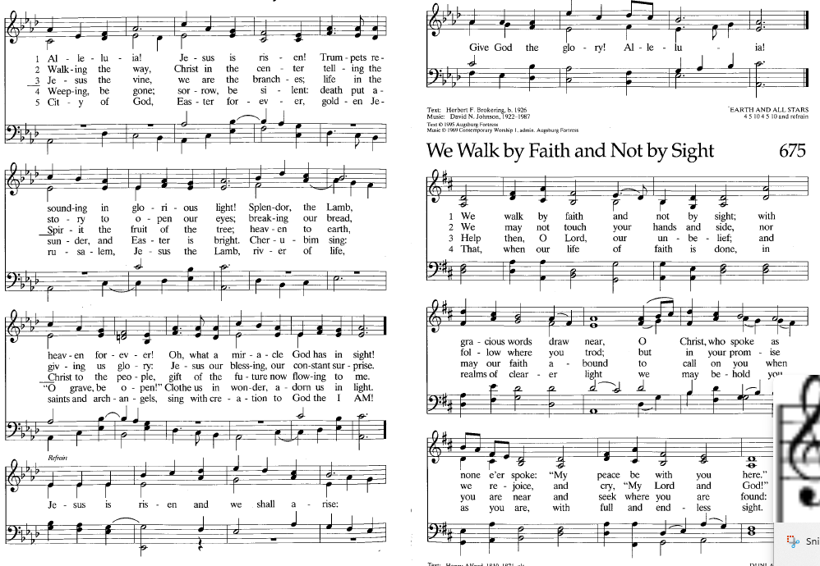

The Celebrant then says to the people

Alleluia. Christ is risen.
People The Lord is risen indeed. Alleluia.
The Celebrant may say
Almighty God, to you all hearts are open, all desires known, and from you no secrets are hid: Cleanse the thoughts of our hearts by the inspiration of your Holy Spirit, that we may perfectly love you, and worthily magnify your holy Name; through Christ our Lord. Amen.

When appointed, the following hymn or some other song of praise is sung or said, all standing

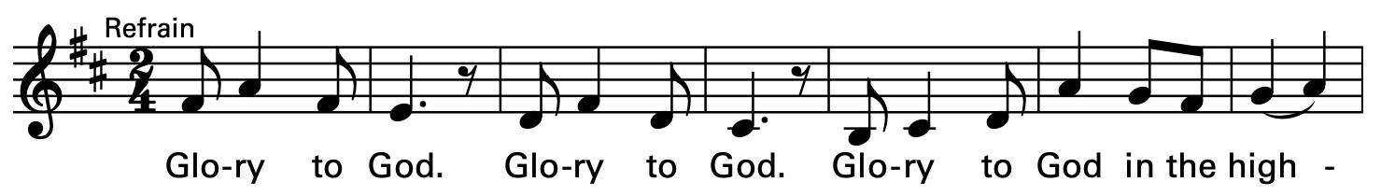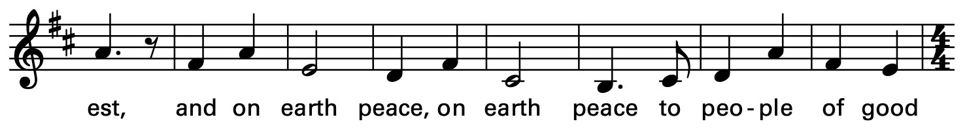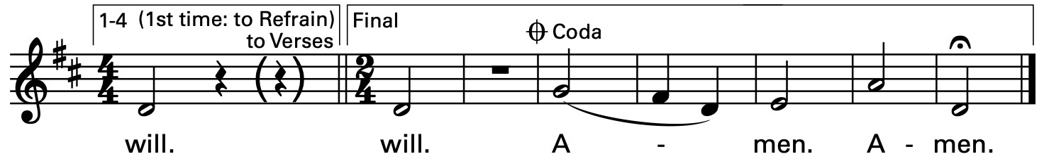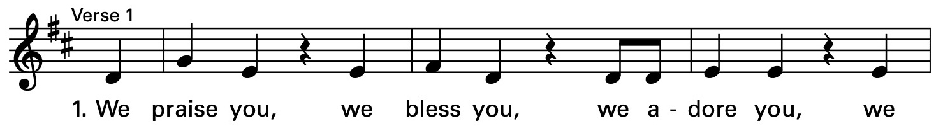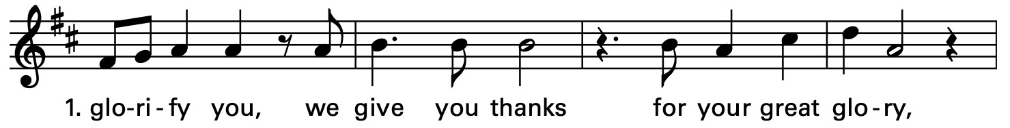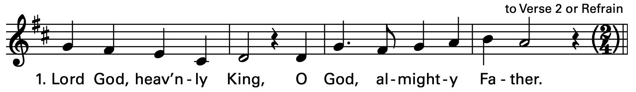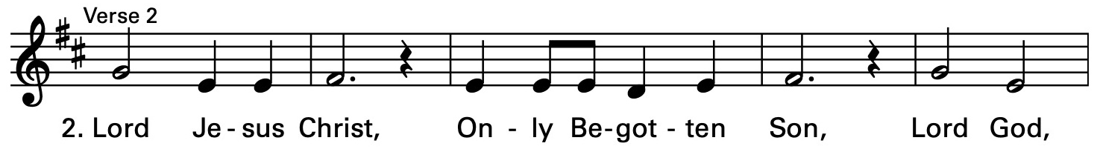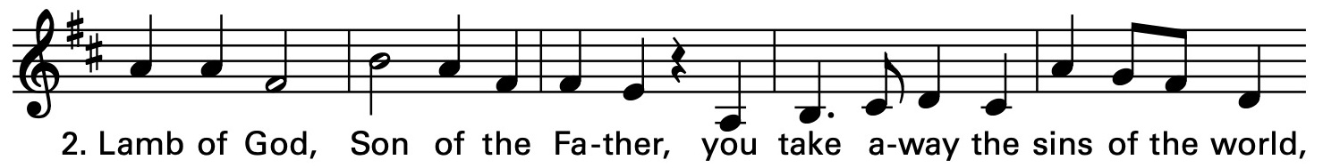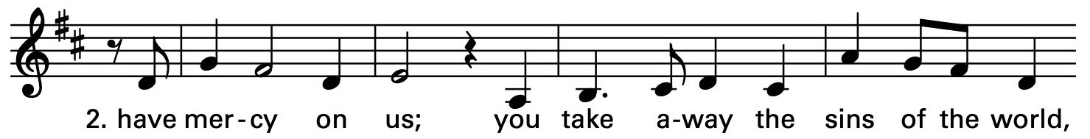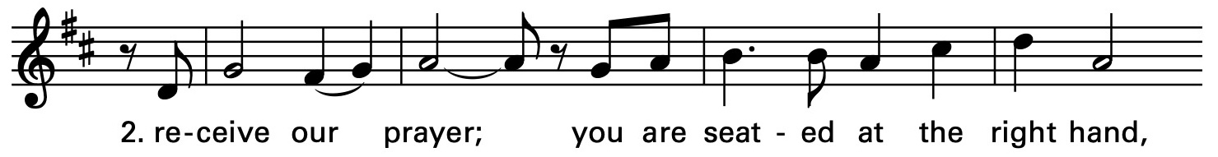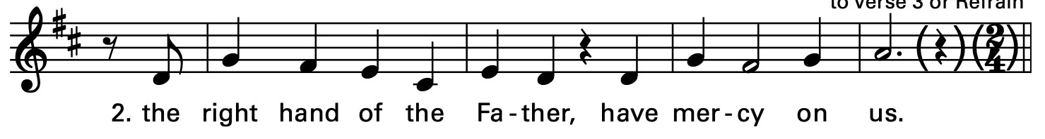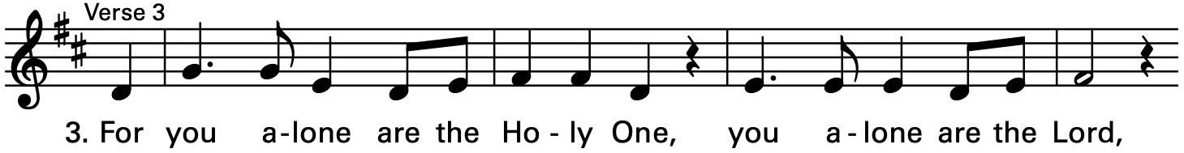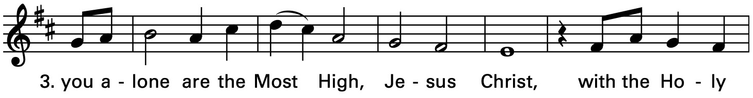

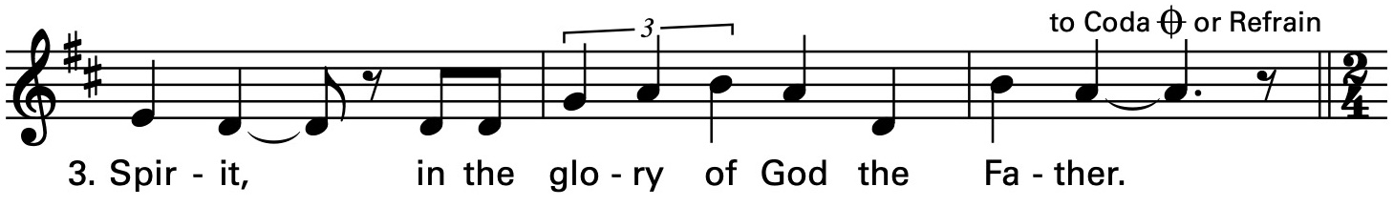

The Collect of the Day

The Celebrant says to the people
The Lord be with you.
People And also with you.
Celebrant Let us pray.
O God, whose Son Jesus is the good shepherd of your people: Grant that when we hear his voice we may know him who calls us each by name, and follow where he leads; who, with you and the Holy Spirit, lives and reigns, one God, for ever and ever. Amen.
The Lessons

The people sit. One or two lessons, as appointed, are read, the Reader first saying

A Reading from the Acts of the Apostles (2:42-47)

Those who had been baptized devoted themselves to the apostles' teaching and fellowship, to the breaking of bread and the prayers. Awe came upon everyone, because many wonders and signs were being done by the apostles. All who believed were together and had all things in common; they would sell their possessions and goods and distribute the proceeds to all, as any had need. Day by day, as they spent much time together in the temple, they broke bread at home and ate their food with glad and generous hearts, praising God and having the goodwill of all the people. And day by day the Lord added to their number those who were being saved.

The Word of the Lord.
People Thanks be to God.

Silence may follow

Psalm 23

1 The Lord is my shepherd; *
I shall not be in want.

2 He makes me lie down in green pastures *
and leads me beside still waters.

3 He revives my soul *
and guides me along right pathways for his Name's sake.

4 Though I walk through the valley of the shadow of death,
I shall fear no evil; *
for you are with me;
your rod and your staff, they comfort me.

5 You spread a table before me in the presence of those who trouble me; *
you have anointed my head with oil,
and my cup is running over.

6 Surely your goodness and mercy shall follow me all the days of my life, *
and I will dwell in the house of the Lord for ever.

Silence may follow.

A Reading from the first letter of Peter (2:19-25)
It is a credit to you if, being aware of God, you endure pain while suffering unjustly. If you endure when you are beaten for doing wrong, what credit is that? But if you endure when you do right and suffer for it, you have God's approval. For to this you have been called, because Christ also suffered for you, leaving you an example, so that you should follow in his steps. “He committed no sin, and no deceit was found in his mouth.” When he was abused, he did not return abuse; when he suffered, he did not threaten; but he entrusted himself to the one who judges justly. He himself bore our sins in his body on the cross, so that, free from sins, we might live for righteousness; by his wounds you have been healed. For you were going astray like sheep, but now you have returned to the shepherd and guardian of your souls.
The Word of the Lord.
People Thanks be to God.

Wonder, Love, and Praise 756 – Lead me, guide me, along the way

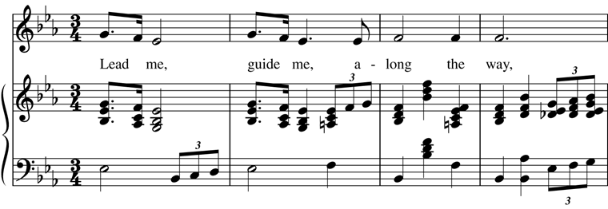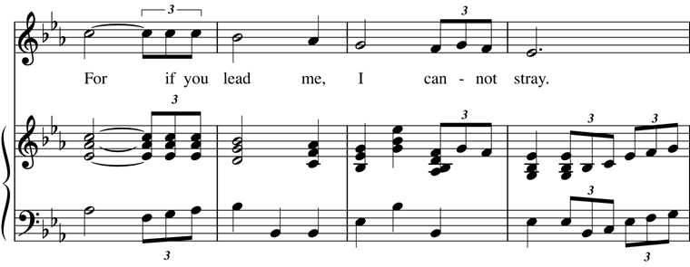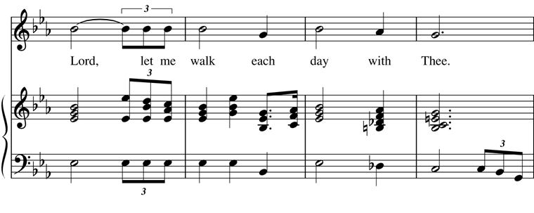

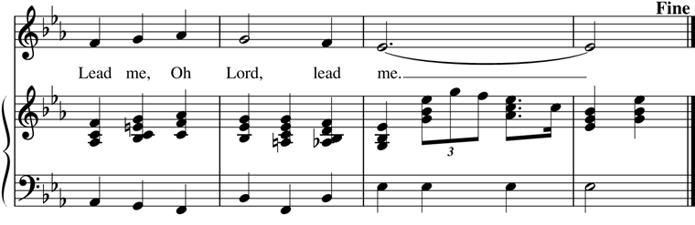

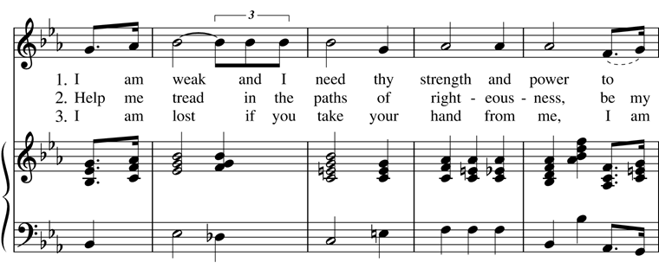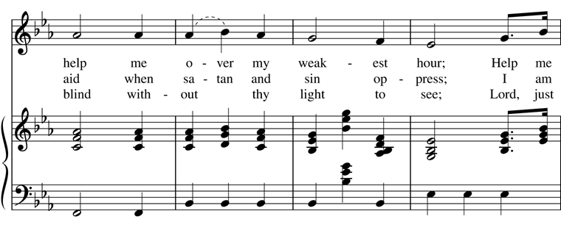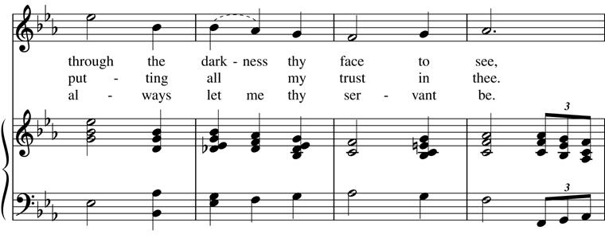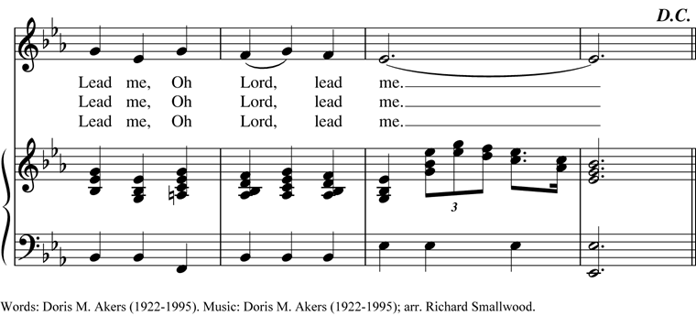
Deacon The Holy Gospel of our Lord Jesus Christ
according to John (10:1-10)
People Glory to you, Lord Christ.
Jesus said, “Very truly, I tell you, anyone who does not enter the sheepfold by the gate but climbs in by another way is a thief and a bandit. The one who enters by the gate is the shepherd of the sheep. The gatekeeper opens the gate for him, and the sheep hear his voice. He calls his own sheep by name and leads them out. When he has brought out all his own, he goes ahead of them, and the sheep follow him because they know his voice. They will not follow a stranger, but they will run from him because they do not know the voice of strangers.” Jesus used this figure of speech with them, but they did not understand what he was saying to them. So again Jesus said to them, “Very truly, I tell you, I am the gate for the sheep. All who came before me are thieves and bandits; but the sheep did not listen to them. I am the gate. Whoever enters by me will be saved, and will come in and go out and find pasture. The thief comes only to steal and kill and destroy. I came that they may have life, and have it abundantly.”
After the Gospel, the Reader says
The Gospel of the Lord.
People Praise to you, Lord Christ.
The Sermon The Rev. Mike Mayor
All standing
The Nicene Creed
We believe in one God,
the Father, the Almighty,
maker of heaven and earth,
of all that is, seen and unseen.
We believe in one Lord, Jesus Christ,
the only Son of God,
eternally begotten of the Father,
God from God, Light from Light,
true God from true God,
begotten, not made,
of one Being with the Father.
Through him all things were made.
For us and for our salvation
he came down from heaven:
by the power of the Holy Spirit
he became incarnate from the Virgin Mary,
and was made man.
For our sake he was crucified under Pontius Pilate;
he suffered death and was buried.
On the third day he rose again
in accordance with the Scriptures;
he ascended into heaven
and is seated at the right hand of the Father.
He will come again in glory to judge the living and the dead,
and his kingdom will have no end.
We believe in the Holy Spirit, the Lord, the giver of life,
who proceeds from the Father and the Son.
With the Father and the Son he is worshiped and glorified.
He has spoken through the Prophets.
We believe in one holy catholic and apostolic Church.
We acknowledge one baptism for the forgiveness of sins.
We look for the resurrection of the dead,
and the life of the world to come. Amen.
The Prayers of the People – Form IV

Deacon or other leader

Let us pray for the Church and for the world.

Grant, Almighty God, that all who confess your Name may be united in your truth, live together in your love, and reveal your glory in the world.

We remember especially Sean, our Presiding Bishop; Phil, our Bishop; Mike, our priest; and Linda, our Deacon.

In our diocesan cycle of prayer we remember St. Peter’s, Seattle; Trinity, Seattle; and Apostles, Seattle

Silence

Lord, in your mercy
Hear our prayer.

Guide the people of this land, and of all the nations, in the ways of justice and peace; that we may honor one another and serve the common good.

Silence

Lord, in your mercy
Hear our prayer.

Give us all a reverence for the earth as your own creation, that we may use its resources rightly in the service of others and to your honor and glory.

Silence

Lord, in your mercy
Hear our prayer.

Bless all whose lives are closely linked with ours, and grant that we may serve Christ in them, and love one another as he loves us.

In our parish cycle of prayer we remember Lisa & Paul, Sandra & Jim, Gail, and Chris & Denise

Silence

Lord, in your mercy
Hear our prayer.

Comfort and heal all those who suffer in body, mind, or spirit; give them courage and hope in their troubles, and bring them the joy of your salvation.

Silence

Lord, in your mercy
Hear our prayer.

We commend to your mercy all who have died, that your will for them may be fulfilled; and we pray that we may share with all your saints in your eternal kingdom.

Silence

Lord, in your mercy
Hear our prayer.

The Celebrant adds a concluding Collect.
The Peace

All stand. The Celebrant says to the people
The peace of the Lord be always with you.
People And also with you.

Then the Ministers and People may greet one another in the name of the Lord.

Hymnal 664 – My Shepherd will supply my need

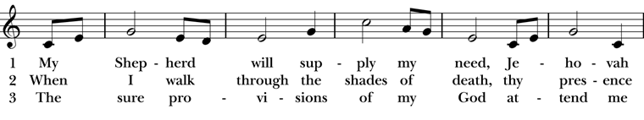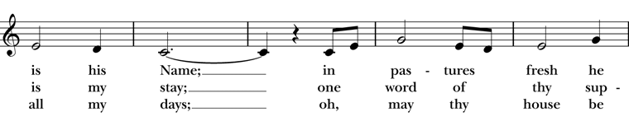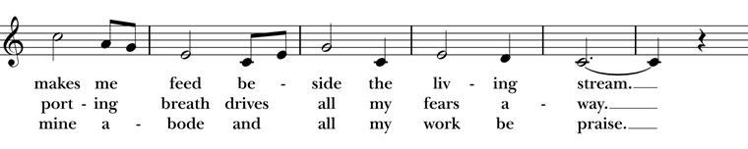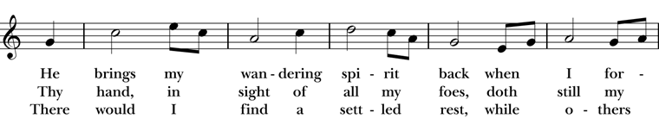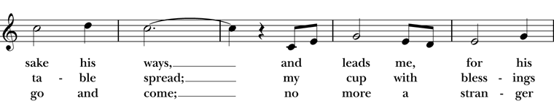

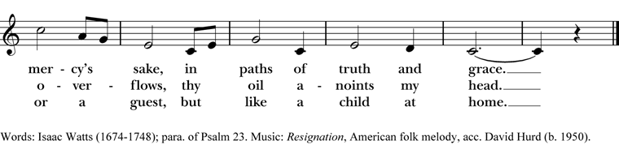
Doxology

The Great Thanksgiving – Eucharistic Prayer D
The people remain standing.
The Celebrant, whether bishop or priest, faces them and sings or says
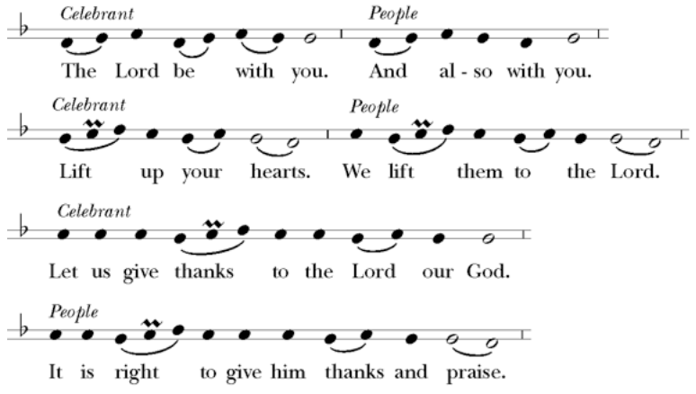

Then, facing the Holy Table, the Celebrant proceeds
It is truly right to glorify you, Father, and to give you thanks; for you alone are God, living and true, dwelling in light inaccessible from before time and for ever.
Fountain of life and source of all goodness, you made all things and fill them with your blessing; you created them to rejoice in the splendor of your radiance.
Countless throngs of angels stand before you to serve you night and day; and, beholding the glory of your presence, they offer you unceasing praise. Joining with them, and giving voice to every creature under heaven, we acclaim you, and glorify your Name, as we sing (say),

Celebrant and People
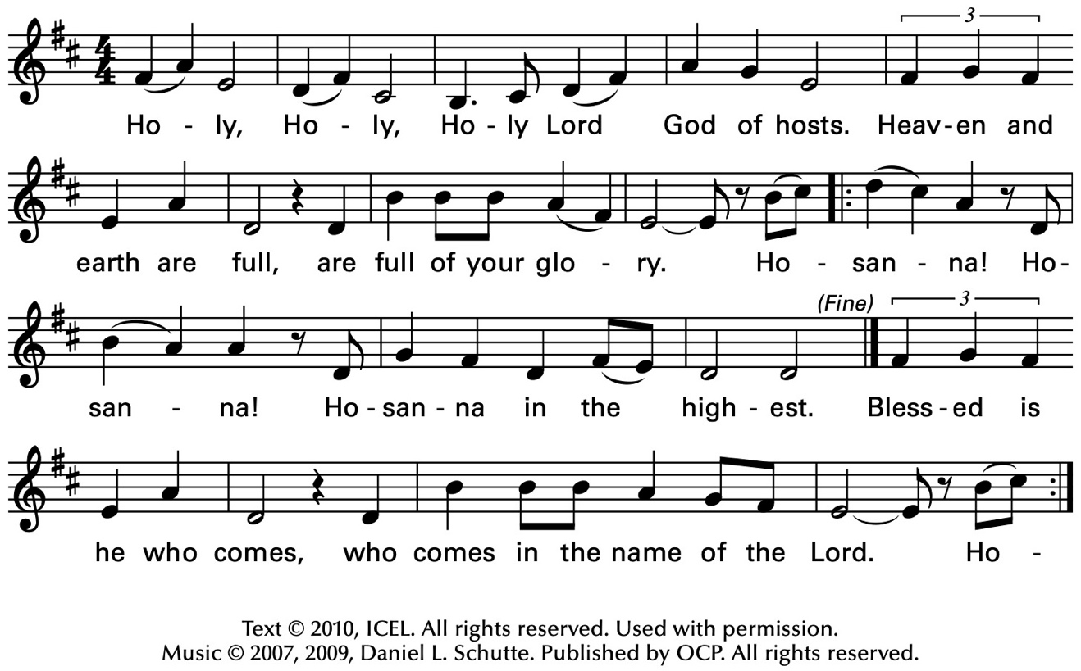
The Celebrant continues
We acclaim you, holy Lord, glorious in power. Your mighty works reveal your wisdom and love. You formed us in your own image, giving the whole world into our care, so that, in obedience to you, our Creator, we might rule and serve all your creatures. When our disobedience took us far from you, you did not abandon us to the power of death. In your mercy you came to our help, so that in seeking you we might find you. Again and again you called us into covenant with you, and through the prophets you taught us to hope for salvation.
Father, you loved the world so much that in the fullness of time you sent your only Son to be our Savior. Incarnate by the Holy Spirit, born of the Virgin Mary, he lived as one of us, yet without sin. To the poor he proclaimed the good news of salvation; to prisoners, freedom; to the sorrowful, joy. To fulfill your purpose he gave himself up to death; and, rising from the grave, destroyed death, and made the whole creation new.
And, that we might live no longer for ourselves, but for him who died and rose for us, he sent the Holy Spirit, his own first gift for those who believe, to complete his work in the world, and to bring to fulfillment the sanctification of all.
At the following words concerning the bread, the Celebrant is to hold it, or lay a hand upon it; and at the words concerning the cup, to hold or place a hand upon the cup and any other vessel containing wine to be consecrated.

When the hour had come for him to be glorified by you, his heavenly Father, having loved his own who were in the world, he loved them to the end; at supper with them he took bread, and when he had given thanks to you, he broke it, and gave it to his disciples, and said, "Take, eat: This is my Body, which is given for you. Do this for the remembrance of me."

After supper he took the cup of wine; and when he had given thanks, he gave it to them, and said, "Drink this, all of you: This is my Blood of the new Covenant, which is shed for you and for many for the forgiveness of sins. Whenever you drink it, do this for the remembrance of me."

Father, we now celebrate this memorial of our redemption. Recalling Christ's death and his descent among the dead, proclaiming his resurrection and ascension to your right hand, awaiting his coming in glory; and offering to you, from the gifts you have given us, this bread and this cup, we praise you and we bless you.

Celebrant and People

We praise you,
we bless you,
we give thanks to you,
and we pray to you, Lord our God.

The Celebrant continues

Lord, we pray that in your goodness and mercy your Holy Spirit may descend upon us, and upon these gifts, sanctifying them and showing them to be holy gifts for your holy people, the bread of life and the cup of salvation, the Body and Blood of your Son Jesus Christ.

Grant that all who share this bread and cup may become one body and one spirit, a living sacrifice in Christ, to the praise of your Name.

Remember, Lord, your one holy catholic and apostolic Church, redeemed by the blood of your Christ. Reveal its unity, guard its faith, and preserve it in peace.

And grant that we may find our inheritance with the Blessed Virgin Mary, with patriarchs, prophets, apostles, and martyrs, and all the saints who have found favor with you in ages past. We praise you in union with them and give you glory through your Son Jesus Christ our Lord.

Through Christ, and with Christ, and in Christ, all honor and glory are yours, Almighty God and Father, in the unity of the Holy Spirit, for ever and ever.

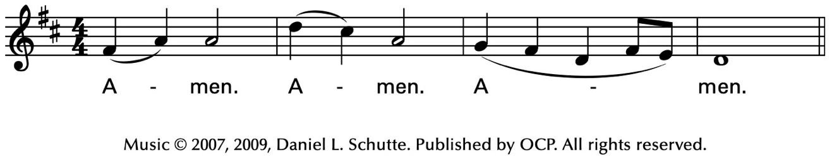
Celebrant
As our Savior Christ
has taught us,
we now pray,

People and Celebrant
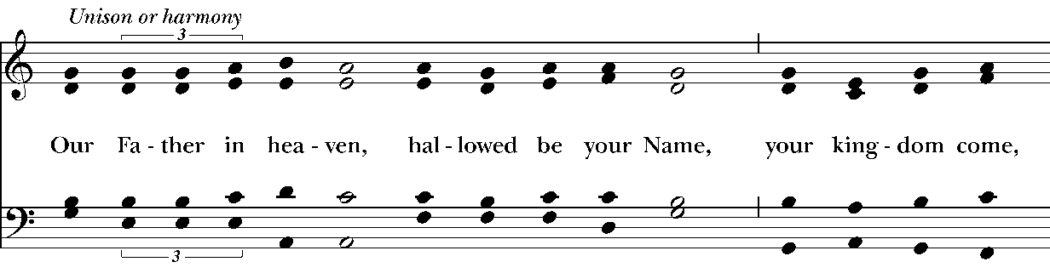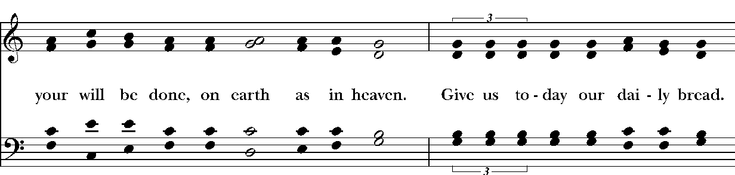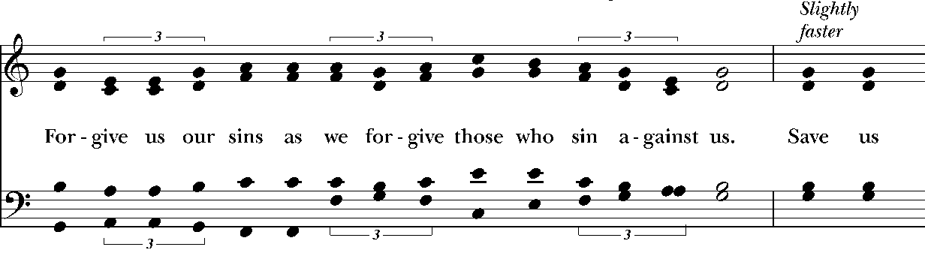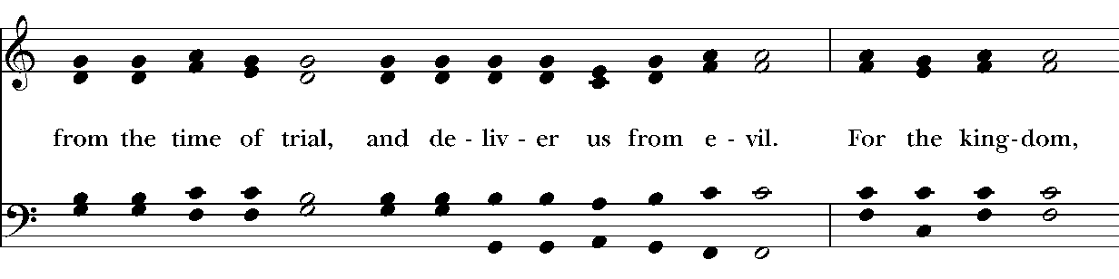
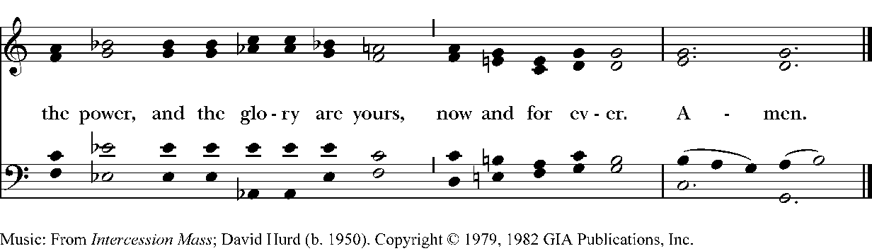
The Breaking of the Bread

The Celebrant breaks the consecrated Bread.

A period of silence is kept.

Then may be sung or said

Celebrant

People
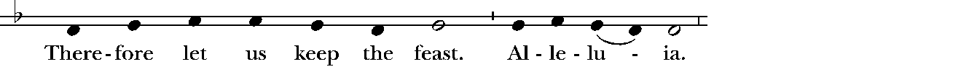
Music: Ambrosian chant; adapt. Mason Martens (1933-1991)

Facing the people, the Celebrant says the following Invitation

The Gifts of God for the People of God.
and may add Take them in remembrance that Christ died for
you, and feed on him in your hearts by faith,
with thanksgiving.

The Bread and Wine are given to the communicants with these words

The Body of Christ, the bread of heaven. [Amen.]
The Blood of Christ, the cup of salvation. [Amen.]

Hymnal 645– The King of love my shepherd is
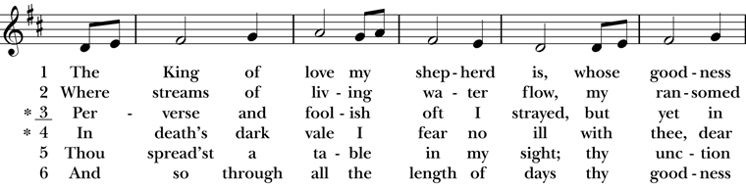
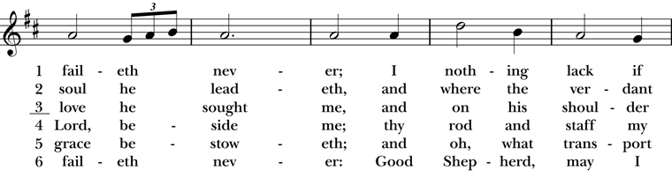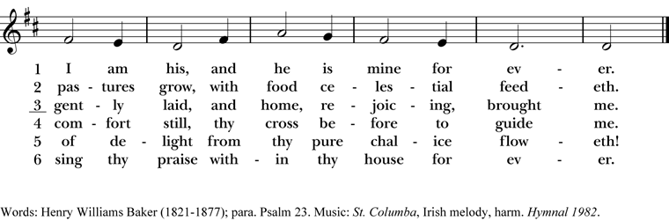
After communion the Celebrant says
Let us pray.

Celebrant and People
Eternal God, heavenly Father,
you have graciously accepted us as living members
of your Son our Savior Jesus Christ,
and you have fed us with spiritual food
in the Sacrament of his Body and Blood.
Send us now into the world in peace,
and grant us strength and courage
to love and serve you
with gladness and singleness of heart;
through Christ our Lord. Amen.
The Bishop when present, or the Priest, may bless the people.
Hymnal 708 – Savior, like a shepherd lead us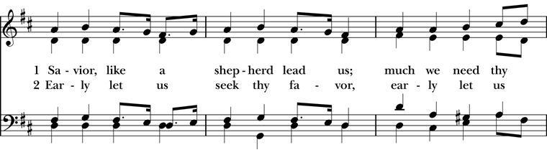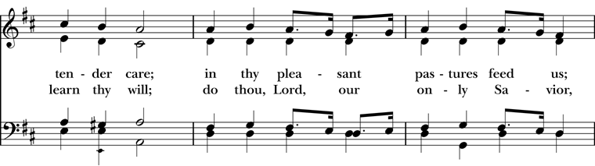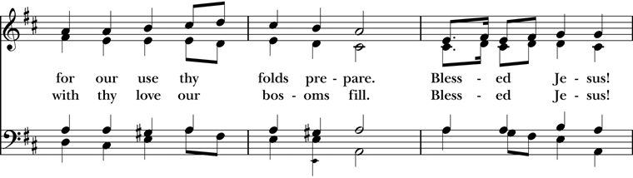
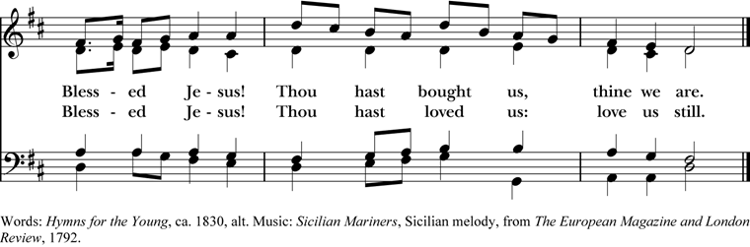
Deacon Go in peace to love and serve the Lord. Alleluia. Alleluia.
People Thanks be to God. Alleluia. Alleluia.
Postlude
Announcements
Flowers for this Sunday
The flowers for this Sunday, April 26, 2026 are given by Terry Grundy to the Glory of God and in celebration of her daughter Ashley's birthday.
All Parish Meeting Sunday 4/26
You are cordially invited to our first 2026 All Parish Meeting today. We will start the meeting shortly after the 10:00 service once every one has treats, and coffee or tea!
This year our focus during the All Parish Meetings will be the 2026 Mission Priorities as set by your vestry during this year’s annual retreat. These priorities’ success are dependent on YOU, dear friends! So we ask that you pull up a chair, see the good works taking place, and consider where and how each and every one of us can make an impact within our beloved community. We look forward to seeing you there!
Fellowship Book Group
Please join us for fellowship and lively discussion. We start with fellowship at 6:00 pm and discussion starts at 6:30 pm. We’d love to have you join us. The next meeting will be on our usual meeting day, (4th Monday of the month) April 27, 2026 via zoom.
The Zoom link and passcode are:
Meeting ID: 82826550583
Passcode: 121698
The book for April will be “Remarkably Bright Creatures”, by Shelby Van Pelt. (Available for order at various used bookstores, Audible, or possibly at your local library)
After Tova Sullivan’s husband died, she began working the night shift at the Sowell Bay Aquarium, mopping floors and tidying up. Keeping busy has always helped her cope, which she’s been doing since her eighteen-year-old son, Erik, mysteriously vanished on a boat in Puget Sound over thirty years ago. Tova becomes acquainted with curmudgeonly Marcellus, a giant Pacific octopus living at the aquarium. Marcellus knows more than anyone can imagine but wouldn’t dream of lifting one of his eight arms for his human captors—until he forms a remarkable friendship with Tova.
We are providing the title of the book chosen for the next month, so readers will have time to get on library wait lists or plan for any ordering backlog. The book for May will be "The Heaven & Earth Grocery Store", by James McBride.
Questions? Speak with any of the following: Shelly Fairbanks, DeeDee Fournier, Jen Killion, Melinda Jackson
Soup Kitchen
Susan Myers and Deacon Linda
Thank you to the volunteers for providing the food: Maria H. for providing soup and bread; Rick B. and Steve A. for serving; Susan M. for assisting in the kitchen; Barb J. and Patti M. for serving at the Hospitality Table.
This week's totals:

People served: 19
Bus passes given out: 10
How many picked up mail: 3
Laundry Packets given out: 19
Toiletries given out: 10
Socks given away: 8
We need volunteers to provide soup, fruit, bread or dessert for the last Wednesday in April.
Please sign up on the Soup Kitchen form on the Communications Board in the parish hall.
Food donations can be bought on Sunday mornings or on Wednesdays before 10:00 am. Just mark them “Soup Kitchen”.
Items we need for the health care basket are shampoo, Conditioner, Deodorant, and shaving cream. These items are available and affordable at the Dollar Tree.
Proverbs 22:9 – Whoever has a bountiful eye will be blessed, for he shares his bread with the poor.
Puyallup Food Bank Donations
Now that Spring weather is warming up and we see new life sprouting, here are a few ideas for April's Food Bank:

- Facial Tissues, for allergies
- Diapers & Pull Ups, all sizes
- Baby Wipes
- Paper Towels
- Toilet Paper

Of course, any donation that is shelf stable is welcome. You may also make monetary donations; please mark your checks, "Food Bank".

Thank you for your support of our community.
Maria Haack, Vestry Liaison for Outreach
Upcoming Opportunities For Outreach
Deacon Linda and Maria Haack, Vestry Liaison for Outreach
Outreach projects we have been involved with at Christ Church since the first of the year are Souper Bowl of Caring, Sock Drive, and volunteering with Christ Church’s Soup Kitchen.
Upcoming opportunities for outreach through Christ Church are:
- Thursday, June 24, 2026 United Way Day of Action Snack Packs for kids – Fairgrounds in AgriPlex Building; Time: 4 pm to 7 pm; Sip, Serve & Celebrate - Snack pack and community building project for summer meals – making Snack Packs for school children in Pierce County
- June through September - 11 am to 1 pm Lunches To Go- Set up canopy outside in front of the church and give free lunches and pop to whomever is hungry
- September 13 Operation Backpack- Free backpacks handed out to parishioners, and you are invited to fill a backpack with school supplies for Puyallup School District students
National Day of Prayer
The Daughters of the King will be hosting Daily Devotions and prayers at noon (1200-12:30) and early evening (5:00-5:30) on National day of Prayer, May 7. We will meet in the parish hall. Please join us. All are welcome.

Monthly Financial Report
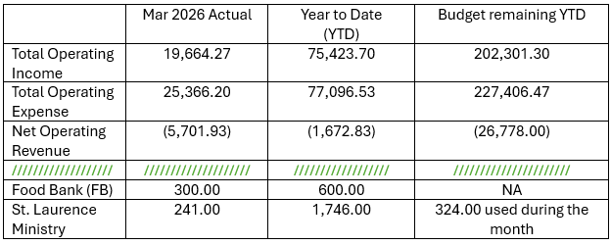
Deacon Becky's Funeral
Deacon Becky Scott's funeral has been set for Saturday, May 2, at 2:00 pm, at Christ Church. The bishop will be present to preside and Fr. Mike will be the preacher. A reception will follow.

We know that Becky was an important person in the life of our church and that many from the congregation will want to attend. In addition Becky had a very active life in the diocese and so this will likely be a well attended funeral, please plan accordingly.

Sermon Notes

Today’s Ministers of Worship

Celebrant: The Rev. Mike Mayor
Deacon: The Rev. Linda Potter
Lectors: Carla Golden, Rolin Stone
Acolyte: Denise Quintana
Eucharistic Minister: Christine Scholer
Livestream Coordinator: Bonnie Quintana
Nursery Attendants: Barry O’Brien
Barb Johnsey
Pianist: Vicki Melton
Greeters: Christine Scholer, Carla Golden
Usher: Sue Golden
Closer: Sue Golden
Altar Guild: Lisa Chatterton
Sydney Walczak
Music permission through OneLicense #A-706918


Scan to give online. All payments are processed through Paypal.

Christ Episcopal Church
A congregation of the Episcopal Diocese of Olympia
Bishop – The Rt. Rev. Philip N. LaBelle
Rector – The Rev. Mike Mayor
Vestry
Sr. Warden – Shelly Fairbanks
Jr. Warden for Property – Jeremy Duplissey
Jr. Warden for Communication – Barry O’Brien
Treasurer – Melinda Jackson
Clerk – Tanya Elder
Member – Steve Angelo
Member – Roddi Barton
Member – Maria Haack
Member – Susan Myers
Member – Dave Steere
Member – Rolin Stone
210 5th St. SW | Puyallup, WA | 98371
253-848-2323 | office@episcopallup.com
www.episcopallup.com

