Third Sunday of Easter
Holy Eucharist, Rite II

10:00 am – April 19, 2026

Welcome to Christ Church
We are so happy you have chosen to come and participate in worship this morning. Your presence today strengthens the Body of Christ, not only here but throughout the world.
Land Acknowledgment
Christ Church acknowledges that we gather on the traditional homeland of the Puyallup Tribe. The Puyallup people have lived on and stewarded these lands since the beginning of time, and continue to do so today. We honor and give thanks for the land itself and the life of all the indigenous peoples of this area.
New to Christ Church?
Welcome to Christ Episcopal Church of Puyallup. Wherever you are on your spiritual journey, you are welcome here! We invite you to sign our guestbook, visit our website (www.episcopallup.com) or connect with one of the clergy.
Questions?
Please ask. The ushers (one of the persons who gave you a bulletin) can answer your questions or concerns. Restrooms are available in the hallway to the west of the worship space.
About our Liturgy
Worship lies at the heart of the Christian life. It is in worship that we express our theology and define our identity. We encounter God within worship and are formed and transformed as the people of God. One of the hallmarks of the Episcopal Church is its liturgical worship. Liturgy literally is “the work of the people,” and refers to the patterns, forms, words, and actions through which public worship is conducted.

Hymnal 432 – O praise ye the Lord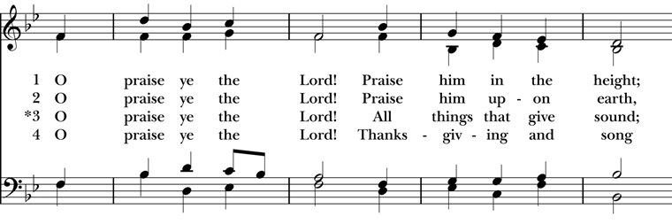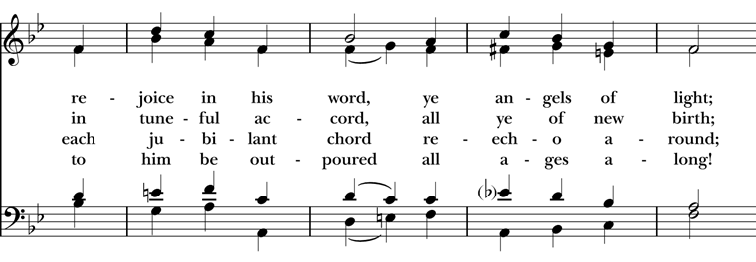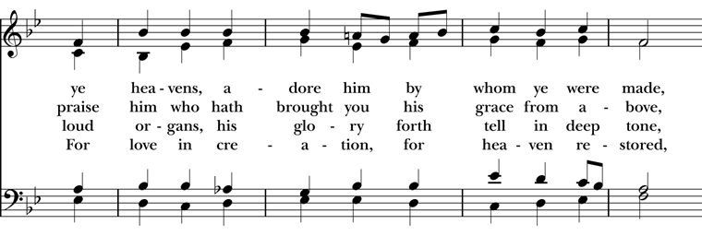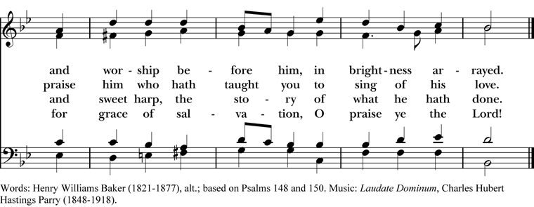

The Celebrant then says to the people

Alleluia. Christ is risen.
People The Lord is risen indeed. Alleluia.
The Celebrant may say
Almighty God, to you all hearts are open, all desires known, and from you no secrets are hid: Cleanse the thoughts of our hearts by the inspiration of your Holy Spirit, that we may perfectly love you, and worthily magnify your holy Name; through Christ our Lord. Amen.

When appointed, the following hymn or some other song of praise is sung or said, all standing

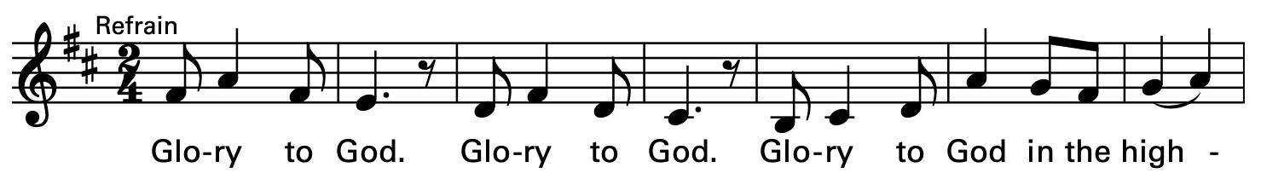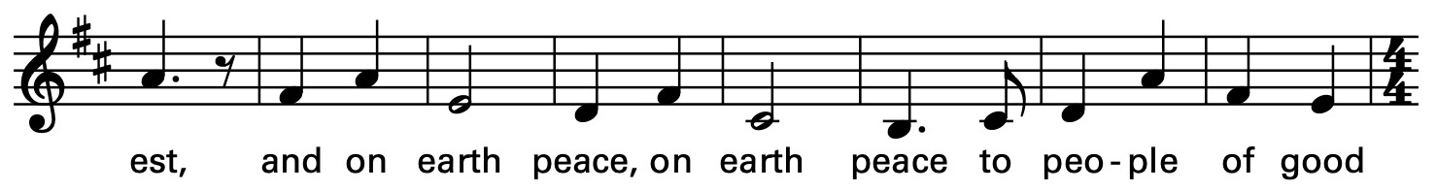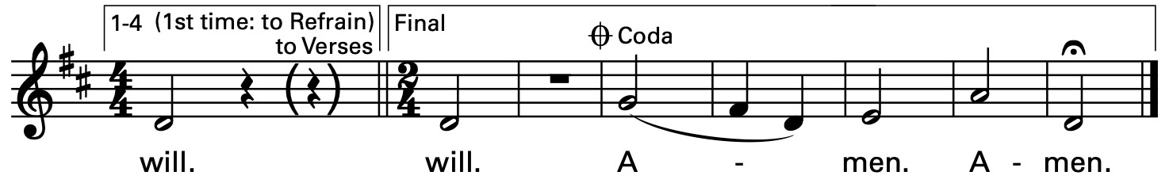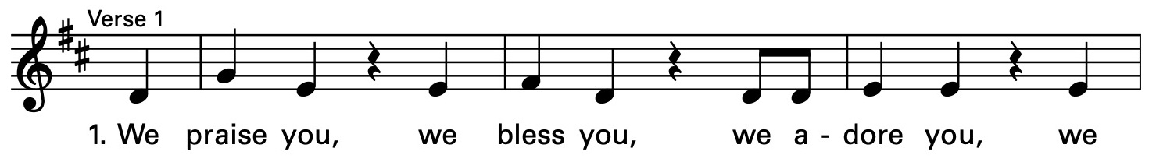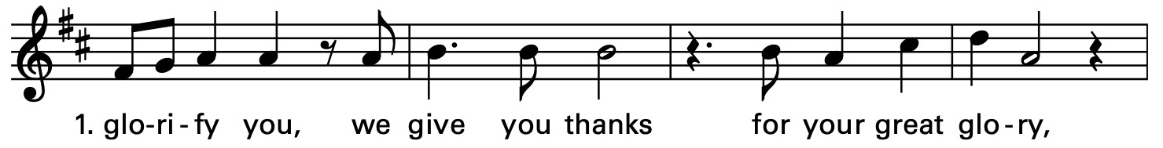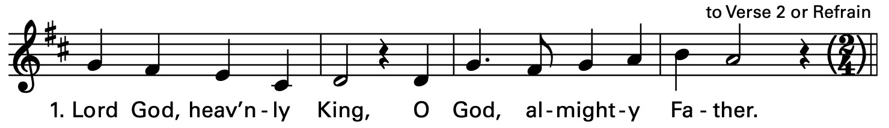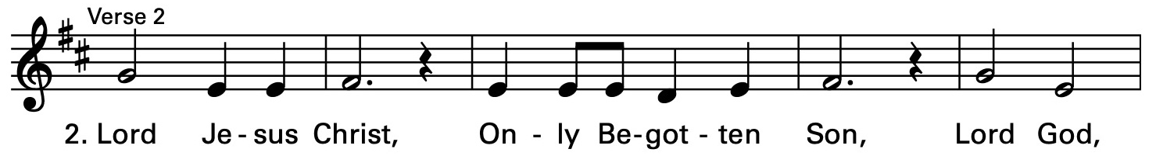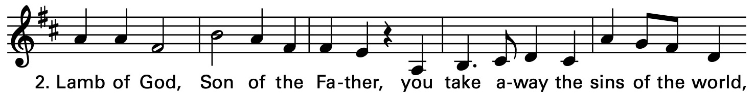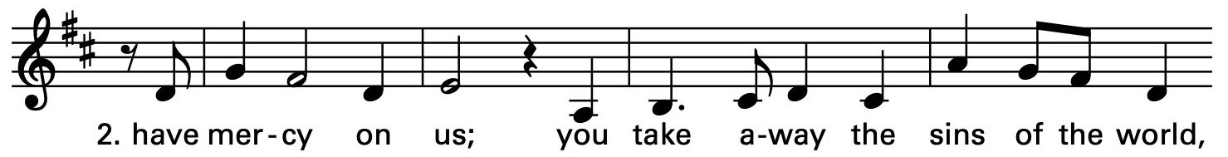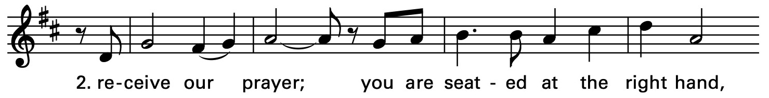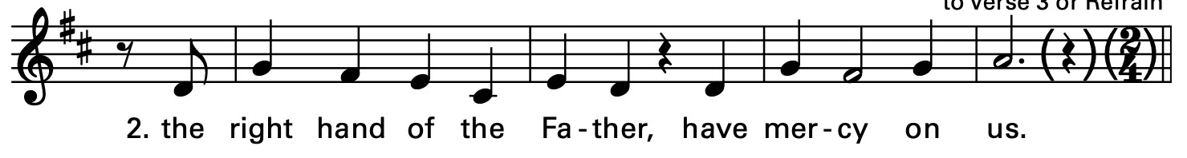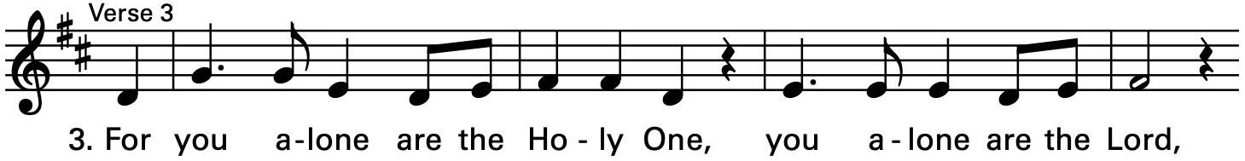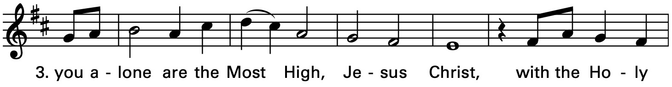

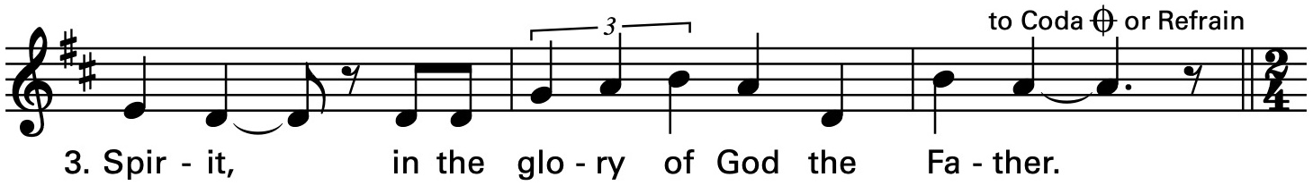

The Collect of the Day

The Celebrant says to the people
The Lord be with you.
People And also with you.
Celebrant Let us pray.
O God, whose blessed Son made himself known to his disciples in the breaking of bread: Open the eyes of our faith, that we may behold him in all his redeeming work; who lives and reigns with you, in the unity of the Holy Spirit, one God, now and for ever. Amen.
The Lessons

The people sit. One or two lessons, as appointed, are read, the Reader first saying

A Reading from the Acts of the Apostles (2:14a,36-41)

Peter, standing with the eleven, raised his voice and addressed the crowd, “Let the entire house of Israel know with certainty that God has made him both Lord and Messiah, this Jesus whom you crucified.” Now when they heard this, they were cut to the heart and said to Peter and to the other apostles, “Brothers, what should we do?” Peter said to them, “Repent, and be baptized every one of you in the name of Jesus Christ so that your sins may be forgiven; and you will receive the gift of the Holy Spirit. For the promise is for you, for your children, and for all who are far away, everyone whom the Lord our God calls to him.” And he testified with many other arguments and exhorted them, saying, “Save yourselves from this corrupt generation.” So those who welcomed his message were baptized, and that day about three thousand persons were added.

The Word of the Lord.
People Thanks be to God.

Silence may follow

Psalm 116:1-3, 10-17

1 I love the Lord, because he has heard the voice of my supplication, *
because he has inclined his ear to me whenever I called upon him.

2 The cords of death entangled me;
the grip of the grave took hold of me; *
I came to grief and sorrow.

3 Then I called upon the Name of the Lord: *
“O Lord, I pray you, save my life."

10 How shall I repay the Lord *
for all the good things he has done for me?

11 I will lift up the cup of salvation *
and call upon the Name of the Lord.

12 I will fulfill my vows to the Lord *
in the presence of all his people.

13 Precious in the sight of the Lord *
is the death of his servants.

14 O Lord, I am your servant; *
I am your servant and the child of your handmaid;
you have freed me from my bonds.

15 I will offer you the sacrifice of thanksgiving *
and call upon the Name of the Lord.

16 I will fulfill my vows to the Lord *
in the presence of all his people,

17 In the courts of the Lord'S house, *
in the midst of you, O Jerusalem.
Hallelujah!

Silence may follow.

A Reading from the first letter of Peter (1:17-23)
If you invoke as Father the one who judges all people impartially according to their deeds, live in reverent fear during the time of your exile. You know that you were ransomed from the futile ways inherited from your ancestors, not with perishable things like silver or gold, but with the precious blood of Christ, like that of a lamb without defect or blemish. He was destined before the foundation of the world, but was revealed at the end of the ages for your sake. Through him you have come to trust in God, who raised him from the dead and gave him glory, so that your faith and hope are set on God. Now that you have purified your souls by your obedience to the truth so that you have genuine mutual love, love one another deeply from the heart. You have been born anew, not of perishable but of imperishable seed, through the living and enduring word of God.
The Word of the Lord.
People Thanks be to God.

With One Voice 693 – Baptized in water

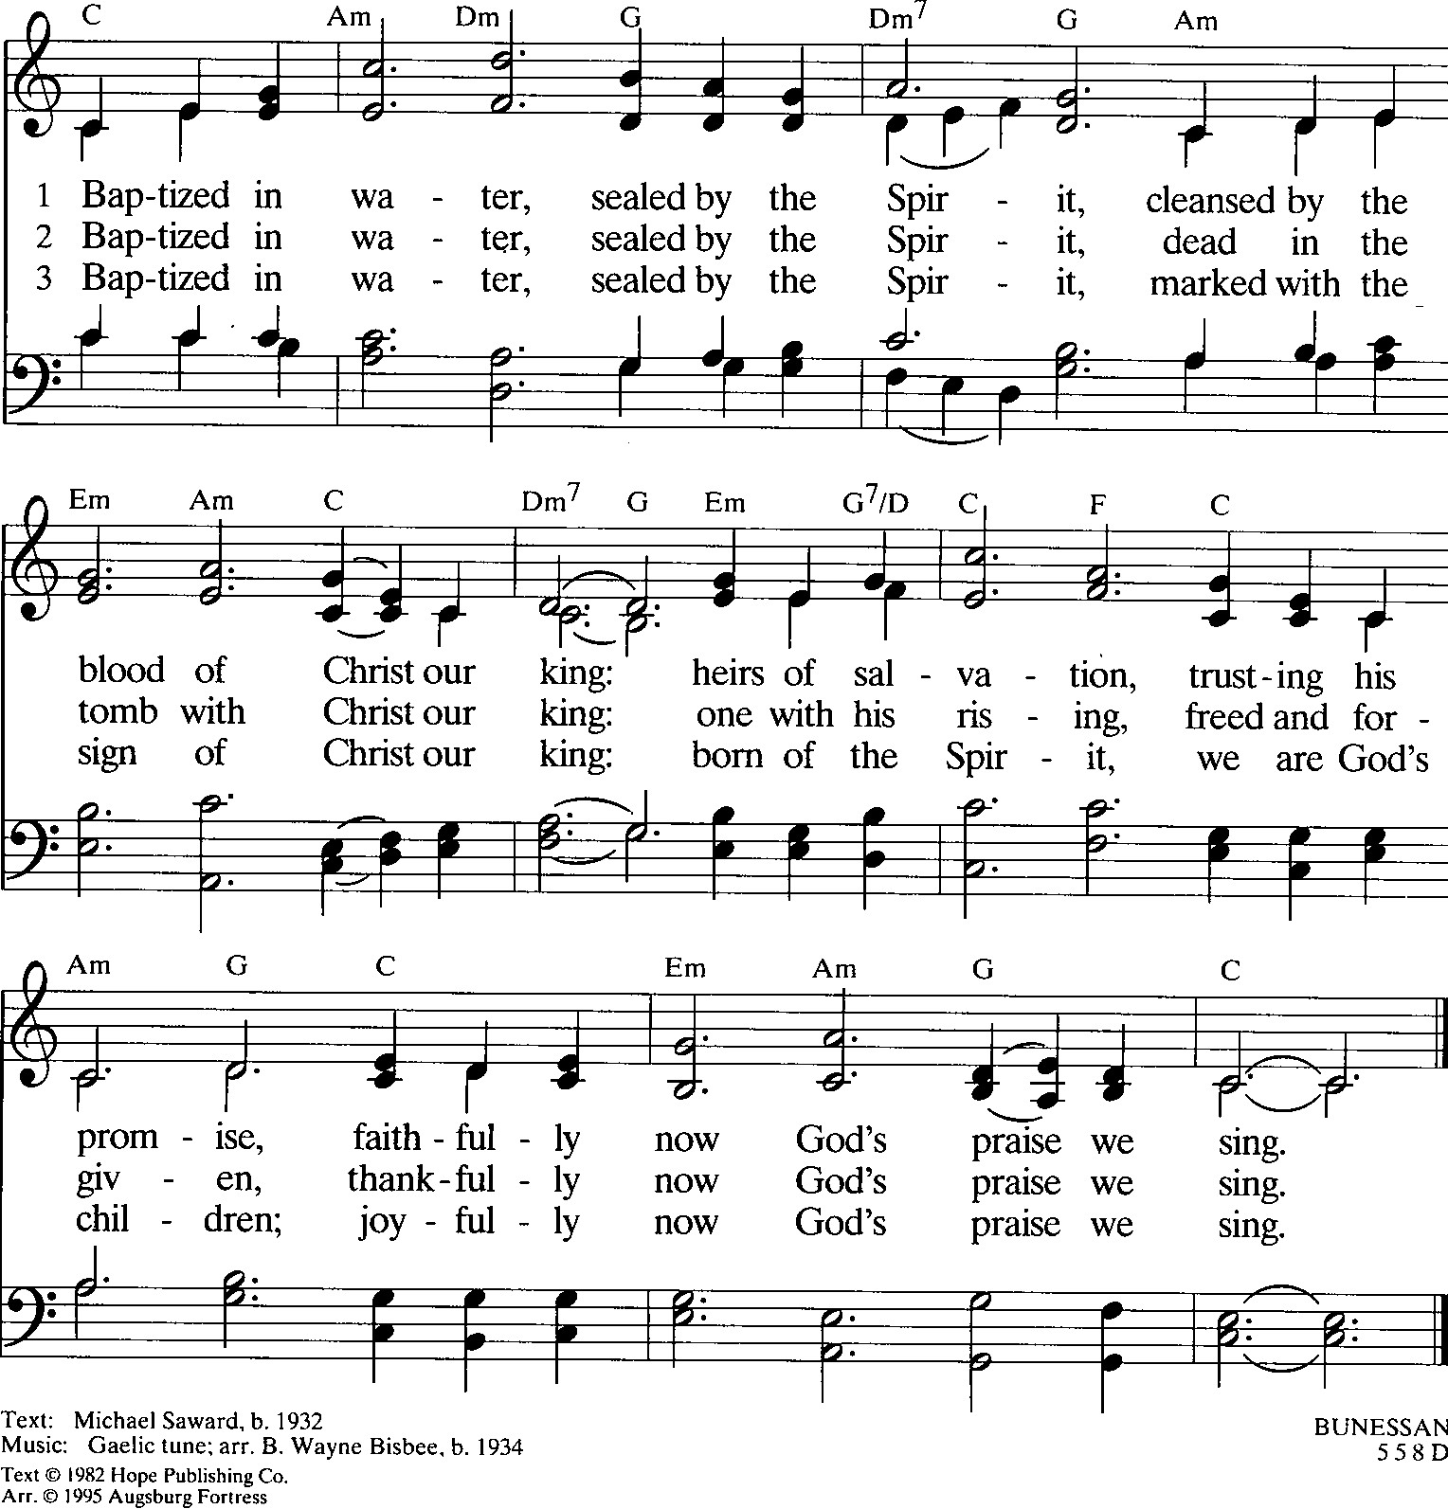

Deacon The Holy Gospel of our Lord Jesus Christ
according to Luke (24:13-35)
People Glory to you, Lord Christ.
Now on that same day two of Jesus' disciples were going to a village called Emmaus, about seven miles from Jerusalem, and talking with each other about all these things that had happened. While they were talking and discussing, Jesus himself came near and went with them, but their eyes were kept from recognizing him. And he said to them, “What are you discussing with each other while you walk along?” They stood still, looking sad. Then one of them, whose name was Cleopas, answered him, “Are you the only stranger in Jerusalem who does not know the things that have taken place there in these days?” He asked them, “What things?” They replied, “The things about Jesus of Nazareth, who was a prophet mighty in deed and word before God and all the people, and how our chief priests and leaders handed him over to be condemned to death and crucified him. But we had hoped that he was the one to redeem Israel. Yes, and besides all this, it is now the third day since these things took place. Moreover, some women of our group astounded us. They were at the tomb early this morning, and when they did not find his body there, they came back and told us that they had indeed seen a vision of angels who said that he was alive. Some of those who were with us went to the tomb and found it just as the women had said; but they did not see him.” Then he said to them, “Oh, how foolish you are, and how slow of heart to believe all that the prophets have declared! Was it not necessary that the Messiah should suffer these things and then enter into his glory?” Then beginning with Moses and all the prophets, he interpreted to them the things about himself in all the scriptures. As they came near the village to which they were going, he walked ahead as if he were going on. But they urged him strongly, saying, “Stay with us, because it is almost evening and the day is now nearly over.” So he went in to stay with them. When he was at the table with them, he took bread, blessed and broke it, and gave it to them. Then their eyes were opened, and they recognized him; and he vanished from their sight. They said to each other, “Were not our hearts burning within us while he was talking to us on the road, while he was opening the scriptures to us?” That same hour they got up and returned to Jerusalem; and they found the eleven and their companions gathered together. They were saying, “The Lord has risen indeed, and he has appeared to Simon!” Then they told what had happened on the road, and how he had been made known to them in the breaking of the bread.
After the Gospel, the Reader says
The Gospel of the Lord.
People Praise to you, Lord Christ.
The Sermon The Rev. Mike Mayor
All standing
The Nicene Creed
We believe in one God,
the Father, the Almighty,
maker of heaven and earth,
of all that is, seen and unseen.
We believe in one Lord, Jesus Christ,
the only Son of God,
eternally begotten of the Father,
God from God, Light from Light,
true God from true God,
begotten, not made,
of one Being with the Father.
Through him all things were made.
For us and for our salvation
he came down from heaven:
by the power of the Holy Spirit
he became incarnate from the Virgin Mary,
and was made man.
For our sake he was crucified under Pontius Pilate;
he suffered death and was buried.
On the third day he rose again
in accordance with the Scriptures;
he ascended into heaven
and is seated at the right hand of the Father.
He will come again in glory to judge the living and the dead,
and his kingdom will have no end.
We believe in the Holy Spirit, the Lord, the giver of life,
who proceeds from the Father and the Son.
With the Father and the Son he is worshiped and glorified.
He has spoken through the Prophets.
We believe in one holy catholic and apostolic Church.
We acknowledge one baptism for the forgiveness of sins.
We look for the resurrection of the dead,
and the life of the world to come. Amen.
The Prayers of the People – Form IV

Deacon or other leader

Let us pray for the Church and for the world.

Grant, Almighty God, that all who confess your Name may be united in your truth, live together in your love, and reveal your glory in the world.

We remember especially Sean, our Presiding Bishop; Phil, our Bishop; Mike, our priest; and Linda, our Deacon.

In our diocesan cycle of prayer we remember Saint Mark’s Cathedral, Seattle and St. Paul’s, Seattle.

Silence

Lord, in your mercy
Hear our prayer.

Guide the people of this land, and of all the nations, in the ways of justice and peace; that we may honor one another and serve the common good.

Silence

Lord, in your mercy
Hear our prayer.

Give us all a reverence for the earth as your own creation, that we may use its resources rightly in the service of others and to your honor and glory.

Silence

Lord, in your mercy
Hear our prayer.

Bless all whose lives are closely linked with ours, and grant that we may serve Christ in them, and love one another as he loves us.

In our parish cycle of prayer we remember Rick, Bruce & Peggy, Mike & Jan, and Sandi

Silence

Lord, in your mercy
Hear our prayer.

Comfort and heal all those who suffer in body, mind, or spirit; give them courage and hope in their troubles, and bring them the joy of your salvation.

Silence

Lord, in your mercy
Hear our prayer.

We commend to your mercy all who have died, that your will for them may be fulfilled; and we pray that we may share with all your saints in your eternal kingdom.

Silence

Lord, in your mercy
Hear our prayer.

The Celebrant adds a concluding Collect.
The Peace

All stand. The Celebrant says to the people
The peace of the Lord be always with you.
People And also with you.

Then the Ministers and People may greet one another in the name of the Lord.

Hymnal 174 – At the Lamb’s high feast we sing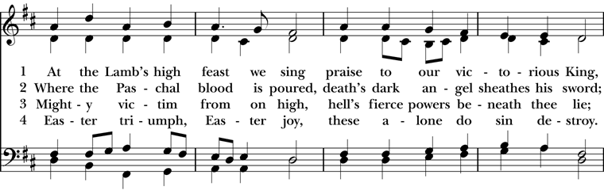

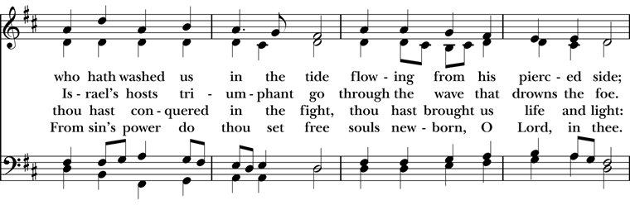
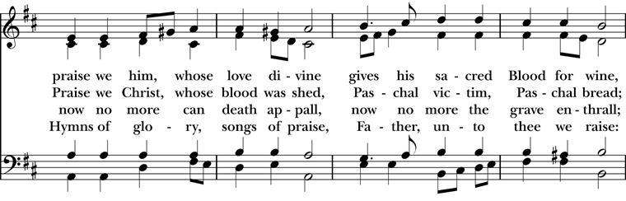

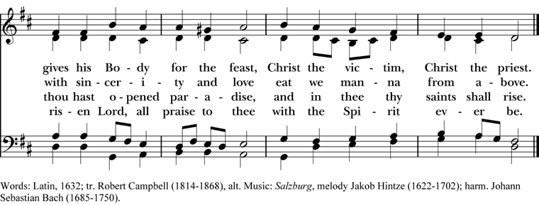

Doxology

The Great Thanksgiving – Eucharistic Prayer D
The people remain standing.
The Celebrant, whether bishop or priest, faces them and sings or says
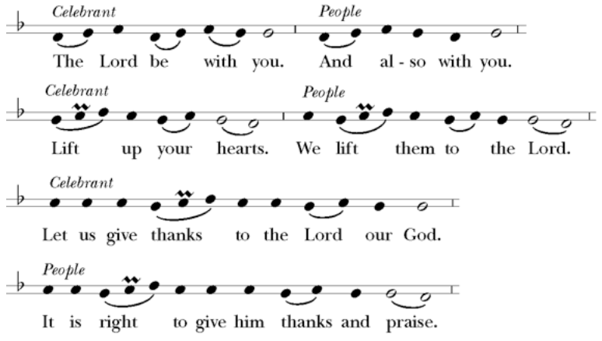

Then, facing the Holy Table, the Celebrant proceeds
It is truly right to glorify you, Father, and to give you thanks; for you alone are God, living and true, dwelling in light inaccessible from before time and for ever.
Fountain of life and source of all goodness, you made all things and fill them with your blessing; you created them to rejoice in the splendor of your radiance.
Countless throngs of angels stand before you to serve you night and day; and, beholding the glory of your presence, they offer you unceasing praise. Joining with them, and giving voice to every creature under heaven, we acclaim you, and glorify your Name, as we sing (say),

Celebrant and People
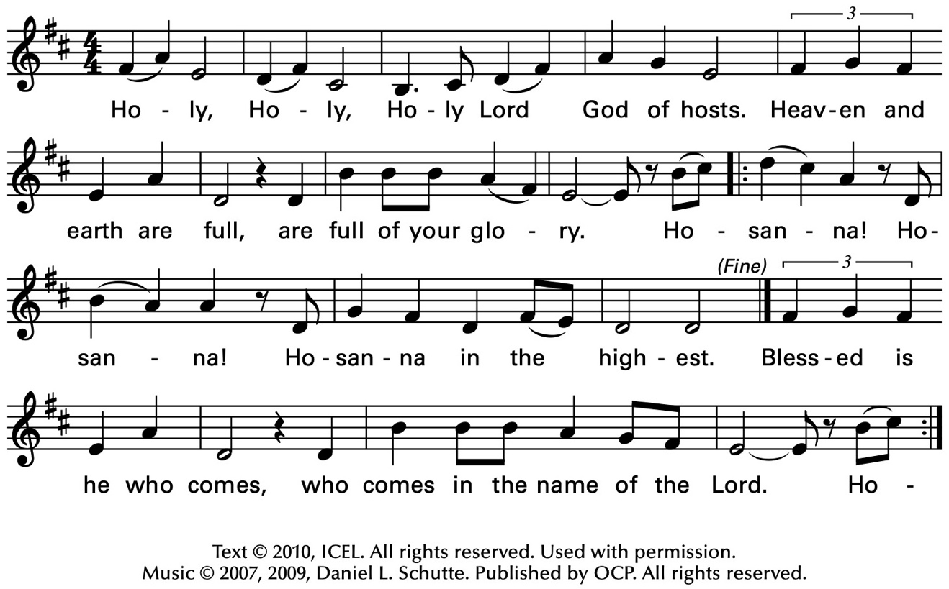
The Celebrant continues
We acclaim you, holy Lord, glorious in power. Your mighty works reveal your wisdom and love. You formed us in your own image, giving the whole world into our care, so that, in obedience to you, our Creator, we might rule and serve all your creatures. When our disobedience took us far from you, you did not abandon us to the power of death. In your mercy you came to our help, so that in seeking you we might find you. Again and again you called us into covenant with you, and through the prophets you taught us to hope for salvation.
Father, you loved the world so much that in the fullness of time you sent your only Son to be our Savior. Incarnate by the Holy Spirit, born of the Virgin Mary, he lived as one of us, yet without sin. To the poor he proclaimed the good news of salvation; to prisoners, freedom; to the sorrowful, joy. To fulfill your purpose he gave himself up to death; and, rising from the grave, destroyed death, and made the whole creation new.
And, that we might live no longer for ourselves, but for him who died and rose for us, he sent the Holy Spirit, his own first gift for those who believe, to complete his work in the world, and to bring to fulfillment the sanctification of all.
At the following words concerning the bread, the Celebrant is to hold it, or lay a hand upon it; and at the words concerning the cup, to hold or place a hand upon the cup and any other vessel containing wine to be consecrated.

When the hour had come for him to be glorified by you, his heavenly Father, having loved his own who were in the world, he loved them to the end; at supper with them he took bread, and when he had given thanks to you, he broke it, and gave it to his disciples, and said, "Take, eat: This is my Body, which is given for you. Do this for the remembrance of me."

After supper he took the cup of wine; and when he had given thanks, he gave it to them, and said, "Drink this, all of you: This is my Blood of the new Covenant, which is shed for you and for many for the forgiveness of sins. Whenever you drink it, do this for the remembrance of me."

Father, we now celebrate this memorial of our redemption. Recalling Christ's death and his descent among the dead, proclaiming his resurrection and ascension to your right hand, awaiting his coming in glory; and offering to you, from the gifts you have given us, this bread and this cup, we praise you and we bless you.

Celebrant and People

We praise you,
we bless you,
we give thanks to you,
and we pray to you, Lord our God.

The Celebrant continues

Lord, we pray that in your goodness and mercy your Holy Spirit may descend upon us, and upon these gifts, sanctifying them and showing them to be holy gifts for your holy people, the bread of life and the cup of salvation, the Body and Blood of your Son Jesus Christ.

Grant that all who share this bread and cup may become one body and one spirit, a living sacrifice in Christ, to the praise of your Name.

Remember, Lord, your one holy catholic and apostolic Church, redeemed by the blood of your Christ. Reveal its unity, guard its faith, and preserve it in peace.

And grant that we may find our inheritance with the Blessed Virgin Mary, with patriarchs, prophets, apostles, and martyrs, and all the saints who have found favor with you in ages past. We praise you in union with them and give you glory through your Son Jesus Christ our Lord.

Through Christ, and with Christ, and in Christ, all honor and glory are yours, Almighty God and Father, in the unity of the Holy Spirit, for ever and ever.

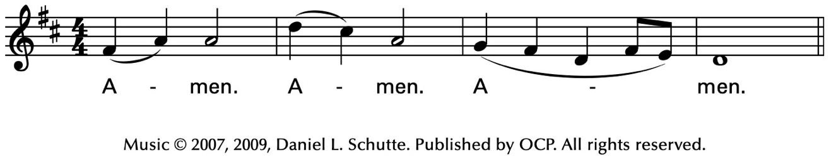
Celebrant
As our Savior Christ
has taught us,
we now pray,

People and Celebrant
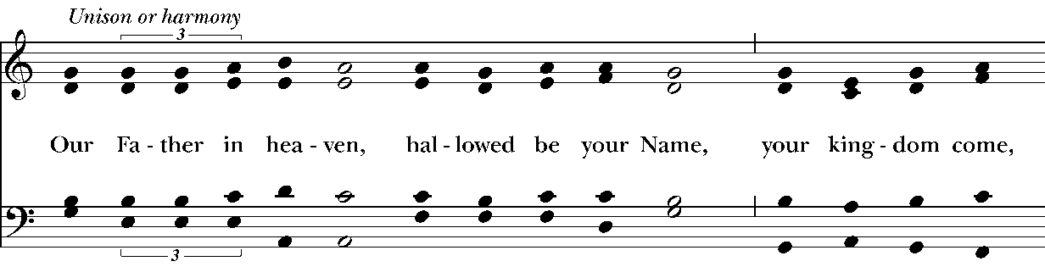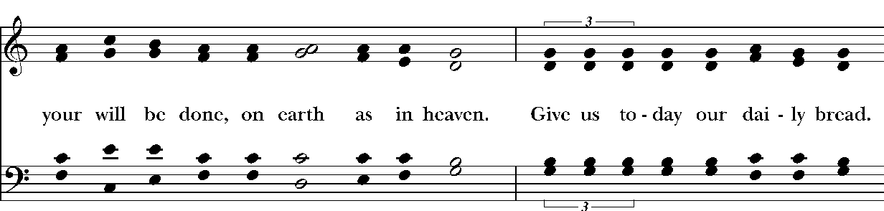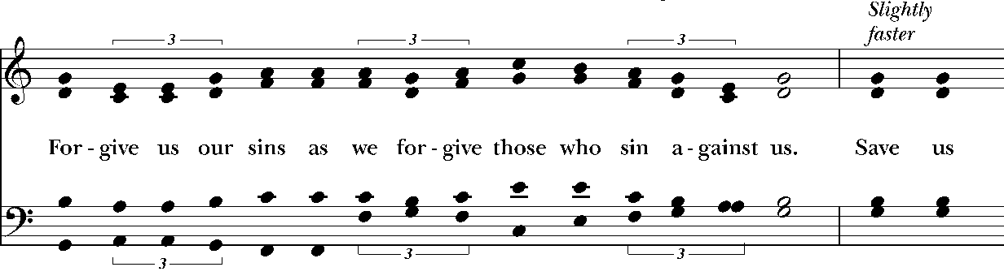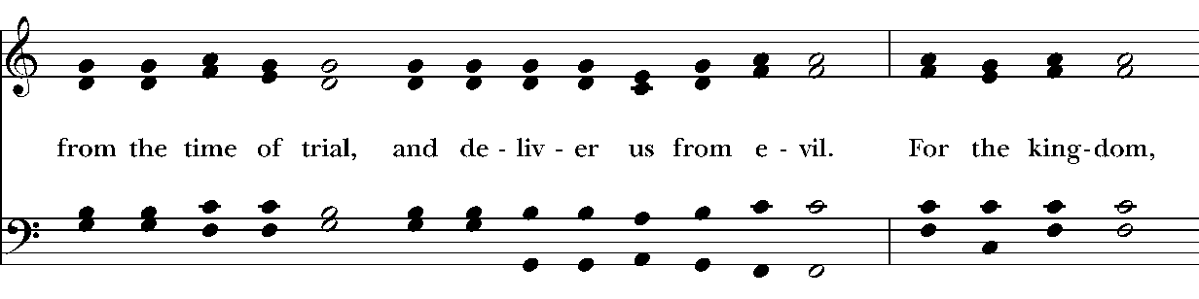
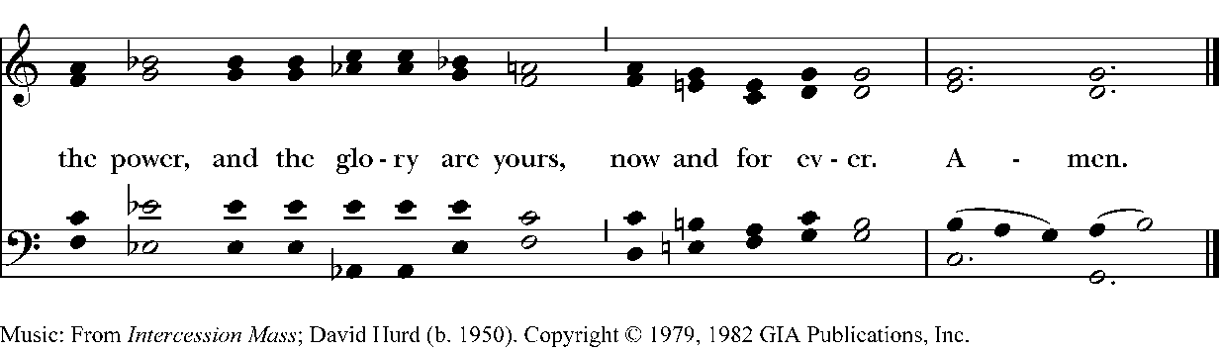
The Breaking of the Bread

The Celebrant breaks the consecrated Bread.

A period of silence is kept.

Then may be sung or said

Celebrant

People
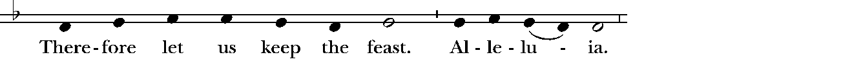
Music: Ambrosian chant; adapt. Mason Martens (1933-1991)

Facing the people, the Celebrant says the following Invitation

The Gifts of God for the People of God.
and may add Take them in remembrance that Christ died for
you, and feed on him in your hearts by faith,
with thanksgiving.

The Bread and Wine are given to the communicants with these words

The Body of Christ, the bread of heaven. [Amen.]
The Blood of Christ, the cup of salvation. [Amen.]

Lift Every Voice and Sing 146 – Break Thou the Bread of Life
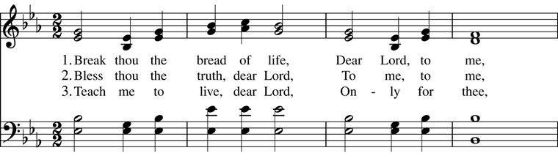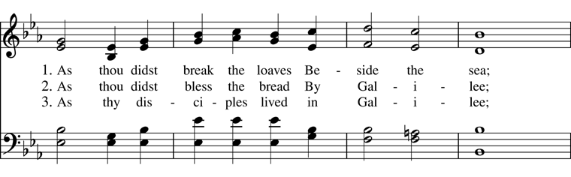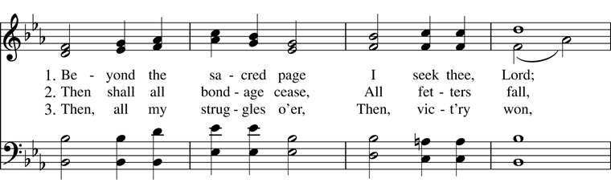
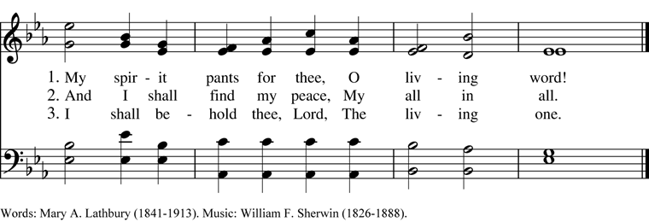
After communion the Celebrant says
Let us pray.

Celebrant and People
Eternal God, heavenly Father,
you have graciously accepted us as living members
of your Son our Savior Jesus Christ,
and you have fed us with spiritual food
in the Sacrament of his Body and Blood.
Send us now into the world in peace,
and grant us strength and courage
to love and serve you
with gladness and singleness of heart;
through Christ our Lord. Amen.
The Bishop when present, or the Priest, may bless the people.
Hymnal 492 – Sing, ye faithful, sing with gladness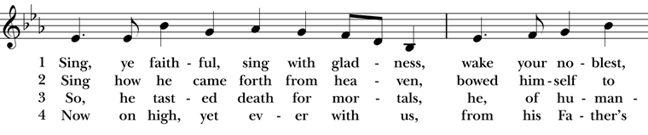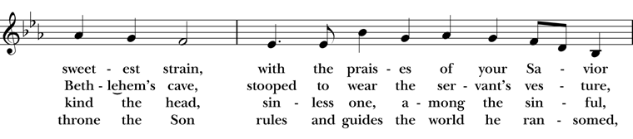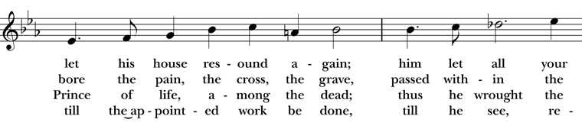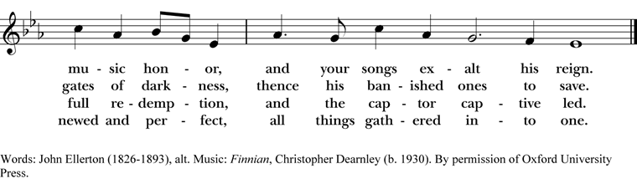
Deacon Go in peace to love and serve the Lord. Alleluia. Alleluia.
People Thanks be to God. Alleluia. Alleluia.
Postlude

Announcements
Flowers for this Sunday
The flowers for this Sunday, April 19, 2026 are given by Peggy Wheeler to the Glory of God, and in celebration of family.
All Parish Meeting Sunday 4/26
You are cordially invited to our first 2026 All Parish Meeting on 4/26. We will start the meeting shortly after the 10:00 service once every one has treats, coffee or tea!
This year our focus during the All Parish Meetings will be the 2026 Mission Priorities as set by your vestry during this year’s annual retreat. These priorities’ success are dependent on YOU, dear friends! So we ask that you pull up a chair, see the good works taking place, and consider where and how each and every one of us can make an impact within our beloved community. We look forward to seeing you there!
Fellowship Book Group
Please join us for fellowship and lively discussion. We start with fellowship at 6:00 pm and discussion starts at 6:30 pm. We’d love to have you join us. The next meeting will be on our usual meeting day, (4th Monday of the month) April 27, 2026 via zoom.
The Zoom link and passcode are:
Meeting ID: 82826550583
Passcode: 121698
The book for April will be “Remarkably Bright Creatures”, by Shelby Van Pelt. (Available for order at various used bookstores, Audible, or possibly at your local library)
After Tova Sullivan’s husband died, she began working the night shift at the Sowell Bay Aquarium, mopping floors and tidying up. Keeping busy has always helped her cope, which she’s been doing since her eighteen-year-old son, Erik, mysteriously vanished on a boat in Puget Sound over thirty years ago. Tova becomes acquainted with curmudgeonly Marcellus, a giant Pacific octopus living at the aquarium. Marcellus knows more than anyone can imagine but wouldn’t dream of lifting one of his eight arms for his human captors—until he forms a remarkable friendship with Tova.
We are providing the title of the book chosen for the next month, so readers will have time to get on library wait lists or plan for any ordering backlog. The book for May will be "The Heaven & Earth Grocery Store", by James McBride.
Questions? Speak with any of the following: Shelly Fairbanks, DeeDee Fournier, Jen Killion, Melinda Jackson
Soup Kitchen
Susan Myers and Deacon Linda
Thank you to the volunteers for providing the food: Dan S. for providing the soup; for Cindy J. for providing the bread and serving; Trish S. for providing dessert; Maria H. and Rick B. for serving; Susan M. for assisting in the kitchen; Sue G. and Patti M. for serving at the Hospitality Table.
This week's totals:

People served: 17
Bus passes given out: 7
How many picked up mail: 3
Toiletries given out: 12
Socks given away: 12
We need volunteers to provide soup, fruit, bread or dessert for the next two Wednesdays in April. Please sign up on the Soup Kitchen form on the Communications Board in the parish hall.
Food donations can be bought on Sunday mornings or on Wednesdays before 10:00 am. Just mark them “Soup Kitchen”.
Items we need for the health care basket are shampoo, Conditioner, Deodorant, and shaving cream. These items are available and affordable at the Dollar Tree.
Proverbs 22:9
Whoever has a bountiful eye will be blessed, for he shares his bread with the poor.
Puyallup Food Bank Donations
Now that Spring weather is warming up and we see new life sprouting, here are a few ideas for April's Food Bank:

- Facial Tissues, for allergies
- Diapers & Pull Ups, all sizes
- Baby Wipes
- Paper Towels
- Toilet Paper

Of course, any donation that is shelf stable is welcome. You may also make monetary donations; please mark your checks, "Food Bank".
Thank you for your support of our community.
Maria Haack, Vestry Liaison for Outreach
Upcoming Opportunities For Outreach
Deacon Linda and Maria Haack, Vestry Liaison for Outreach
Outreach projects we have been involved with at Christ Church since the first of the year are Souper Bowl of Caring, Sock Drive, and volunteering with Christ Church’s Soup Kitchen.
Upcoming opportunities for outreach through Christ Church are:
- Thursday, June 24, 2026 United Way Day of Action Snack Packs for kids – Fairgrounds in AgriPlex Building Time: 4 pm to 7 pm Sip, Serve & Celebrate - Snack pack and community building project for summer meals – making Snack Packs for school children in Pierce County
- June through September - 11 am to 1 pm Lunches To Go- Set up canopy outside in front of the church and give free lunches and pop to whomever is hungry
- September 13 Operation Backpack- Free backpacks handed out to parishioners, and you are invited to fill a backpack with school supplies for Puyallup School District students
Sermon Notes

Sermon Notes

Today’s Ministers of Worship

Celebrant: The Rev. Mike Mayor
Deacon: The Rev. Linda Potter
Lectors: Jen Killion, Sue Golden
Acolyte: Tristen Schilling
Eucharistic Minister: Jeremy Duplissey
Livestream Coordinator: Jeremy Duplissey
Nursery Attendants: Melinda Jackson
Pianist: Vicki Melton
Greeters: Christine Scholer, Carla Golden
Usher: Tanya Elder
Closer: Lynn Sissel
Altar Guild: Christine Scholer, Jean Irey
Music permission through OneLicense #A-706918


Scan to give online. All payments are processed through Paypal.
Christ Episcopal Church
A congregation of the Episcopal Diocese of Olympia
Bishop – The Rt. Rev. Philip N. LaBelle
Rector – The Rev. Mike Mayor
Vestry
Sr. Warden – Shelly Fairbanks
Jr. Warden for Property – Jeremy Duplissey
Jr. Warden for Communication – Barry O’Brien
Treasurer – Melinda Jackson
Clerk – Tanya Elder
Member – Steve Angelo
Member – Roddi Barton
Member – Maria Haack
Member – Susan Myers
Member – Dave Steere
Member – Rolin Stone
210 5th St. SW | Puyallup, WA | 98371
253-848-2323 | office@episcopallup.com
www.episcopallup.com

