Third Sunday in Lent
Holy Eucharist, Rite II

10:00 am – March 8, 2026

Welcome to Christ Church
We are so happy you have chosen to come and participate in worship this morning. Your presence today strengthens the Body of Christ, not only here but throughout the world.
Land Acknowledgment
Christ Church acknowledges that we gather on the traditional homeland of the Puyallup Tribe. The Puyallup people have lived on and stewarded these lands since the beginning of time, and continue to do so today. We honor and give thanks for the land itself and the life of all the indigenous peoples of this area.
New to Christ Church?
Welcome to Christ Episcopal Church of Puyallup. Wherever you are on your spiritual journey, you are welcome here! We invite you to sign our guestbook, visit our website (www.episcopallup.com) or connect with one of the clergy.
Questions?
Please ask. The ushers (one of the persons who gave you a bulletin) can answer your questions or concerns. Restrooms are available in the hallway to the west of the worship space.
About our Liturgy
Worship lies at the heart of the Christian life. It is in worship that we express our theology and define our identity. We encounter God within worship and are formed and transformed as the people of God. One of the hallmarks of the Episcopal Church is its liturgical worship. Liturgy literally is “the work of the people,” and refers to the patterns, forms, words, and actions through which public worship is conducted.
Hymnal 686 – Come, thou fount of every blessing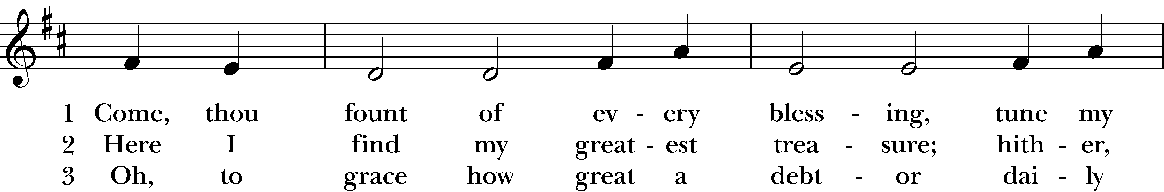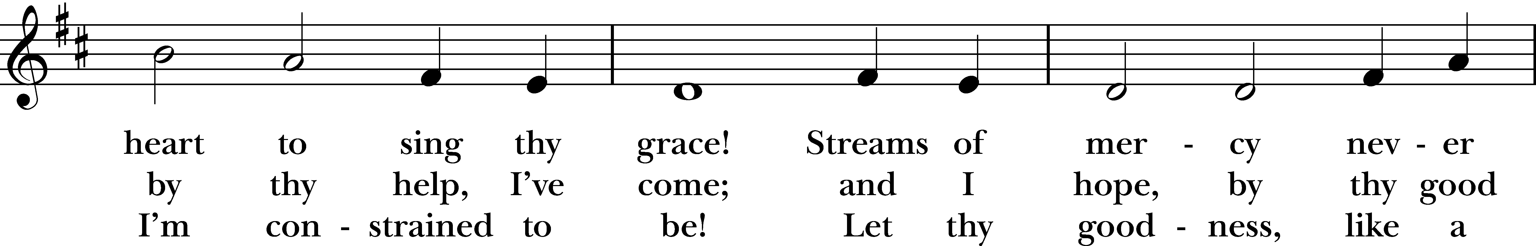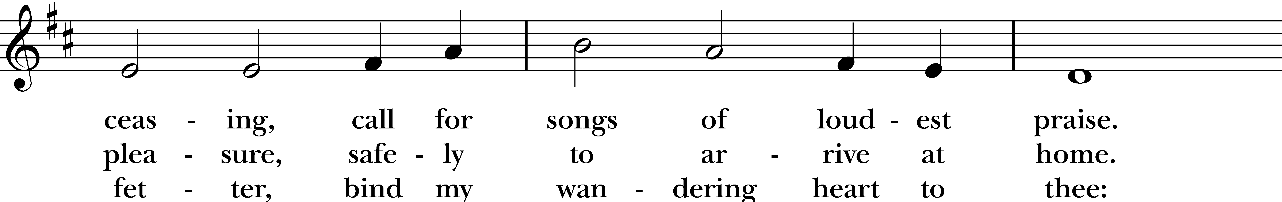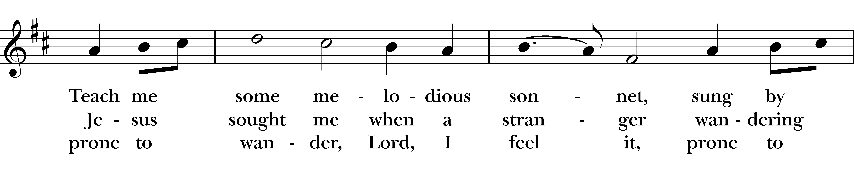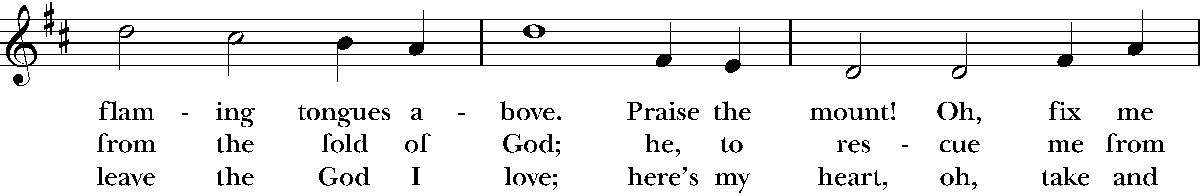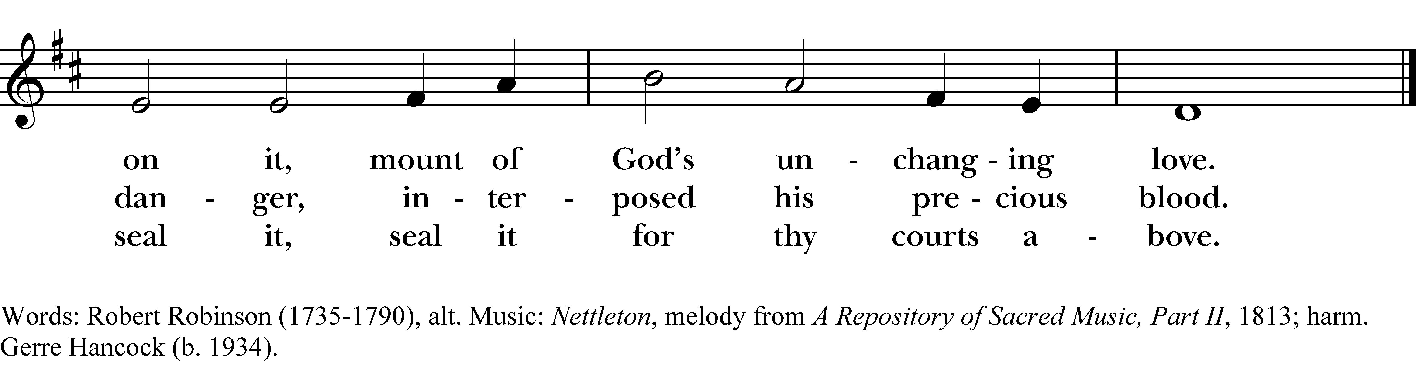

The people standing, the Celebrant says
Bless the Lord who forgives all our sins.
People God’s mercy endures for ever.

The decalogue may be said here
Hear the commandments of God to his people:
I am the Lord your God who brought you out of bondage.
You shall have no other gods but me.
Amen. Lord have mercy.
You shall not make for yourself any idol.
Amen. Lord have mercy.
You shall not invoke with malice the Name of the Lord your God.
Amen. Lord have mercy.
Remember the Sabbath Day and keep it holy.
Amen. Lord have mercy.
Honor your father and your mother.
Amen. Lord have mercy.
You shall not commit murder.
Amen. Lord have mercy.
You shall not commit adultery.
Amen. Lord have mercy.
You shall not steal.
Amen. Lord have mercy.
You shall not be a false witness.
Amen. Lord have mercy.
You shall not covet anything that belongs to your neighbor.
Amen. Lord have mercy.

The Celebrant may read one of the following sentences
Jesus said, “The first commandment is this: Hear, O Israel: The Lord our God is the only Lord. Love the Lord your God with all your heart, with all your soul, with all your mind, and with all your strength. The second is this: Love your neighbor as yourself. There is no other commandment greater than these.” Mark 12:29-31
If we say that we have no sin, we deceive ourselves, and the truth is not in us. But if we confess our sins, God, who is faithful and just, will forgive our sins and cleanse us from all unrighteousness. 1 John 1:8,9
Since we have a great high priest who has passed through the heavens, Jesus, the Son of God, let us with confidence draw near to the throne of grace, that we may receive mercy and find grace to help in time of need. Hebrews 4:14, 16

The Deacon or Celebrant then says
Let us confess our sins against God and our neighbor.

Silence may be kept.

Minister and People
Most merciful God,
we confess that we have sinned against you
in thought, word, and deed,
by what we have done,
and by what we have left undone.
We have not loved you with our whole heart;
we have not loved our neighbors as ourselves.
We are truly sorry and we humbly repent.
For the sake of your Son Jesus Christ,
have mercy on us and forgive us;
that we may delight in your will,
and walk in your ways,
to the glory of your Name. Amen.

The Bishop when present, or the Priest, stands and says
Almighty God have mercy on you, forgive you all your sins through our Lord Jesus Christ, strengthen you in all goodness, and by the power of the Holy Spirit keep you in eternal life. Amen.
When appointed, the following hymn or some other song of praise is sung or said, all standing

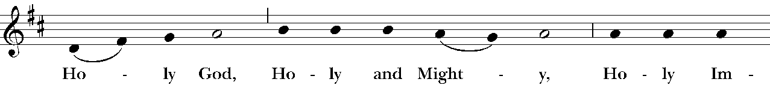

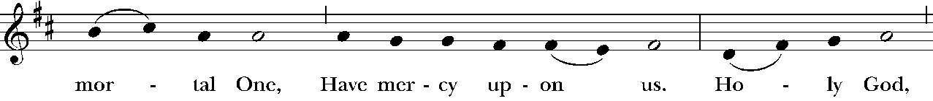

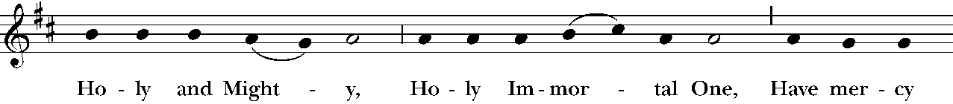

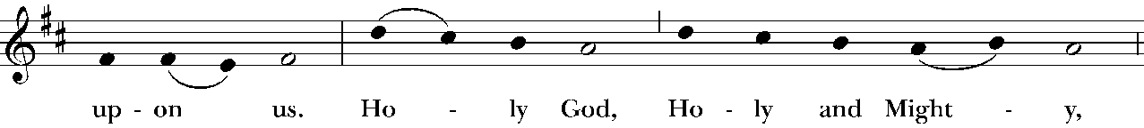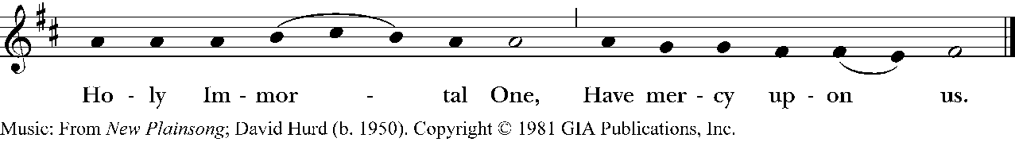

The Collect of the Day

The Celebrant says to the people
The Lord be with you.
People And also with you.
Celebrant Let us pray.
Almighty God, you know that we have no power in ourselves to help ourselves: Keep us both outwardly in our bodies and inwardly in our souls, that we may be defended from all adversities which may happen to the body, and from all evil thoughts which may assault and hurt the soul; through Jesus Christ our Lord, who lives and reigns with you and the Holy Spirit, one God, for ever and ever. Amen.
The Lessons

The people sit. One or two lessons, as appointed, are read, the Reader first saying
A Reading from the book of Exodus (17:1-7)

From the wilderness of Sin the whole congregation of the Israelites journeyed by stages, as the Lord commanded. They camped at Rephidim, but there was no water for the people to drink. The people quarreled with Moses, and said, “Give us water to drink.” Moses said to them, “Why do you quarrel with me? Why do you test the Lord?” But the people thirsted there for water; and the people complained against Moses and said, “Why did you bring us out of Egypt, to kill us and our children and livestock with thirst?” So Moses cried out to the Lord, “What shall I do with this people? They are almost ready to stone me.” The Lord said to Moses, “Go on ahead of the people, and take some of the elders of Israel with you; take in your hand the staff with which you struck the Nile, and go. I will be standing there in front of you on the rock at Horeb. Strike the rock, and water will come out of it, so that the people may drink.” Moses did so, in the sight of the elders of Israel. He called the place Massah and Meribah, because the Israelites quarreled and tested the Lord, saying, “Is the Lord among us or not?”

The Word of the Lord.
People Thanks be to God.

Silence may follow

Psalm 95

1 Come, let us sing to the Lord; *
let us shout for joy to the Rock of our salvation.

2 Let us come before his presence with thanksgiving *
and raise a loud shout to him with psalms.

3 For the Lord is a great God, *
and a great King above all gods.

4 In his hand are the caverns of the earth, *
and the heights of the hills are his also.

5 The sea is his, for he made it, *
and his hands have molded the dry land.

6 Come, let us bow down, and bend the knee, *
and kneel before the Lord our Maker.

7 For he is our God,
and we are the people of his pasture and the sheep of his hand. *
Oh, that today you would hearken to his voice!

8 Harden not your hearts, as your forebears did in the wilderness, *
at Meribah, and on that day at Massah, when they tempted me.

9 They put me to the test, *
though they had seen my works.

10 Forty years long I detested that generation and said, *
“This people are wayward in their hearts; they do not know my ways.”

11 So I swore in my wrath, *
“They shall not enter into my rest.”

Silence may follow.

A Reading from Paul’s letter to the Romans (5:1-11)
Since we are justified by faith, we have peace with God through our Lord Jesus Christ, through whom we have obtained access to this grace in which we stand; and we boast in our hope of sharing the glory of God. And not only that, but we also boast in our sufferings, knowing that suffering produces endurance, and endurance produces character, and character produces hope, and hope does not disappoint us, because God's love has been poured into our hearts through the Holy Spirit that has been given to us. For while we were still weak, at the right time Christ died for the ungodly. Indeed, rarely will anyone die for a righteous person-- though perhaps for a good person someone might actually dare to die. But God proves his love for us in that while we still were sinners Christ died for us. Much more surely then, now that we have been justified by his blood, will we be saved through him from the wrath of God. For if while we were enemies, we were reconciled to God through the death of his Son, much more surely, having been reconciled, will we be saved by his life. But more than that, we even boast in God through our Lord Jesus Christ, through whom we have now received reconciliation.
The Word of the Lord.
People Thanks be to God.
Silence may follow.
Wonder, Love & Praise 805 – I Want Jesus to Walk with Me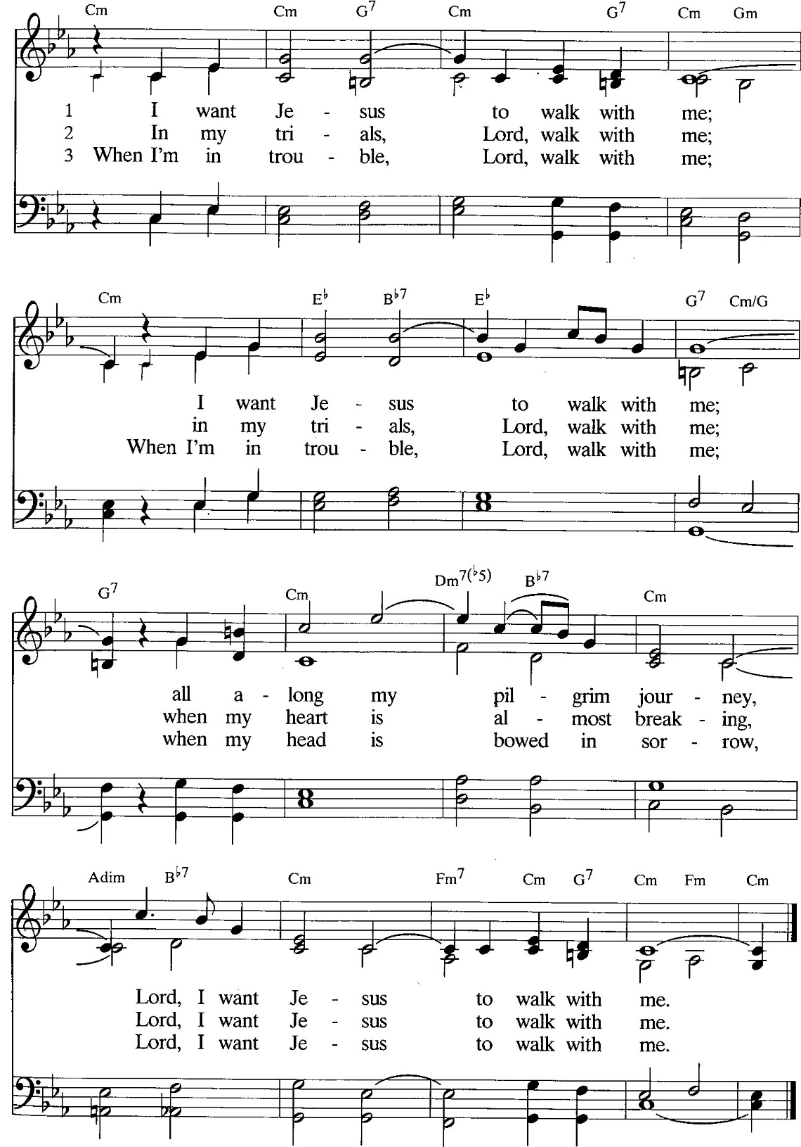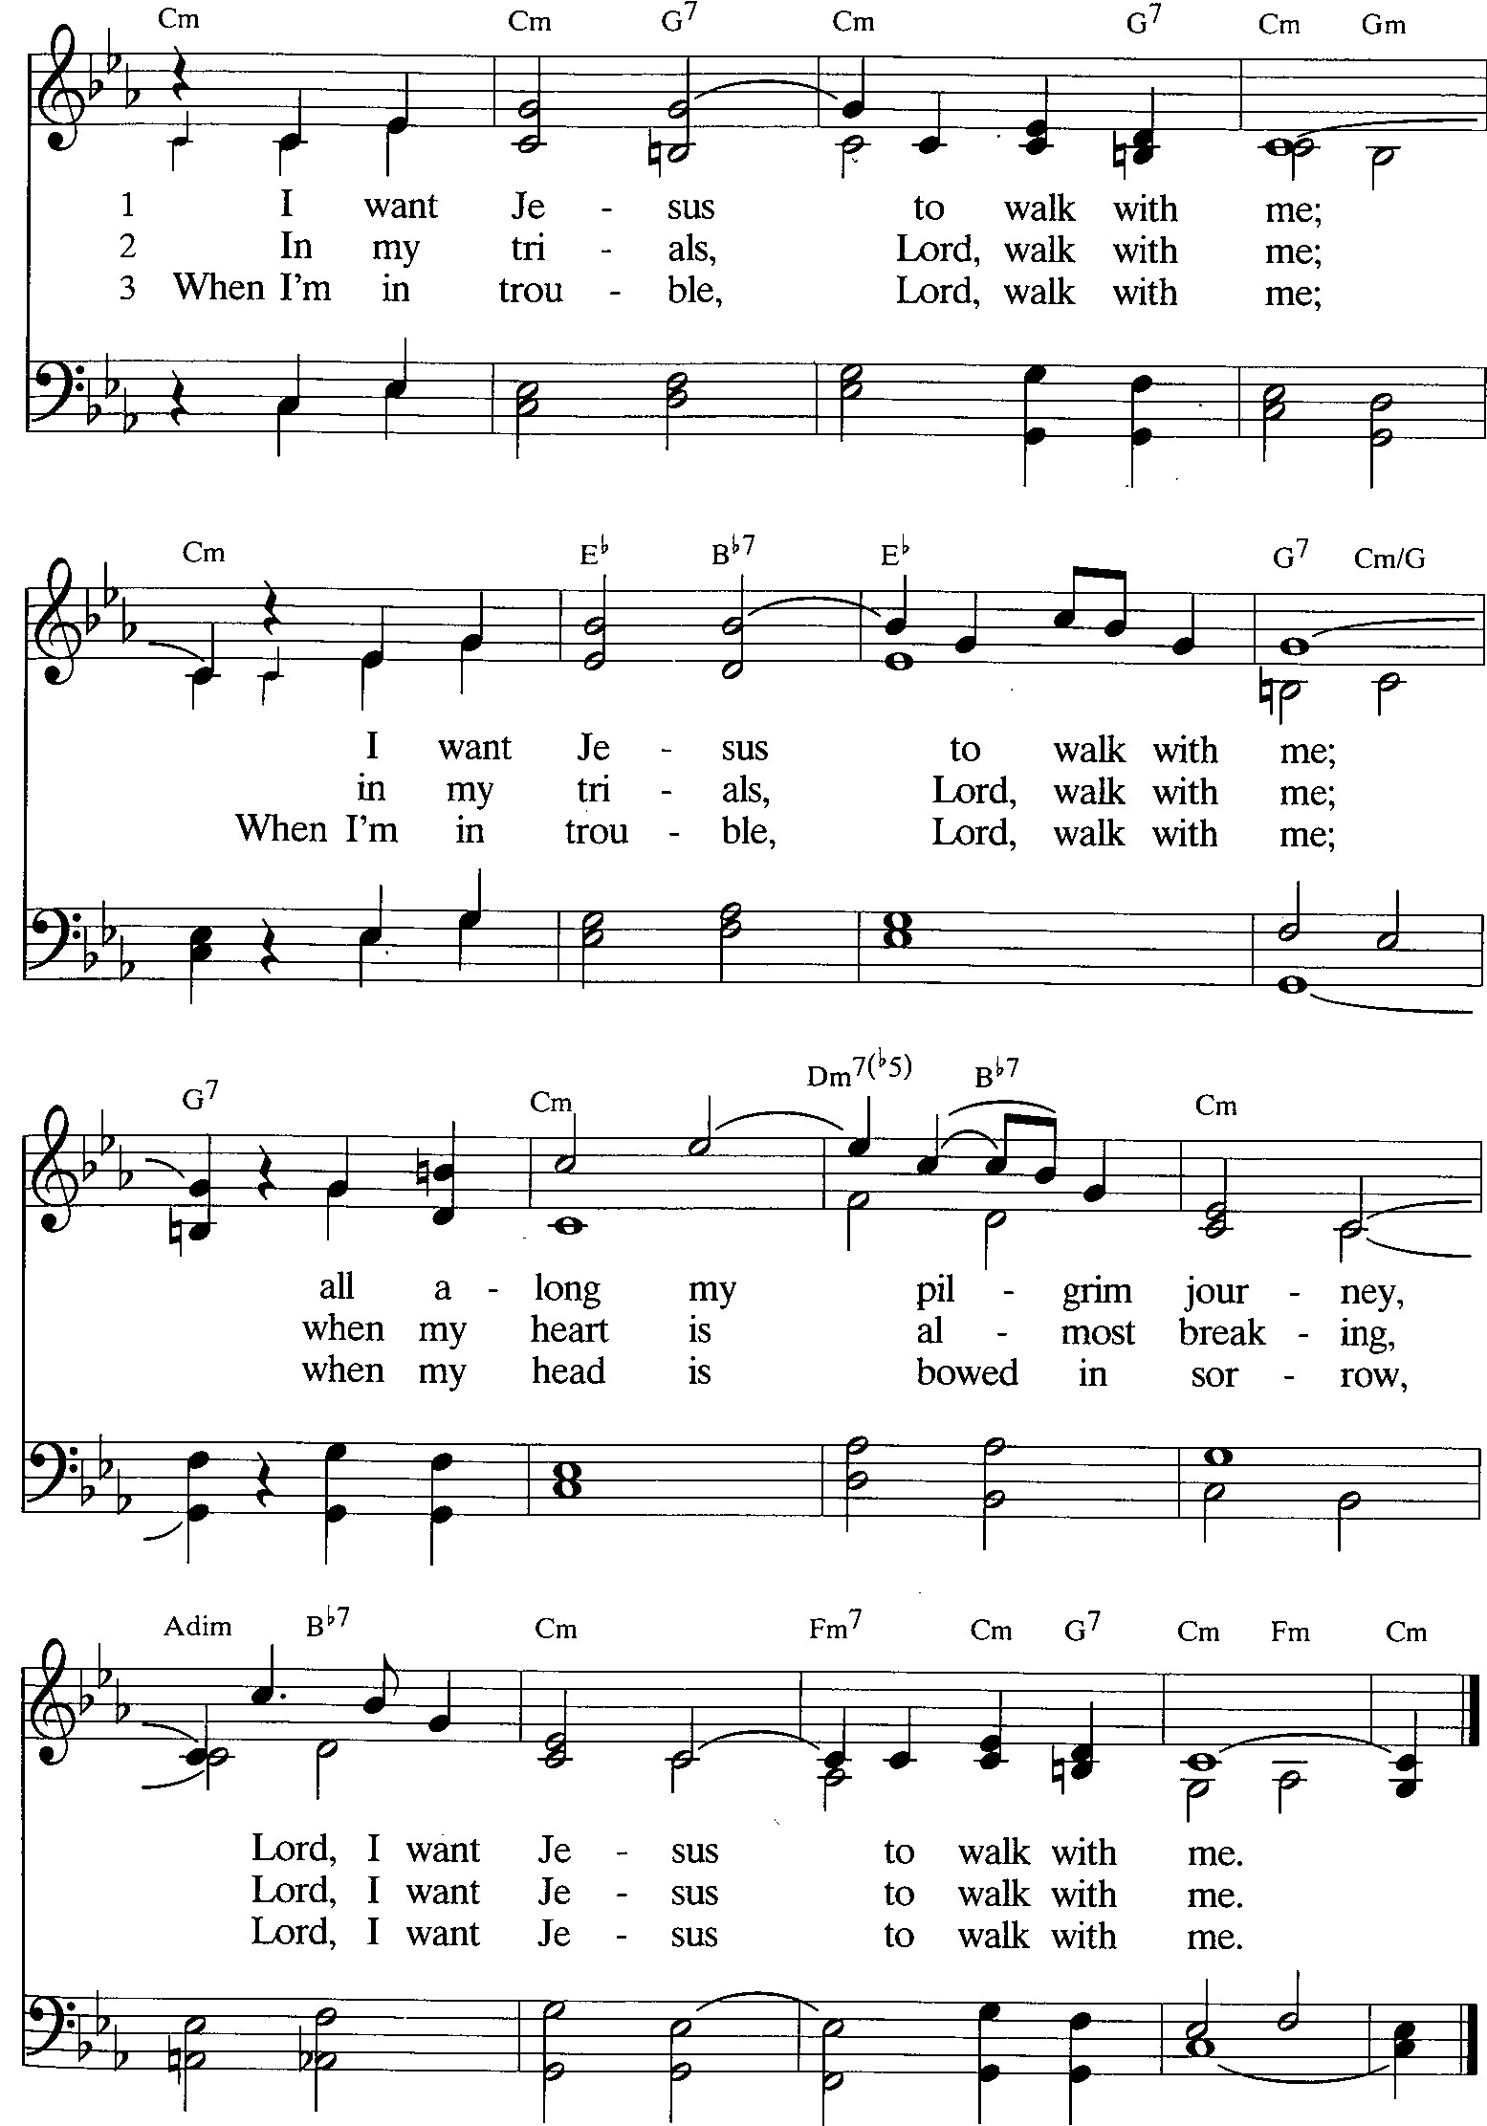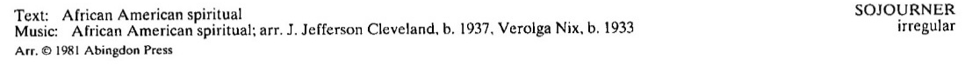
Deacon The Holy Gospel of our Lord Jesus Christ
according to (John 4:5-42)
People Glory to you, Lord Christ.
Jesus came to a Samaritan city called Sychar, near the plot of ground that Jacob had given to his son Joseph. Jacob’s well was there, and Jesus, tired out by his journey, was sitting by the well. It was about noon. A Samaritan woman came to draw water, and Jesus said to her, “Give me a drink.” (His disciples had gone to the city to buy food.) The Samaritan woman said to him, “How is it that you, a Jew, ask a drink of me, a woman of Samaria?” (Jews do not share things in common with Samaritans.) Jesus answered her, “If you knew the gift of God, and who it is that is saying to you, ‘Give me a drink,’ you would have asked him, and he would have given you living water.” The woman said to him, “Sir, you have no bucket, and the well is deep. Where do you get that living water? Are you greater than our ancestor Jacob, who gave us the well, and with his sons and his flocks drank from it?” Jesus said to her, “Everyone who drinks of this water will be thirsty again, but those who drink of the water that I will give them will never be thirsty. The water that I will give will become in them a spring of water gushing up to eternal life.” The woman said to him, “Sir, give me this water, so that I may never be thirsty or have to keep coming here to draw water.” Jesus said to her, “Go, call your husband, and come back.” The woman answered him, “I have no husband.” Jesus said to her, “You are right in saying, ‘I have no husband’; for you have had five husbands, and the one you have now is not your husband. What you have said is true!” The woman said to him, “Sir, I see that you are a prophet. Our ancestors worshiped on this mountain, but you say that the place where people must worship is in Jerusalem.” Jesus said to her, “Woman, believe me, the hour is coming when you will worship the Father neither on this mountain nor in Jerusalem. You worship what you do not know; we worship what we know, for salvation is from the Jews. But the hour is coming, and is now here, when the true worshipers will worship the Father in spirit and truth, for the Father seeks such as these to worship him. God is spirit, and those who worship him must worship in spirit and truth.” The woman said to him, “I know that Messiah is coming” (who is called Christ). “When he comes, he will proclaim all things to us.” Jesus said to her, “I am he, the one who is speaking to you.” Just then his disciples came. They were astonished that he was speaking with a woman, but no one said, “What do you want?” or, “Why are you speaking with her?” Then the woman left her water jar and went back to the city. She said to the people, “Come and see a man who told me everything I have ever done! He cannot be the Messiah, can he?” They left the city and were on their way to him. Meanwhile the disciples were urging him, “Rabbi, eat something.” But he said to them, “I have food to eat that you do not know about.” So the disciples said to one another, “Surely no one has brought him something to eat?” Jesus said to them, “My food is to do the will of him who sent me and to complete his work. Do you not say, ‘Four months more, then comes the harvest’? But I tell you, look around you, and see how the fields are ripe for harvesting. The reaper is already receiving wages and is gathering fruit for eternal life, so that sower and reaper may rejoice together. For here the saying holds true, ‘One sows and another reaps.’ I sent you to reap that for which you did not labor. Others have labored, and you have entered into their labor.” Many Samaritans from that city believed in him because of the woman’s testimony, “He told me everything I have ever done.” So when the Samaritans came to him, they asked him to stay with them; and he stayed there two days. And many more believed because of his word. They said to the woman, “It is no longer because of what you said that we believe, for we have heard for ourselves, and we know that this is truly the Savior of the world.”
After the Gospel, the Reader says
The Gospel of the Lord.
People Praise to you, Lord Christ.
The Sermon The Rev. Mike Mayor
All standing
The Nicene Creed
We believe in one God,
the Father, the Almighty,
maker of heaven and earth,
of all that is, seen and unseen.
We believe in one Lord, Jesus Christ,
the only Son of God,
eternally begotten of the Father,
God from God, Light from Light,
true God from true God,
begotten, not made,
of one Being with the Father.
Through him all things were made.
For us and for our salvation
he came down from heaven:
by the power of the Holy Spirit
he became incarnate from the Virgin Mary,
and was made man.
For our sake he was crucified under Pontius Pilate;
he suffered death and was buried.
On the third day he rose again
in accordance with the Scriptures;
he ascended into heaven
and is seated at the right hand of the Father.
He will come again in glory to judge the living and the dead,
and his kingdom will have no end.
We believe in the Holy Spirit, the Lord, the giver of life,
who proceeds from the Father and the Son.
With the Father and the Son he is worshiped and glorified.
He has spoken through the Prophets.
We believe in one holy catholic and apostolic Church.
We acknowledge one baptism for the forgiveness of sins.
We look for the resurrection of the dead,
and the life of the world to come. Amen.
The Prayers of the People – Form III

The Leader and People pray responsively

Father, we pray for your holy Catholic Church;
That we all may be one.

Grant that every member of the Church may truly and humbly serve you;
That your Name may be glorified by all people.

We pray for all bishops, priests, and deacons;
That they may be faithful ministers of your Word and Sacraments.

We pray for all who govern and hold authority in the nations
of the world;
That there may be justice and peace on the earth.

Give us grace to do your will in all that we undertake;
That our works may find favor in your sight.

Have compassion on those who suffer from any grief or trouble;
That they may be delivered from their distress.

Give to the departed eternal rest.
Let light perpetual shine upon them.

We praise you for your saints who have entered into joy;
May we also come to share in your heavenly kingdom.

Let us pray for our own needs and those of others.

Silence

The People may add their own petitions.

For Sean, our Presiding Bishop; for Phil, our Bishop; for Mike, our priest; and for Linda, our deacon.

In our diocesan cycle of prayer, I ask your prayers for St. Elizabeth’s, Burien and Good Shepherd, Federal Way.

In our parish cycle of prayer, I ask your prayers for Becky, Amy & Sean, Ginger & Kevin, and Zibby & Larry.

The Celebrant adds a concluding Collect.
The Peace

All stand. The Celebrant says to the people
The peace of the Lord be always with you.
People And also with you.

Then the Ministers and People may greet one another in the name of the Lord.
Offertory Hymnal 343 – Shepherd of Souls, Refresh and Bless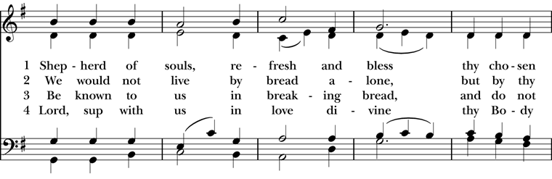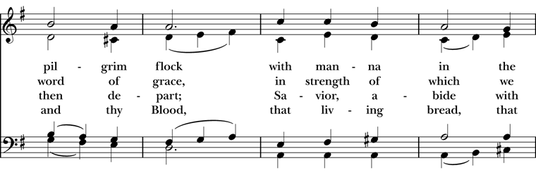
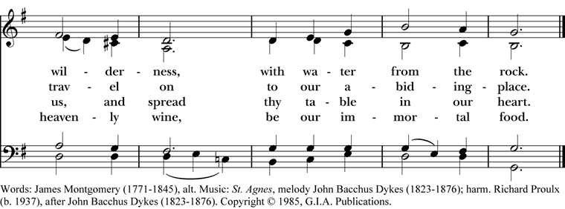
Doxology
The Great Thanksgiving – Eucharistic Prayer B
The people remain standing.
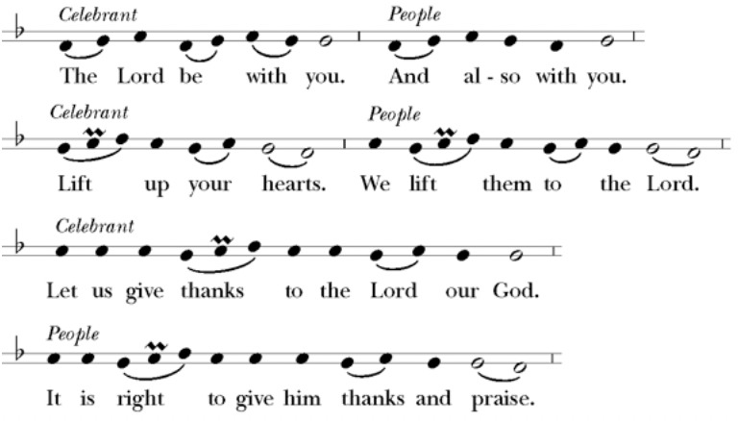
Then, facing the Holy Table, the Celebrant proceeds
It is right, and a good and joyful thing, always and every- where to give thanks to you, Father Almighty, Creator of heaven and earth.
Here a Proper Preface is sung or said on all Sundays, and on other occasions as appointed.
Therefore we praise you, joining our voices with Angels and Archangels and with all the company of heaven, who for ever sing this hymn to proclaim the glory of your Name:
Celebrant and People

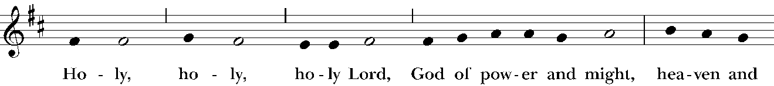

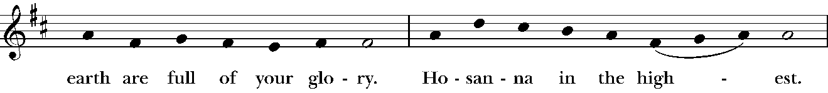

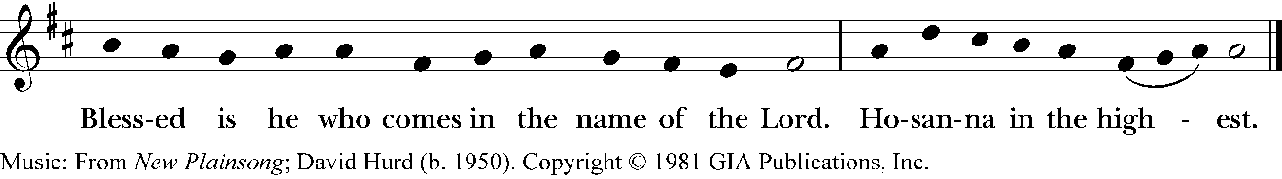

The people stand or kneel.
The Celebrant continues
We give thanks to you, O God, for the goodness and love which you have made known to us in creation; in the calling of Israel to be your people; in your Word spoken through the prophets; and above all in the Word made flesh, Jesus, your Son. For in these last days you sent him to be incarnate from the Virgin Mary, to be the Savior and Redeemer of the world. In him, you have delivered us from evil, and made us worthy to stand before you. In him, you have brought us out of error into truth, out of sin into righteousness, out of death into life.

At the following words concerning the bread, the Celebrant is to hold it, or lay a hand upon it; and at the words concerning the cup, to hold or place a hand upon the cup and any other vessel containing wine to be consecrated.

On the night he was handed over to suffering and death, our Lord Jesus Christ took bread; and when he had given thanks to you, he broke it, and gave it to his disciples, and said, “Take, eat: This is my Body, which is given for you. Do this for the remembrance of me.”

After supper he took the cup of wine; and when he had given thanks, he gave it to them, and said, “Drink this, all of you: This is my Blood of the new Covenant, which is shed for you and for many for the forgiveness of sins. Whenever you drink it, do this for the remembrance of me.”

Therefore, according to his command, O Father,

Celebrant and People

We remember his death,
We proclaim his resurrection,
We await his coming in glory;
The Celebrant continues

And we offer our sacrifice of praise and thanksgiving to you, O Lord of all; presenting to you, from your creation, this bread and this wine.

We pray you, gracious God, to send your Holy Spirit upon these gifts that they may be the Sacrament of the Body of Christ and his Blood of the new Covenant. Unite us to your Son in his sacrifice, that we may be acceptable through him, being sanctified by the Holy Spirit. In the fullness of time, put all things in subjection under your Christ, and bring us to that heavenly country where, with all your saints, we may enter the everlasting heritage of your sons and daughters; through Jesus Christ our Lord, the firstborn of all creation, the head of the Church, and the author of our salvation.

By him, and with him, and in him, in the unity of the Holy Spirit all honor and glory is yours, Almighty Father, now and for ever.

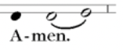
Celebrant
And now, as our Savior
Christ has taught us,
we are bold to say,
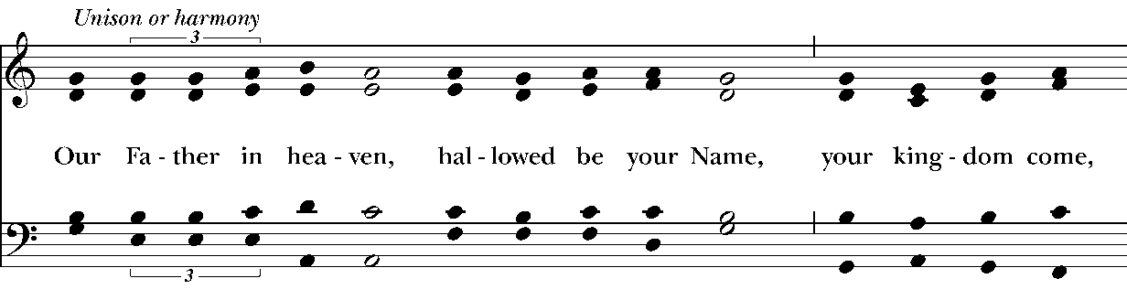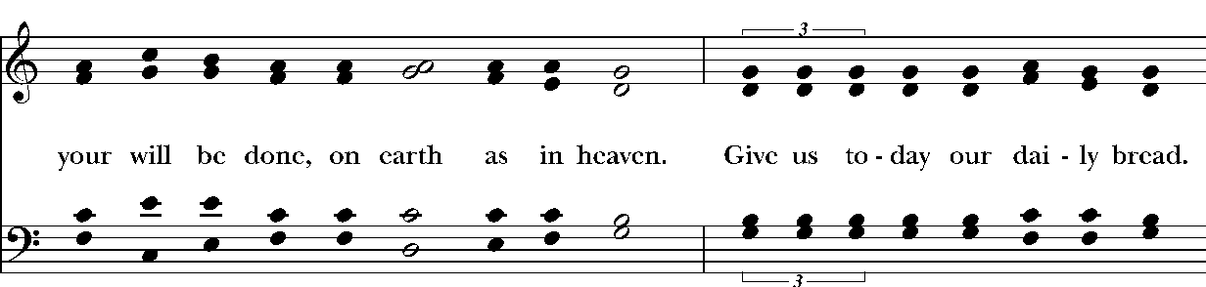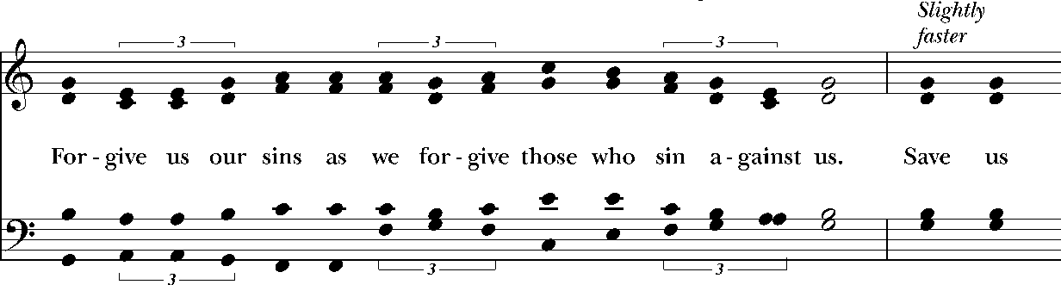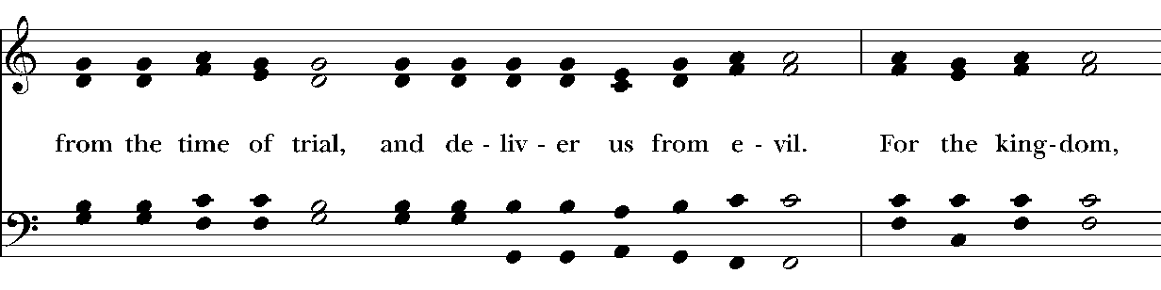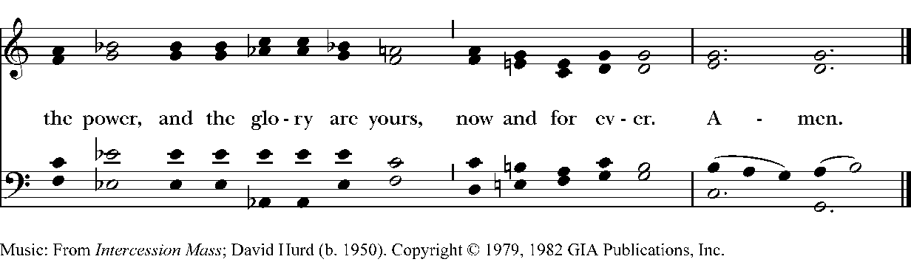
The Breaking of the Bread

The Celebrant breaks the consecrated Bread.

A period of silence is kept.

Then may be sung or said
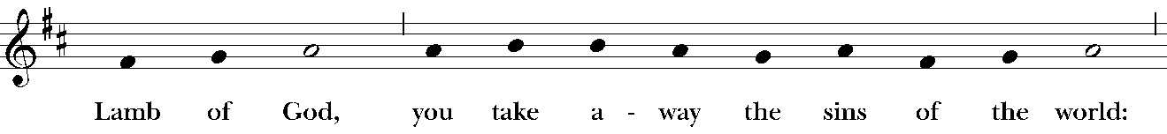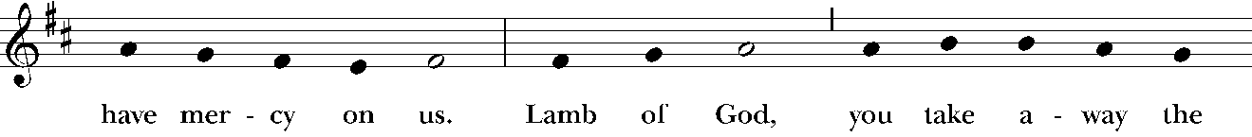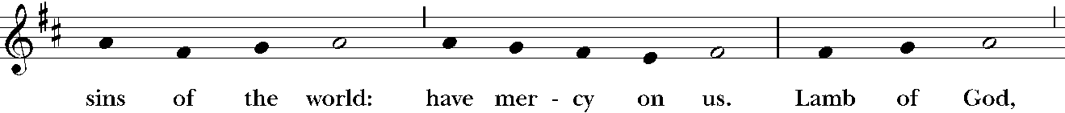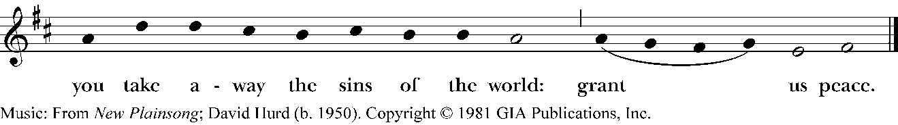

Facing the people, the Celebrant says the following Invitation
The Gifts of God for the People of God.
and may add Take them in remembrance that Christ died for
you, and feed on him in your hearts by faith,
with thanksgiving.
The ministers immediately deliver the Sacrament to the people.
The Sacrament is given to the communicants with these words
The Body of Christ, the bread of heaven. [Amen.]
The Blood of Christ, the cup of salvation. [Amen.]
Hymn 685 – Rock of Ages, Cleft For Me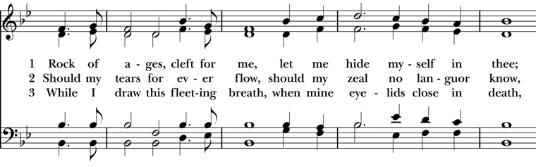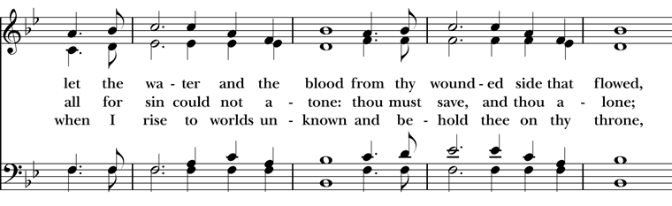
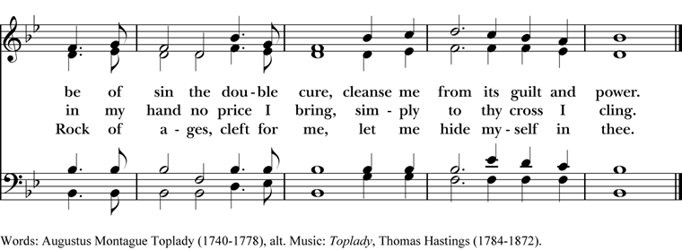

After communion the Celebrant says
Let us pray.
Celebrant and People
Eternal God, heavenly Father,
you have graciously accepted us as living members
of your Son our Savior Jesus Christ,
and you have fed us with spiritual food
in the Sacrament of his Body and Blood.
Send us now into the world in peace,
and grant us strength and courage
to love and serve you
with gladness and singleness of heart;
through Christ our Lord. Amen.
The Celebrant may bless the people.
Hymnal 690 – Guide me, O thou great Jehovah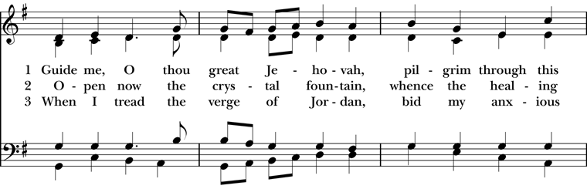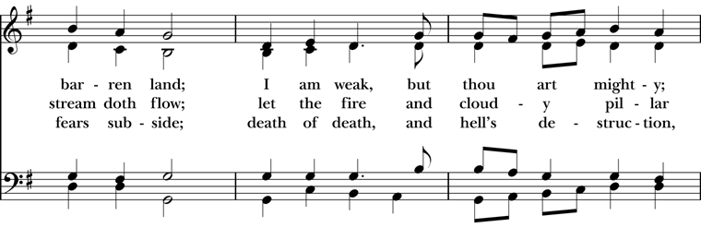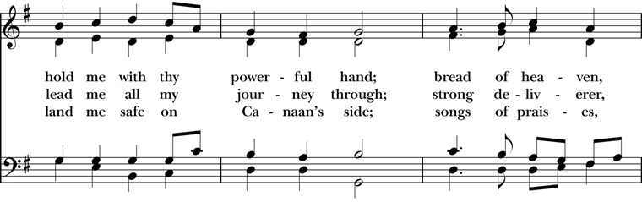
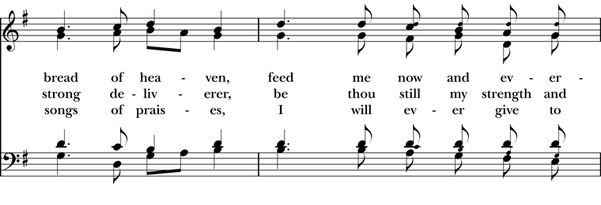
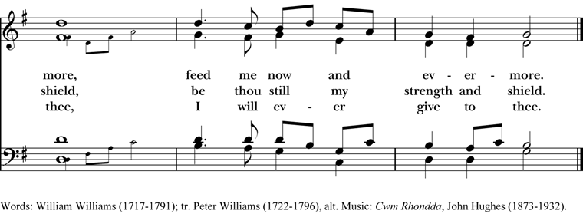

Deacon Let us go forth in the name of Christ.
People Thanks be to God.
Postlude

Announcements
Lenten Soup Supper and Program
Our Lenten Soup Supper and Program will continue for the next three Wednesday evenings of Lent at 6pm. We, as before, will begin with a simple meal followed by an opportunity for learning and formation.
This year’s program is an exploration of spiritual practices that deepen one’s life journey. The remaining topics are: Service, Stewardship, and Meditation. A signup sheet is in the Parish Hall to bring food items: Soup, Bread, and Fruit. Please join us. It should be an enjoyable and informative experience.
Please join us. It should be an enjoyable and informative experience.
Fellowship Book Group
Please join us for fellowship and lively discussion. We start with fellowship at 6:00 pm and discussion starts at 6:30 pm. We’d love to have you join us. The next meeting will be on our usual meeting day, (4th Monday of the month) March 23, 2026 via zoom.
The Zoom link and passcode are:
Meeting ID: 82826550583
Passcode: 121698
The book for March will be "You Better Be Lightning", by Andrea Gibson. (Available for order at various used bookstores, Audible, or possibly at your local library)
You Better Be Lightning ranges from close examination of the deeply personal to the vastness of the world, exploring the expansiveness of the human experience from love to illness, from space to climate change, and so much more in between. One of the most celebrated poets and performers of the last two decades, Andrea Gibson's trademark honesty and vulnerability are on full display, welcoming and inviting listeners to be just as they are.
We are providing the title of the book chosen for the next month, so readers will have time to get on library wait lists or plan for any ordering backlog. The book for April will be “Remarkably Bright Creatures”, by Shelby Van Pelt.
Questions? Speak with any of the following: Shelly Fairbanks, DeeDee Fournier, Jen Killion, Melinda Jackson
Monthly Financial Update
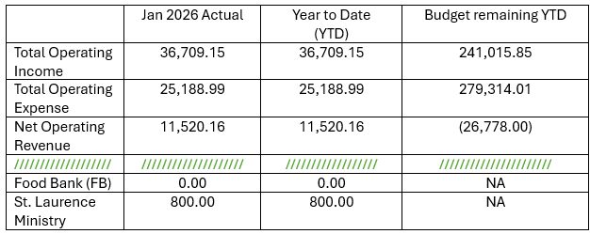
Soup Kitchen
Susan Myers and Deacon Linda
Thank you to the volunteers for providing the food: Maria H. for providing soup; Steve A. for providing fruit; Rick B. and Steve A. for serving; Susan M. for assisting in the kitchen; Sue G. and Barb J. for serving at the Hospitality Table.
This week's totals:

People served: 8
Bus passes given out: 0
How many picked up mail: 3
Toiletries given out: 7
Socks given away: 1

We need volunteers to provide soup, fruit, bread or dessert for Wednesdays in March. We are also in need of volunteers to serve the food. Please sign up on the Soup Kitchen form on the Communications Board in the parish hall.
Food donations can be bought on Sunday mornings or on Wednesdays before 10:00 am. Just mark them “Soup Kitchen”.
We also need volunteers to sit at the Hospitality Table and welcome people in and offer health care products or bus tickets. Duties are very easy and simple and you would normally serve 1 or 2 times a month. Contact Deacon Linda.
Items we always need for the health care basket are toothpaste, toothbrushes, shaving cream, razors, shampoo, hair conditioner, body lotion, small Kleenex packets, and deodorant. Most of these items are available and affordable at the Dollar Tree.
“And do not forget to do good and to share with others, for with such sacrifices God is pleased.” Hebrews 13:16
Puyallup Food Bank Donations
Since this month has St. Patrick's Day, let's think about items we can give to the Food Bank that might help people mark the holiday? Here are just a couple ideas:

- Green Jello
- Green tea
- Green beans
- Other shelf stable items that are green anything you would like to donate 🙂

As always, any monies you would like to donate, can be put in the collection plate or mailed to the church office. Please mark it for the food bank. That way the office knows where the money belongs.
Thank you for bringing a spark of hope and help to our neighbors! 💖
Judy Hansen, Vestry Outreach
Sock Drive on Palm Sunday March 29
Deacon Linda
Luke 19:36: As he rode along, the crowds spread out their garments on the road ahead of him.
Instead of garments we are asking the crowds for socks. Everyone should have access to new, clean socks year-round for all ailments and conditions they may have. Lack of new, clean socks is the plight of the homeless, the poor and anyone in need, and the health issues they have often due to poor podiatric hygiene because they lack something as basic as a pair of new, clean socks.
How can you help? Donate socks. (Right now Christ Church is completely out of socks.) Please bring a pair of new, clean socks to donate to those in need on Palm Sunday, March 29 at both services. Volunteers will stand at the entry door into the sanctuary. There will be baskets available to put the new socks in. The socks will be distributed through Christ Church's Wednesday Hospitality Table to those in need.
Thank you for considering helping others.
Readers Needed For Stations of the Cross
On Wednesday, April 1, at noon and 6:30 pm, make your pilgrimage to the Stations of the Cross. Christians have been making the pilgrimage to Jerusalem for centuries to walk the Stations of the Cross and follow Jesus’ footsteps.
Very early on in Christianity people went around the city and marked the places that they believed Jesus had walked on his way to the cross. This became the Stations of the Cross. Christ Church's Stations of the Cross are meant to assist us as we attempt to grasp the significance of Jesus walking towards the cross and dying so that the world could be redeemed. These stations are particularly powerful as we become one with Jesus on this reflective day.
Readers are needed on Wednesday, April 1 at both services to read at each of the 14 stations. Please sign up on the clipboard on the table just outside the Sanctuary door.
Maundy Thursday Agape Supper Sign Up
As is traditional for the day, there will be an Agape Supper on Maundy Thursday, April 3, after the 6:30 pm service.
Volunteers are needed to provide Pita bread, Eastern cheeses (Feta, Provolone, etc.) Dried Fruit (Apricots, Prunes, Raisins, Dates, etc.), olives, sparkling cider, set up and clean up.
﻿Please check the sign-up sheet on the table in the parish hall to help.
Maundy Thursday to Good Friday Prayer Vigil
What is a Vigil?
To be on a vigil is to be wakeful for a purpose. This Holy Week Christ Church will have a Prayer Vigil following our Maundy Thursday liturgy (Agapé meal, washing of feet, and stripping of the altar) on Thursday, Apri 2. This will be a vigil until the start of the Good Friday noon church service on April 3. The vigil can occur in your homes during the night.
The Words of Jesus
“Could you not keep awake one hour?” were the words of Jesus in reproach to his followers. We are now the ones who get an opportunity to stay awake and pray.
You are welcome to use your favorite book of prayers, read any of the Psalms, or any of the Gospels of the readings for Holy Week. It is a time to be in conversation with God. While it may be a challenge, it can be a wonder-filled, grace-filled blessing.
Gospels of Holy Week: John 12:1-11, John 12:20-36, John 13:21-32, John 13:1-17, 31b-35, John 18:1-19:42, Matthew 27:57-66, John 19:38-42.
Please sign up on the Night Watch Prayer Vigil list and indicate where you will be doing the night watch either at home or at the church at the Meditation space in the parish hall. If you plan to come to the church on Friday morning to pray, please write that on the sign up list so we can have someone to let you into the church. Any questions? Contact Deacon Linda
Today’s Ministers of Worship

Celebrant: The Rev. Mike Mayor
Deacon: The Rev. Linda Potter
Lectors: Sayre Steere, David Steere
Acolyte: Brian Davidek
Eucharistic Minister: Jeremy Duplissey
Livestream Coordinator: Jeremy Duplissey
Nursery Attendants: Barry O'Brien, Melinda Jackson
Pianist: Vicki Melton
Usher: Jean Hissong
Greeters: Carla Golden, DeeDee Fournier, Helen Godwin, Christine Scholer, Tiffany Richards
Closer: Lynn Sissel
Altar Guild: Christine Scholer, Jean Irey
Music permission through OneLicense #A-706918


Scan to give online. All payments are processed through Paypal.
Christ Episcopal Church
A congregation of the Episcopal Diocese of Olympia
Bishop – The Rt. Rev. Philip N. LaBelle
Rector – The Rev. Mike Mayor
Vestry
Sr. Warden – Shelly Fairbanks
Jr. Warden for Property – Jeremy Duplissey
Jr. Warden for Communication – Barry O’Brien
Treasurer – Melinda Jackson
Clerk – Tanya Elder
Member – Steve Angelo
Member – Roddi Barton
Member – Maria Haack
Member – Susan Myers
Member – Dave Steere
Member – Rolin Stone
210 5th St. SW | Puyallup, WA | 98371
253-848-2323 | office@episcopallup.com
www.episcopallup.com

