Fifth Sunday in Lent
Holy Eucharist, Rite II

10:00 am – March 22, 2026

Welcome to Christ Church
We are so happy you have chosen to come and participate in worship this morning. Your presence today strengthens the Body of Christ, not only here but throughout the world.
Land Acknowledgment
Christ Church acknowledges that we gather on the traditional homeland of the Puyallup Tribe. The Puyallup people have lived on and stewarded these lands since the beginning of time, and continue to do so today. We honor and give thanks for the land itself and the life of all the indigenous peoples of this area.
New to Christ Church?
Welcome to Christ Episcopal Church of Puyallup. Wherever you are on your spiritual journey, you are welcome here! We invite you to sign our guestbook, visit our website (www.episcopallup.com) or connect with one of the clergy.
Questions?
Please ask. The ushers (one of the persons who gave you a bulletin) can answer your questions or concerns. Restrooms are available in the hallway to the west of the worship space.
About our Liturgy
Worship lies at the heart of the Christian life. It is in worship that we express our theology and define our identity. We encounter God within worship and are formed and transformed as the people of God. One of the hallmarks of the Episcopal Church is its liturgical worship. Liturgy literally is “the work of the people,” and refers to the patterns, forms, words, and actions through which public worship is conducted.

Prelude- Siciliana Cimarosa
Hymnal 388– O worship the King, all glorious above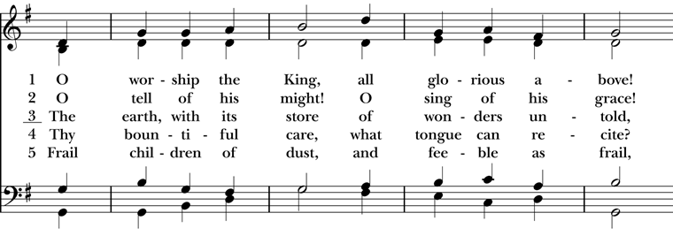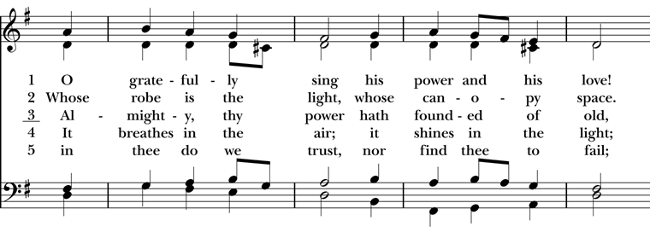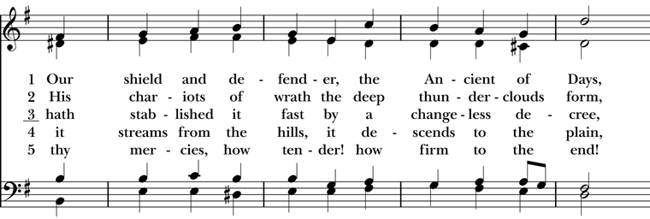
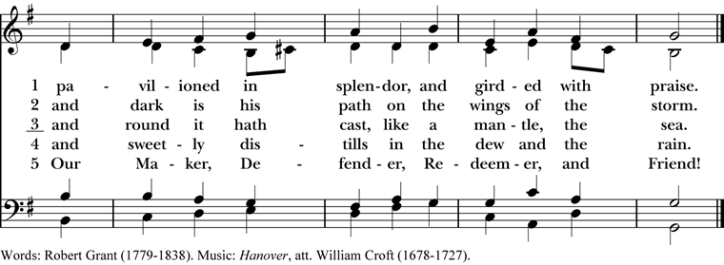
The people standing, the Celebrant says
Bless the Lord who forgives all our sins.
People God’s mercy endures for ever.

The decalogue may be said here
Hear the commandments of God to his people:
I am the Lord your God who brought you out of bondage.
You shall have no other gods but me.
Amen. Lord have mercy.
You shall not make for yourself any idol.
Amen. Lord have mercy.
You shall not invoke with malice the Name of the Lord your God.
Amen. Lord have mercy.
Remember the Sabbath Day and keep it holy.
Amen. Lord have mercy.
Honor your father and your mother.
Amen. Lord have mercy.
You shall not commit murder.
Amen. Lord have mercy.
You shall not commit adultery.
Amen. Lord have mercy.
You shall not steal.
Amen. Lord have mercy.
You shall not be a false witness.
Amen. Lord have mercy.
You shall not covet anything that belongs to your neighbor.
Amen. Lord have mercy.
The Celebrant may read one of the following sentences
Jesus said, “The first commandment is this: Hear, O Israel: The Lord our God is the only Lord. Love the Lord your God with all your heart, with all your soul, with all your mind, and with all your strength. The second is this: Love your neighbor as yourself. There is no other commandment greater than these.” Mark 12:29-31
If we say that we have no sin, we deceive ourselves, and the truth is not in us. But if we confess our sins, God, who is faithful and just, will forgive our sins and cleanse us from all unrighteousness. 1 John 1:8,9
Since we have a great high priest who has passed through the heavens, Jesus, the Son of God, let us with confidence draw near to the throne of grace, that we may receive mercy and find grace to help in time of need. Hebrews 4:14, 16

The Deacon or Celebrant then says
Let us confess our sins against God and our neighbor.

Silence may be kept.

Minister and People
Most merciful God,
we confess that we have sinned against you
in thought, word, and deed,
by what we have done,
and by what we have left undone.
We have not loved you with our whole heart;
we have not loved our neighbors as ourselves.
We are truly sorry and we humbly repent.
For the sake of your Son Jesus Christ,
have mercy on us and forgive us;
that we may delight in your will,
and walk in your ways,
to the glory of your Name. Amen.

The Bishop when present, or the Priest, stands and says
Almighty God have mercy on you, forgive you all your sins through our Lord Jesus Christ, strengthen you in all goodness, and by the power of the Holy Spirit keep you in eternal life. Amen.
When appointed, the following hymn or some other song of praise is sung or said, all standing

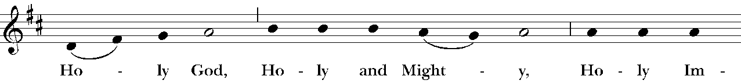

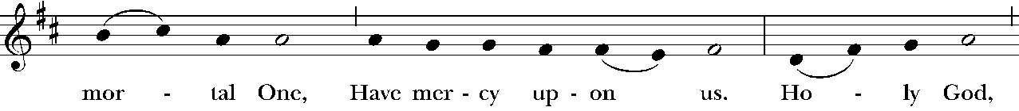

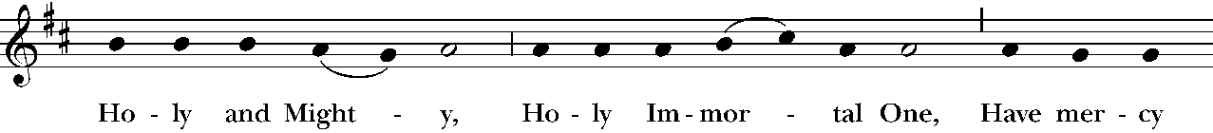

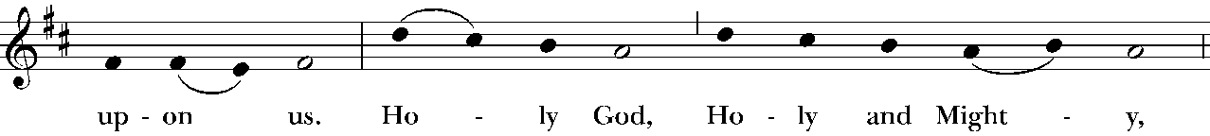

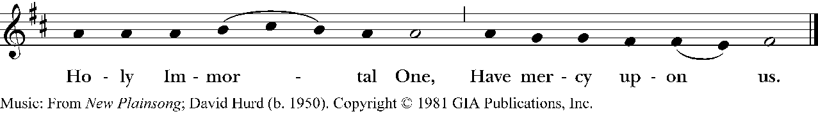

The Collect of the Day

The Celebrant says to the people
The Lord be with you.
People And also with you.
Celebrant Let us pray.
Almighty God, you alone can bring into order the unruly wills and affections of sinners: Grant your people grace to love what you command and desire what you promise; that, among the swift and varied changes of the world, our hearts may surely there be fixed where true joys are to be found; through Jesus Christ our Lord, who lives and reigns with you and the Holy Spirit, one God, now and for ever. Amen.
The Lessons

The people sit. One or two lessons, as appointed, are read, the Reader first saying
A Reading from the Prophet Ezekiel (37:1-14)

The hand of the Lord came upon me, and he brought me out by the spirit of the Lord and set me down in the middle of a valley; it was full of bones. He led me all around them; there were very many lying in the valley, and they were very dry. He said to me, “Mortal, can these bones live?” I answered, “O Lord God, you know.” Then he said to me, “Prophesy to these bones, and say to them: O dry bones, hear the word of the Lord. Thus says the Lord God to these bones: I will cause breath to enter you, and you shall live. I will lay sinews on you, and will cause flesh to come upon you, and cover you with skin, and put breath in you, and you shall live; and you shall know that I am the Lord.” So I prophesied as I had been commanded; and as I prophesied, suddenly there was a noise, a rattling, and the bones came together, bone to its bone. I looked, and there were sinews on them, and flesh had come upon them, and skin had covered them; but there was no breath in them. Then he said to me, “Prophesy to the breath, prophesy, mortal, and say to the breath: Thus says the Lord God: Come from the four winds, O breath, and breathe upon these slain, that they may live.” I prophesied as he commanded me, and the breath came into them, and they lived, and stood on their feet, a vast multitude. Then he said to me, “Mortal, these bones are the whole house of Israel. They say, ‘Our bones are dried up, and our hope is lost; we are cut off completely.’ Therefore prophesy, and say to them, Thus says the Lord God: I am going to open your graves, and bring you up from your graves, O my people; and I will bring you back to the land of Israel. And you shall know that I am the Lord, when I open your graves, and bring you up from your graves, O my people. I will put my spirit within you, and you shall live, and I will place you on your own soil; then you shall know that I, the Lord, have spoken and will act,” says the Lord. The Word of the Lord.
People Thanks be to God.

Silence may follow

Psalm 130

1 Out of the depths have I called to you, O Lord;
Lord, hear my voice; *
let your ears consider well the voice of my supplication.

2 If you, Lord, were to note what is done amiss, *
O Lord, who could stand?

3 For there is forgiveness with you; *
therefore you shall be feared.

4 I wait for the Lord; my soul waits for him; *
in his word is my hope.

5 My soul waits for the Lord,
more than watchmen for the morning, *
more than watchmen for the morning.

6 O Israel, wait for the Lord, *
for with the Lord there is mercy;

7 With him there is plenteous redemption, *
and he shall redeem Israel from all their sins.

Silence may follow.
A Reading from the Paul’s letter to the Romans (8:6-11)
To set the mind on the flesh is death, but to set the mind on the Spirit is life and peace. For this reason the mind that is set on the flesh is hostile to God; it does not submit to God's law-- indeed it cannot, and those who are in the flesh cannot please God. But you are not in the flesh; you are in the Spirit, since the Spirit of God dwells in you. Anyone who does not have the Spirit of Christ does not belong to him. But if Christ is in you, though the body is dead because of sin, the Spirit is life because of righteousness. If the Spirit of him who raised Jesus from the dead dwells in you, he who raised Christ from the dead will give life to your mortal bodies also through his Spirit that dwells in you.
The Word of the Lord.
People Thanks be to God.
Silence may follow.

Hymnal 455– O Love of God
Deacon The Holy Gospel of our Lord Jesus Christ
according to (John 11:1-45)
People Glory to you, Lord Christ.
Now a certain man was ill, Lazarus of Bethany, the village of Mary and her sister Martha. Mary was the one who anointed the Lord with perfume and wiped his feet with her hair; her brother Lazarus was ill. So the sisters sent a message to Jesus, “Lord, he whom you love is ill.” But when Jesus heard it, he said, “This illness does not lead to death; rather it is for God’s glory, so that the Son of God may be glorified through it.” Accordingly, though Jesus loved Martha and her sister and Lazarus, after having heard that Lazarus was ill, he stayed two days longer in the place where he was. Then after this he said to the disciples, “Let us go to Judea again.” The disciples said to him, “Rabbi, the Jews were just now trying to stone you, and are you going there again?” Jesus answered, “Are there not twelve hours of daylight? Those who walk during the day do not stumble, because they see the light of this world. But those who walk at night stumble, because the light is not in them.” After saying this, he told them, “Our friend Lazarus has fallen asleep, but I am going there to awaken him.” The disciples said to him, “Lord, if he has fallen asleep, he will be all right.” Jesus, however, had been speaking about his death, but they thought that he was referring merely to sleep. Then Jesus told them plainly, “Lazarus is dead. For your sake I am glad I was not there, so that you may believe. But let us go to him.” Thomas, who was called the Twin, said to his fellow disciples, “Let us also go, that we may die with him.” When Jesus arrived, he found that Lazarus had already been in the tomb four days. Now Bethany was near Jerusalem, some two miles away, and many of the Jews had come to Martha and Mary to console them about their brother. When Martha heard that Jesus was coming, she went and met him, while Mary stayed at home. Martha said to Jesus, “Lord, if you had been here, my brother would not have died. But even now I know that God will give you whatever you ask of him.” Jesus said to her, “Your brother will rise again.” Martha said to him, “I know that he will rise again in the resurrection on the last day.” Jesus said to her, “I am the resurrection and the life. Those who believe in me, even though they die, will live, and everyone who lives and believes in me will never die. Do you believe this?” She said to him, “Yes, Lord, I believe that you are the Messiah, the Son of God, the one coming into the world.” When she had said this, she went back and called her sister Mary, and told her privately, “The Teacher is here and is calling for you.” And when she heard it, she got up quickly and went to him. Now Jesus had not yet come to the village, but was still at the place where Martha had met him. The Jews who were with her in the house, consoling her, saw Mary get up quickly and go out. They followed her because they thought that she was going to the tomb to weep there. When Mary came where Jesus was and saw him, she knelt at his feet and said to him, “Lord, if you had been here, my brother would not have died.” When Jesus saw her weeping, and the Jews who came with her also weeping, he was greatly disturbed in spirit and deeply moved. He said, “Where have you laid him?” They said to him, “Lord, come and see.” Jesus began to weep. So the Jews said, “See how he loved him!” But some of them said, “Could not he who opened the eyes of the blind man have kept this man from dying?” Then Jesus, again greatly disturbed, came to the tomb. It was a cave, and a stone was lying against it. Jesus said, “Take away the stone.” Martha, the sister of the dead man, said to him, “Lord, already there is a stench because he has been dead four days.” Jesus said to her, “Did I not tell you that if you believed, you would see the glory of God?” So they took away the stone. And Jesus looked upward and said, “Father, I thank you for having heard me. I knew that you always hear me, but I have said this for the sake of the crowd standing here, so that they may believe that you sent me.” When he had said this, he cried with a loud voice, “Lazarus, come out!” The dead man came out, his hands and feet bound with strips of cloth, and his face wrapped in a cloth. Jesus said to them, “Unbind him, and let him go.” Many of the Jews therefore, who had come with Mary and had seen what Jesus did, believed in him.
After the Gospel, the Reader says
The Gospel of the Lord.
People Praise to you, Lord Christ.
The Sermon The Rev. Mike Mayor

All standing
The Nicene Creed
We believe in one God,
the Father, the Almighty,
maker of heaven and earth,
of all that is, seen and unseen.
We believe in one Lord, Jesus Christ,
the only Son of God,
eternally begotten of the Father,
God from God, Light from Light,
true God from true God,
begotten, not made,
of one Being with the Father.
Through him all things were made.
For us and for our salvation
he came down from heaven:
by the power of the Holy Spirit
he became incarnate from the Virgin Mary,
and was made man.
For our sake he was crucified under Pontius Pilate;
he suffered death and was buried.
On the third day he rose again
in accordance with the Scriptures;
he ascended into heaven
and is seated at the right hand of the Father.
He will come again in glory to judge the living and the dead,
and his kingdom will have no end.
We believe in the Holy Spirit, the Lord, the giver of life,
who proceeds from the Father and the Son.
With the Father and the Son he is worshiped and glorified.
He has spoken through the Prophets.
We believe in one holy catholic and apostolic Church.
We acknowledge one baptism for the forgiveness of sins.
We look for the resurrection of the dead,
and the life of the world to come. Amen.
The Prayers of the People – Form III

The Leader and People pray responsively

Father, we pray for your holy Catholic Church;
That we all may be one.

Grant that every member of the Church may truly and humbly serve you;
That your Name may be glorified by all people.

We pray for all bishops, priests, and deacons;
That they may be faithful ministers of your Word and Sacraments.

We pray for all who govern and hold authority in the nations
of the world;
That there may be justice and peace on the earth.

Give us grace to do your will in all that we undertake;
That our works may find favor in your sight.

Have compassion on those who suffer from any grief or trouble;
That they may be delivered from their distress.

Give to the departed eternal rest.
Let light perpetual shine upon them.

We praise you for your saints who have entered into joy;
May we also come to share in your heavenly kingdom.

Let us pray for our own needs and those of others.

Silence

The People may add their own petitions.

For Sean, our Presiding Bishop; for Phil, our Bishop; for Mike, our priest; and for Linda, our deacon.

In our diocesan cycle of prayer, for St. Columba’s, Kent and St. John’s South Sudanese, Kent.

In our parish cycle of prayer, I ask your prayers for Craig & Lynita, Vicky, Chuck & Liz, and Lottie.

The Celebrant adds a concluding Collect.
The Peace

All stand. The Celebrant says to the people
The peace of the Lord be always with you.
People And also with you.

Then the Ministers and People may greet one another in the name of the Lord.

Offertory Hymnal 313 – Let thy Blood in mercy poured 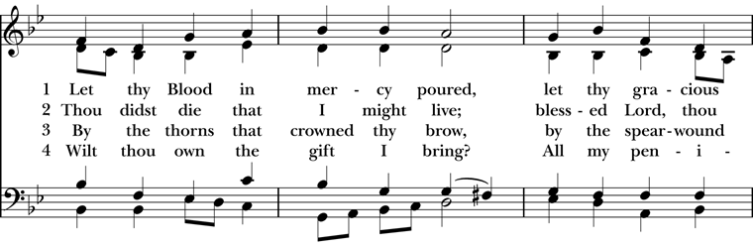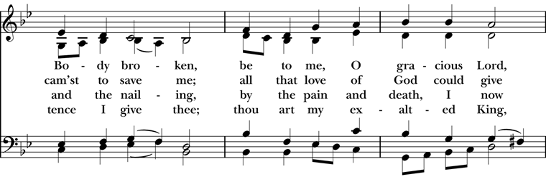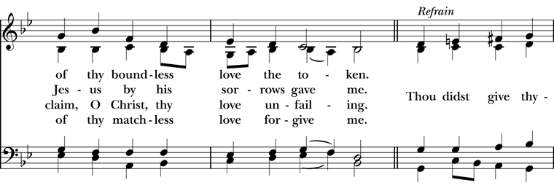
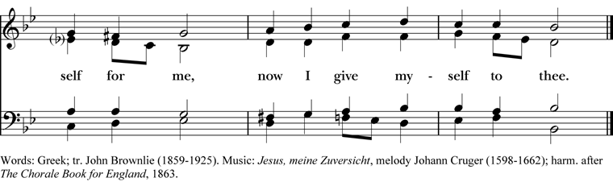

Doxology

The Great Thanksgiving – Eucharistic Prayer B
The people remain standing.
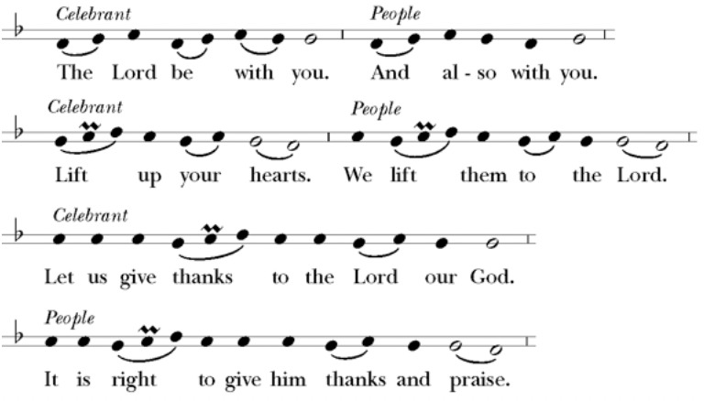
Then, facing the Holy Table, the Celebrant proceeds
It is right, and a good and joyful thing, always and every- where to give thanks to you, Father Almighty, Creator of heaven and earth.
Here a Proper Preface is sung or said on all Sundays, and on other occasions as appointed.
Therefore we praise you, joining our voices with Angels and Archangels and with all the company of heaven, who for ever sing this hymn to proclaim the glory of your Name:
Celebrant and People

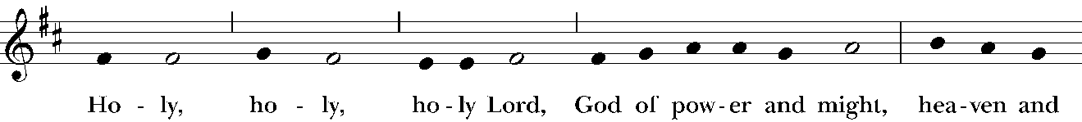

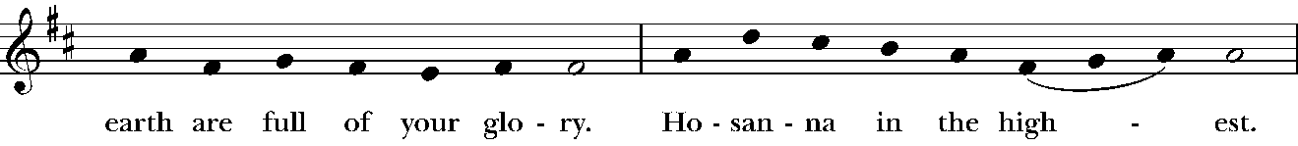

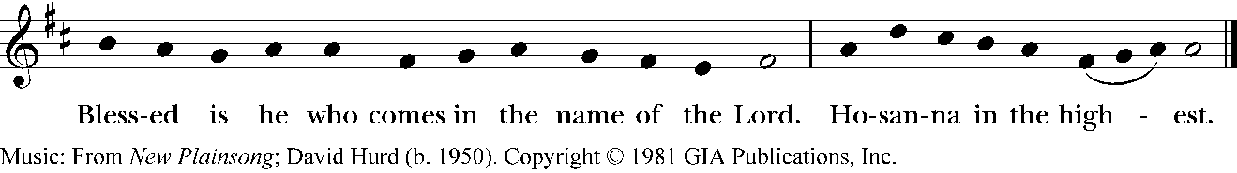

The people stand or kneel.
The Celebrant continues
We give thanks to you, O God, for the goodness and love which you have made known to us in creation; in the calling of Israel to be your people; in your Word spoken through the prophets; and above all in the Word made flesh, Jesus, your Son. For in these last days you sent him to be incarnate from the Virgin Mary, to be the Savior and Redeemer of the world. In him, you have delivered us from evil, and made us worthy to stand before you. In him, you have brought us out of error into truth, out of sin into righteousness, out of death into life.
At the following words concerning the bread, the Celebrant is to hold it, or lay a hand upon it; and at the words concerning the cup, to hold or place a hand upon the cup and any other vessel containing wine to be consecrated.

On the night he was handed over to suffering and death, our Lord Jesus Christ took bread; and when he had given thanks to you, he broke it, and gave it to his disciples, and said, “Take, eat: This is my Body, which is given for you. Do this for the remembrance of me.”

After supper he took the cup of wine; and when he had given thanks, he gave it to them, and said, “Drink this, all of you: This is my Blood of the new Covenant, which is shed for you and for many for the forgiveness of sins. Whenever you drink it, do this for the remembrance of me.”

Therefore, according to his command, O Father,

Celebrant and People

We remember his death,
We proclaim his resurrection,
We await his coming in glory;
The Celebrant continues

And we offer our sacrifice of praise and thanksgiving to you, O Lord of all; presenting to you, from your creation, this bread and this wine.

We pray you, gracious God, to send your Holy Spirit upon these gifts that they may be the Sacrament of the Body of Christ and his Blood of the new Covenant. Unite us to your Son in his sacrifice, that we may be acceptable through him, being sanctified by the Holy Spirit. In the fullness of time, put all things in subjection under your Christ, and bring us to that heavenly country where, with all your saints, we may enter the everlasting heritage of your sons and daughters; through Jesus Christ our Lord, the firstborn of all creation, the head of the Church, and the author of our salvation.

By him, and with him, and in him, in the unity of the Holy Spirit all honor and glory is yours, Almighty Father, now and for ever.

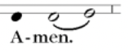
Celebrant
And now, as our Savior
Christ has taught us,
we are bold to say,
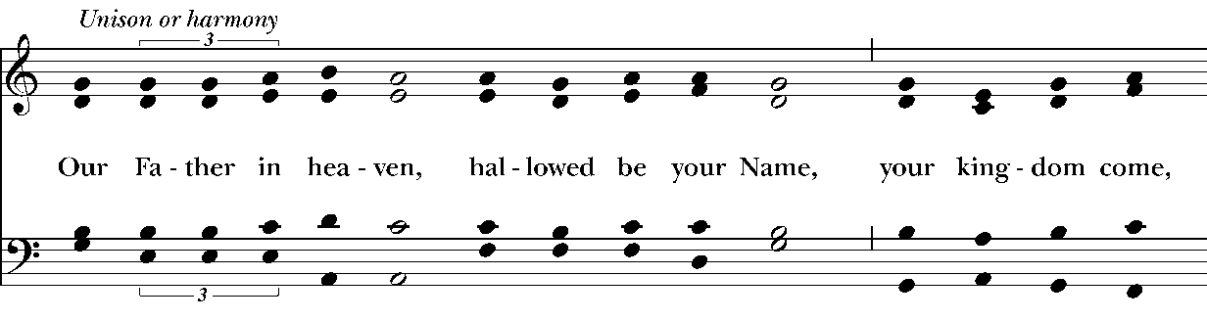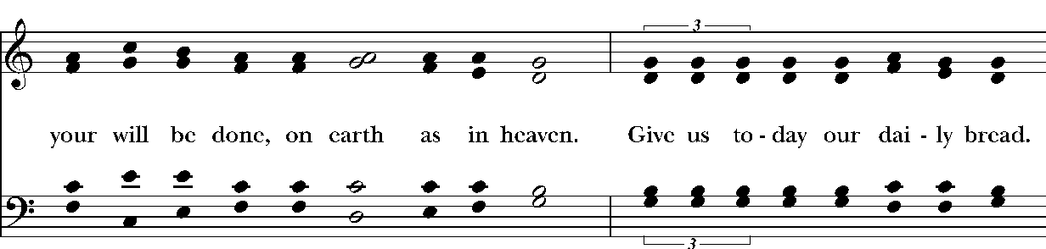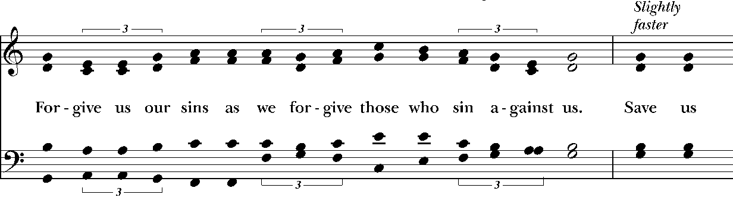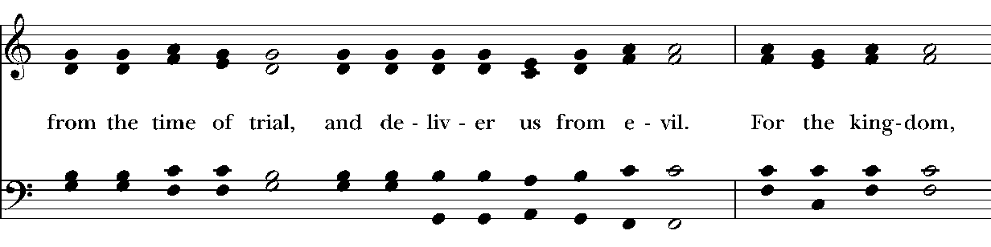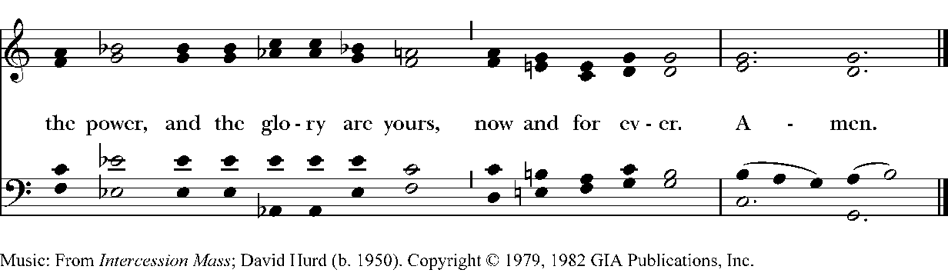
The Breaking of the Bread

The Celebrant breaks the consecrated Bread.

A period of silence is kept.

Then may be sung or said
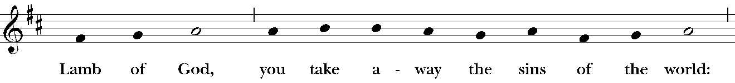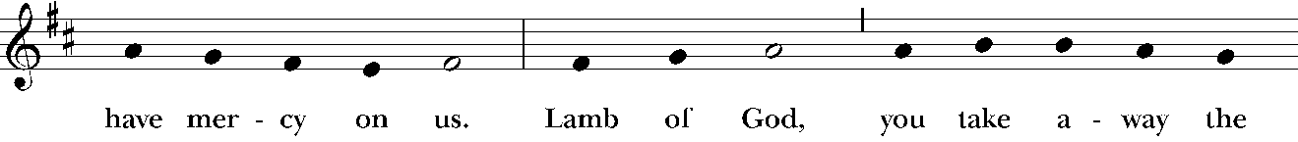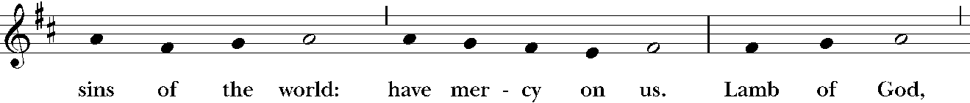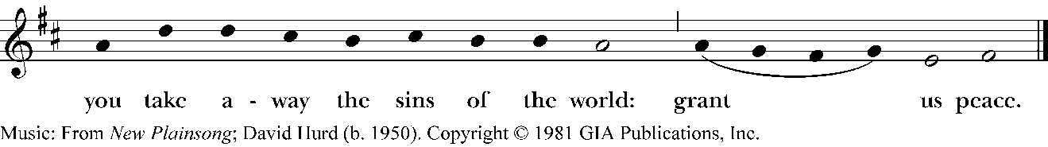
Facing the people, the Celebrant says the following Invitation
The Gifts of God for the People of God.
and may add Take them in remembrance that Christ died for
you, and feed on him in your hearts by faith,
with thanksgiving.
The ministers immediately deliver the Sacrament to the people.
The Sacrament is given to the communicants with these words
The Body of Christ, the bread of heaven. [Amen.]
The Blood of Christ, the cup of salvation. [Amen.]
Music for communion – Adagio, Concerto Opus 9 Abinoni
After communion the Celebrant says
Let us pray.
Celebrant and People
Eternal God, heavenly Father,
you have graciously accepted us as living members
of your Son our Savior Jesus Christ,
and you have fed us with spiritual food
in the Sacrament of his Body and Blood.
Send us now into the world in peace,
and grant us strength and courage
to love and serve you
with gladness and singleness of heart;
through Christ our Lord. Amen.
The Celebrant may bless the people.
Hymnal 665 – All My Hope is Founded 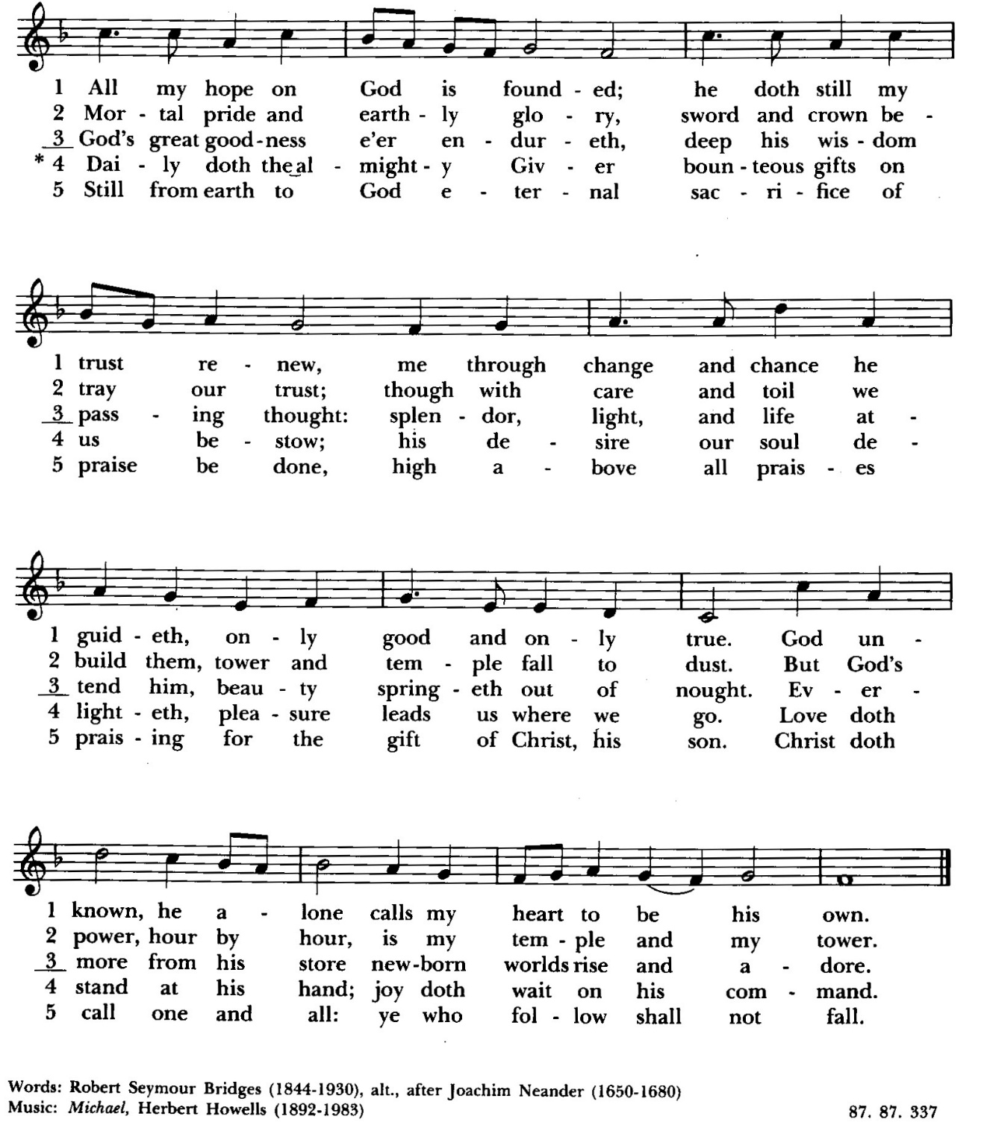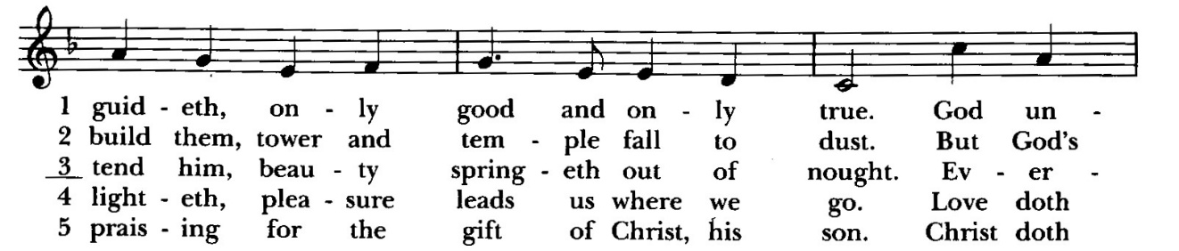
Deacon Let us go forth in the name of Christ.
People Thanks be to God.
Postlude- Plaintive Songs Grieg
Announcements
Lenten Soup Supper and Program
Our Lenten Soup Supper and Program will conclude this Wednesday evening at 6pm. We, as before, will begin with a simple meal followed by an opportunity for learning and formation. This year’s program is an exploration of spiritual practices that deepen one’s life journey. The remaining topic is Meditation. Please join us. It should be an enjoyable and informative experience.
Holy Week
Here are the opportunities for prayer and worship during the holiest week of the year: Palm Sunday, March 29 at 8:00 & 10:00 am, Stations of the Cross, April 1 at Noon & 6:30 pm, Maundy Thursday, April 2 at 6:30 pm, and Good Friday, April 3 at Noon & 6:30 pm.
Great Vigil of Easter- Saturday, April 4 @ 6:30 pm
Celebrate Easter in a tradition going back for centuries. Hear the story of God’s saving deeds in history, renew your baptismal promises, and celebrate with joy the resurrection of our Lord. Note: Incense will be used at this service.
Fellowship Book Group
Please join us for fellowship and lively discussion. We start with fellowship at 6:00 pm and discussion starts at 6:30 pm. We’d love to have you join us. The next meeting will be on our usual meeting day, (4th Monday of the month) March 23, 2026 via zoom.
The Zoom link and passcode are:
Meeting ID: 82826550583
Passcode: 121698
The book for March will be "You Better Be Lightning", by Andrea Gibson. (Available for order at various used bookstores, Audible, or possibly at your local library)
You Better Be Lightning ranges from close examination of the deeply personal to the vastness of the world, exploring the expansiveness of the human experience from love to illness, from space to climate change, and so much more in between. One of the most celebrated poets and performers of the last two decades, Andrea Gibson's trademark honesty and vulnerability are on full display, welcoming and inviting listeners to be just as they are.
We are providing the title of the book chosen for the next month, so readers will have time to get on library wait lists or plan for any ordering backlog. The book for April will be “Remarkably Bright Creatures”, by Shelby Van Pelt.
Questions? Speak with any of the following: Shelly Fairbanks, DeeDee Fournier, Jen Killion, Melinda Jackson
Soup Kitchen
Susan Myers and Deacon Linda
Thank you to the volunteers for providing the food: Maria H. for providing the soup; Jean H. for providing the bread and dessert; Rick B. for serving; Susan M. for assisting in the kitchen; Sue G. and Patti M. for serving at the Hospitality Table.
This week's totals:

People served: 15
Bus passes given out: 11
How many picked up mail: 4
Laundry packets given out: 0
Toiletries given out: 10
Socks given away: 1
We need volunteers to provide soup, fruit, bread or dessert for the next two Wednesdays in March. Please sign up on the Soup Kitchen form on the Communications Board in the parish hall.
Food donations can be bought on Sunday mornings or on Wednesdays before 10:00 am. Just mark them “Soup Kitchen”
Items we are in need of for the health care basket are tooth paste, shaving cream and razors. Most of these items are available and affordable at the Dollar Tree.
1 Peter 4:10 As each has received a gift, use it to serve one another, as good stewards of God's varied grace.
Puyallup Food Bank Donations
Since this month has St. Patrick's Day, let's think about items we can give to the Food Bank that might help people mark the holiday? Here are just a couple ideas:

- Green Jello
- Green tea
- Green beans
- Other shelf stable items that are green anything you would like to donate 🙂

As always, any monies you would like to donate, can be put in the collection plate or mailed to the church office. Please mark it for the food bank. That way the office knows where the money belongs.
Thank you for bringing a spark of hope and help to our neighbors! 💖
Maria Haack, Vestry Outreach
Sock Drive on Palm Sunday March 29
Deacon Linda
Luke 19:36: As he rode along, the crowds spread out their garments on the road ahead of him.
Instead of garments we are asking the crowds for socks. Everyone should have access to new, clean socks year-round for all ailments and conditions they may have. Lack of new, clean socks is the plight of the homeless, the poor and anyone in need, and the health issues they have often due to poor podiatric hygiene because they lack something as basic as a pair of new, clean socks.
How can you help? Donate socks. (Right now Christ Church is completely out of socks.) Please bring a pair of new, clean socks to donate to those in need on Palm Sunday, March 29 at both services. Volunteers will stand at the entry door into the sanctuary. There will be baskets available to put the new socks in. The socks will be distributed through Christ Church's Wednesday Hospitality Table to those in need.
Thank you for considering helping others.
Readers Needed For Stations of the Cross
On Wednesday, April 1, at noon and 6:30 pm, make your pilgrimage to the Stations of the Cross. Christians have been making the pilgrimage to Jerusalem for centuries to walk the Stations of the Cross and follow Jesus’ footsteps.
Very early on in Christianity people went around the city and marked the places that they believed Jesus had walked on his way to the cross. This became the Stations of the Cross. Christ Church's Stations of the Cross are meant to assist us as we attempt to grasp the significance of Jesus walking towards the cross and dying so that the world could be redeemed. These stations are particularly powerful as we become one with Jesus on this reflective day.
Readers are needed on Wednesday, April 1 at both services to read at each of the 14 stations. Please sign up on the clipboard on the table just outside the Sanctuary door.
Maundy Thursday Agape Supper Sign Up
As is traditional for the day, there will be an Agape Supper on Maundy Thursday, April 3, after the 6:30 pm service.
Volunteers are needed to provide Pita bread, Eastern cheeses (Feta, Provolone, etc.) Dried Fruit (Apricots, Prunes, Raisins, Dates, etc.), olives, sparkling cider, set up and clean up.
﻿Please check the sign-up sheet on the table in the parish hall to help.
Maundy Thursday to Good Friday Prayer Vigil
What is a Vigil?
To be on a vigil is to be wakeful for a purpose. This Holy Week Christ Church will have a Prayer Vigil following our Maundy Thursday liturgy (Agapé meal, washing of feet, and stripping of the altar) on Thursday, Apri 2. This will be a vigil until the start of the Good Friday noon church service on April 3. The vigil can occur in your homes during the night.
The Words of Jesus
“Could you not keep awake one hour?” were the words of Jesus in reproach to his followers. We are now the ones who get an opportunity to stay awake and pray.
You are welcome to use your favorite book of prayers, read any of the Psalms, or any of the Gospels of the readings for Holy Week. It is a time to be in conversation with God. While it may be a challenge, it can be a wonder-filled, grace-filled blessing.
Gospels of Holy Week: John 12:1-11, John 12:20-36, John 13:21-32, John 13:1-17, 31b-35, John 18:1-19:42, Matthew 27:57-66, John 19:38-42.
Please sign up on the Night Watch Prayer Vigil list and indicate where you will be doing the night watch either at home or at the church at the Meditation space in the parish hall. If you plan to come to the church on Friday morning to pray, please write that on the sign up list so we can have someone to let you into the church. Any questions? Contact Deacon Linda
Easter Flower Donations
If you would like to donate flowers for our Easter church services, please look for the Easter Flower Form inserted into the Sunday Bulletins. Fill out the form for any thanksgiving or if the flowers are to be in memory of someone. On the memo line of your check mark "Easter Flowers" and place the check and your form in the Offering Plate. Please return the form by Sunday, March 29. Names and dedications will be included in the Easter Bulletins.
Monthly Financial Report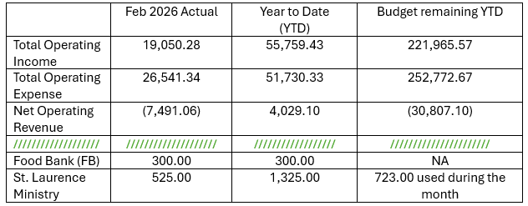

Sermon Notes

Sermon Notes

Today’s Ministers of Worship

Celebrant: The Rev. Mike Mayor
Deacon: The Rev. Linda Potter
Lectors: Diana Mears, Rolin Stone
Acolyte: Denise Quintana
Eucharistic Minister: David Steere
Livestream Coordinator: Bonnie Quintana
Nursery Attendants: Barb Johnsey, Melinda Jackson
Pianist: Vicki Melton
Usher: Sue Golden
Greeters: Carla Golden, DeeDee Fournier, Helen Godwin, Christine Scholer, Tiffany Richards
Closer: Sue Golden
Altar Guild: Sue Golden, Carla Golden, Rolin Stone
Music permission through OneLicense #A-706918


Scan to give online. All payments are processed through Paypal.
Christ Episcopal Church
A congregation of the Episcopal Diocese of Olympia
Bishop – The Rt. Rev. Philip N. LaBelle
Rector – The Rev. Mike Mayor
Vestry
Sr. Warden – Shelly Fairbanks
Jr. Warden for Property – Jeremy Duplissey
Jr. Warden for Communication – Barry O’Brien
Treasurer – Melinda Jackson
Clerk – Tanya Elder
Member – Steve Angelo
Member – Roddi Barton
Member – Maria Haack
Member – Susan Myers
Member – Dave Steere
Member – Rolin Stone
210 5th St. SW | Puyallup, WA | 98371
253-848-2323 | office@episcopallup.com
www.episcopallup.com

