Fourth Sunday in Lent
Holy Eucharist, Rite II

10:00 am – March 15, 2026

Welcome to Christ Church
We are so happy you have chosen to come and participate in worship this morning. Your presence today strengthens the Body of Christ, not only here but throughout the world.
Land Acknowledgment
Christ Church acknowledges that we gather on the traditional homeland of the Puyallup Tribe. The Puyallup people have lived on and stewarded these lands since the beginning of time, and continue to do so today. We honor and give thanks for the land itself and the life of all the indigenous peoples of this area.
New to Christ Church?
Welcome to Christ Episcopal Church of Puyallup. Wherever you are on your spiritual journey, you are welcome here! We invite you to sign our guestbook, visit our website (www.episcopallup.com) or connect with one of the clergy.
Questions?
Please ask. The ushers (one of the persons who gave you a bulletin) can answer your questions or concerns. Restrooms are available in the hallway to the west of the worship space.
About our Liturgy
Worship lies at the heart of the Christian life. It is in worship that we express our theology and define our identity. We encounter God within worship and are formed and transformed as the people of God. One of the hallmarks of the Episcopal Church is its liturgical worship. Liturgy literally is “the work of the people,” and refers to the patterns, forms, words, and actions through which public worship is conducted.
Hymnal 493– O for a thousand tongues to sing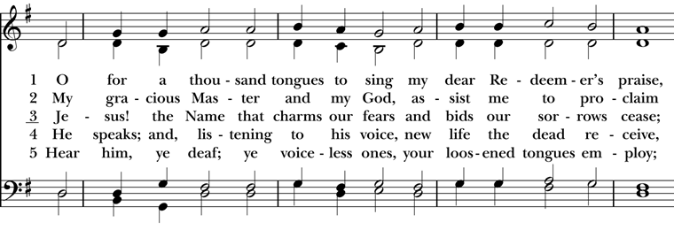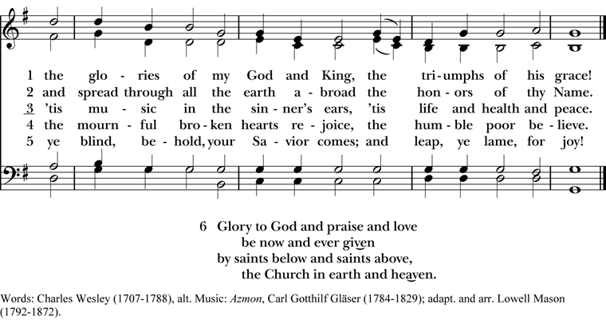
The people standing, the Celebrant says
Bless the Lord who forgives all our sins.
People God’s mercy endures for ever.

The decalogue may be said here
Hear the commandments of God to his people:
I am the Lord your God who brought you out of bondage.
You shall have no other gods but me.
Amen. Lord have mercy.
You shall not make for yourself any idol.
Amen. Lord have mercy.
You shall not invoke with malice the Name of the Lord your God.
Amen. Lord have mercy.
Remember the Sabbath Day and keep it holy.
Amen. Lord have mercy.
Honor your father and your mother.
Amen. Lord have mercy.
You shall not commit murder.
Amen. Lord have mercy.
You shall not commit adultery.
Amen. Lord have mercy.
You shall not steal.
Amen. Lord have mercy.
You shall not be a false witness.
Amen. Lord have mercy.
You shall not covet anything that belongs to your neighbor.
Amen. Lord have mercy.
The Celebrant may read one of the following sentences
Jesus said, “The first commandment is this: Hear, O Israel: The Lord our God is the only Lord. Love the Lord your God with all your heart, with all your soul, with all your mind, and with all your strength. The second is this: Love your neighbor as yourself. There is no other commandment greater than these.” Mark 12:29-31
If we say that we have no sin, we deceive ourselves, and the truth is not in us. But if we confess our sins, God, who is faithful and just, will forgive our sins and cleanse us from all unrighteousness. 1 John 1:8,9
Since we have a great high priest who has passed through the heavens, Jesus, the Son of God, let us with confidence draw near to the throne of grace, that we may receive mercy and find grace to help in time of need. Hebrews 4:14, 16

The Deacon or Celebrant then says
Let us confess our sins against God and our neighbor.

Silence may be kept.

Minister and People
Most merciful God,
we confess that we have sinned against you
in thought, word, and deed,
by what we have done,
and by what we have left undone.
We have not loved you with our whole heart;
we have not loved our neighbors as ourselves.
We are truly sorry and we humbly repent.
For the sake of your Son Jesus Christ,
have mercy on us and forgive us;
that we may delight in your will,
and walk in your ways,
to the glory of your Name. Amen.

The Bishop when present, or the Priest, stands and says
Almighty God have mercy on you, forgive you all your sins through our Lord Jesus Christ, strengthen you in all goodness, and by the power of the Holy Spirit keep you in eternal life. Amen.

When appointed, the following hymn or some other song of praise is sung or said, all standing

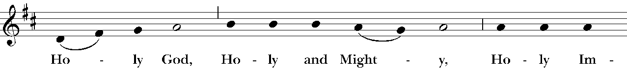

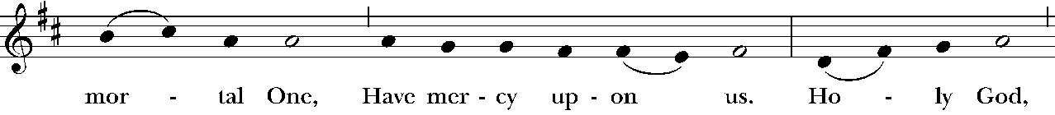

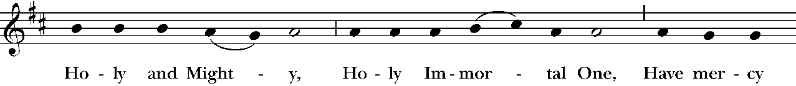

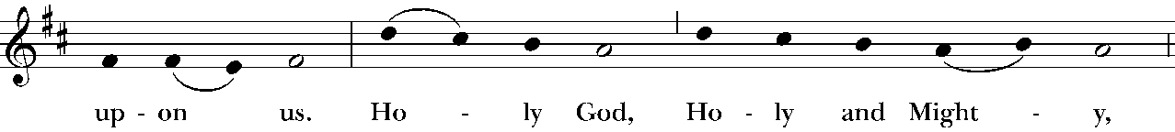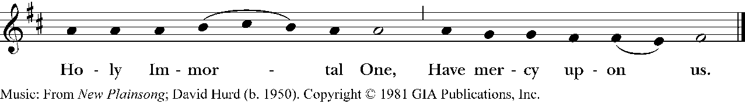

The Collect of the Day

The Celebrant says to the people
The Lord be with you.
People And also with you.
Celebrant Let us pray.
Gracious Father, whose blessed Son Jesus Christ came down from heaven to be the true bread which gives life to the world: Evermore give us this bread, that he may live in us, and we in him; who lives and reigns with you and the Holy Spirit, one God, now and for ever. Amen.

The Lessons

The people sit. One or two lessons, as appointed, are read, the Reader first saying
A Reading from the first book of Samuel (16:1-13)

The Lord said to Samuel, “How long will you grieve over Saul? I have rejected him from being king over Israel. Fill your horn with oil and set out; I will send you to Jesse the Bethlehemite, for I have provided for myself a king among his sons.” Samuel said, “How can I go? If Saul hears of it, he will kill me.” And the Lord said, “Take a heifer with you, and say, ‘I have come to sacrifice to the Lord.’ Invite Jesse to the sacrifice, and I will show you what you shall do; and you shall anoint for me the one whom I name to you.” Samuel did what the Lord commanded, and came to Bethlehem. The elders of the city came to meet him trembling, and said, “Do you come peaceably?” He said, “Peaceably; I have come to sacrifice to the Lord; sanctify yourselves and come with me to the sacrifice.” And he sanctified Jesse and his sons and invited them to the sacrifice. When they came, he looked on Eliab and thought, “Surely the Lord’s anointed is now before the Lord.” But the Lord said to Samuel, “Do not look on his appearance or on the height of his stature, because I have rejected him; for the Lord does not see as mortals see; they look on the outward appearance, but the Lord looks on the heart.” Then Jesse called Abinadab, and made him pass before Samuel. He said, “Neither has the Lord chosen this one.” Then Jesse made Shammah pass by. And he said, “Neither has the Lord chosen this one.” Jesse made seven of his sons pass before Samuel, and Samuel said to Jesse, “The Lord has not chosen any of these.” Samuel said to Jesse, “Are all your sons here?” And he said, “There remains yet the youngest, but he is keeping the sheep.” And Samuel said to Jesse, “Send and bring him; for we will not sit down until he comes here.” He sent and brought him in. Now he was ruddy, and had beautiful eyes, and was handsome. The Lord said, “Rise and anoint him; for this is the one.” Then Samuel took the horn of oil, and anointed him in the presence of his brothers; and the spirit of the Lord came mightily upon David from that day forward. Samuel then set out and went to Ramah.

The Word of the Lord.
People Thanks be to God.

Silence may follow

Psalm 23

1 The Lord is my shepherd; *
I shall not be in want.

2 He makes me lie down in green pastures *
and leads me beside still waters.

3 He revives my soul *
and guides me along right pathways for his Name's sake.

4 Though I walk through the valley of the shadow of death,
I shall fear no evil; *
for you are with me;
your rod and your staff, they comfort me.

5 You spread a table before me in the presence of those who trouble me; *
you have anointed my head with oil,
and my cup is running over.

6 Surely your goodness and mercy shall follow me all the days of my life, *
and I will dwell in the house of the Lord for ever.

Silence may follow.
A Reading from the letter of Paul to the Ephesians 5:8-14
Once you were darkness, but now in the Lord you are light. Live as children of light— for the fruit of the light is found in all that is good and right and true. Try to find out what is pleasing to the Lord. Take no part in the unfruitful works of darkness, but instead expose them. For it is shameful even to mention what such people do secretly; but everything exposed by the light becomes visible, for everything that becomes visible is light. Therefore it says, “Sleeper, awake! Rise from the dead, and Christ will shine on you.”
The Word of the Lord.
People Thanks be to God.
Silence may follow.
Hymnal 490– I want to walk as a child of the light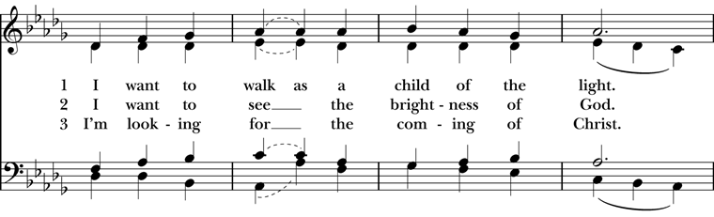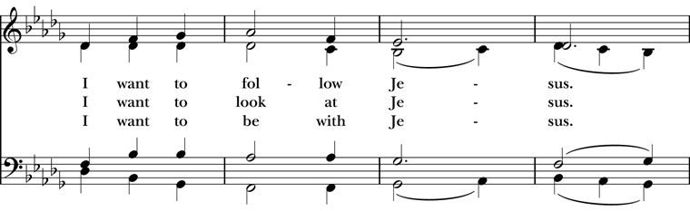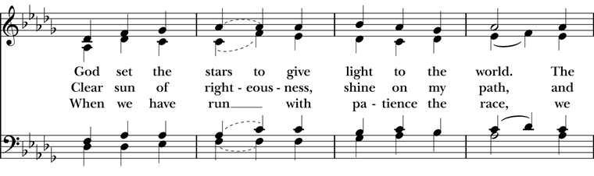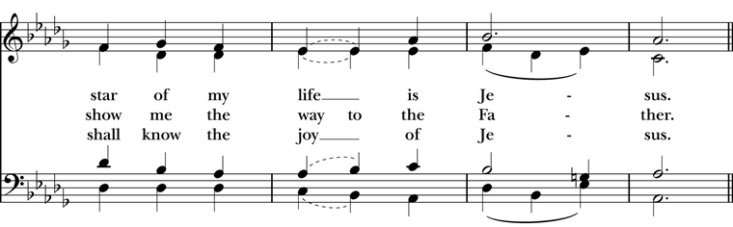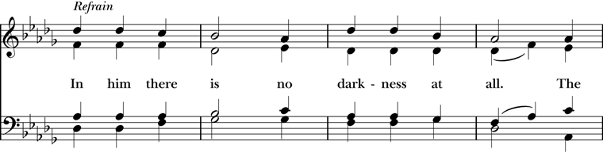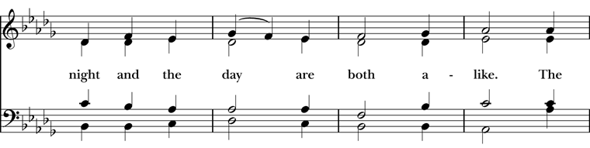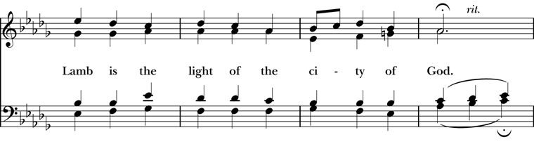
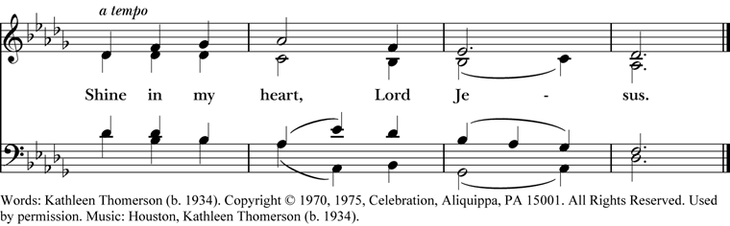
Deacon The Holy Gospel of our Lord Jesus Christ
according to (John 9:1-41)
People Glory to you, Lord Christ.
As Jesus walked along, he saw a man blind from birth. His disciples asked him, “Rabbi, who sinned, this man or his parents, that he was born blind?” Jesus answered, “Neither this man nor his parents sinned; he was born blind so that God’s works might be revealed in him. We must work the works of him who sent me while it is day; night is coming when no one can work. As long as I am in the world, I am the light of the world.” When he had said this, he spat on the ground and made mud with the saliva and spread the mud on the man’s eyes, saying to him, “Go, wash in the pool of Siloam” (which means Sent). Then he went and washed and came back able to see. The neighbors and those who had seen him before as a beggar began to ask, “Is this not the man who used to sit and beg?” Some were saying, “It is he.” Others were saying, “No, but it is someone like him.” He kept saying, “I am the man.” But they kept asking him, “Then how were your eyes opened?” He answered, “The man called Jesus made mud, spread it on my eyes, and said to me, ‘Go to Siloam and wash.’ Then I went and washed and received my sight.” They said to him, “Where is he?” He said, “I do not know.” They brought to the Pharisees the man who had formerly been blind. Now it was a sabbath day when Jesus made the mud and opened his eyes. Then the Pharisees also began to ask him how he had received his sight. He said to them, “He put mud on my eyes. Then I washed, and now I see.” Some of the Pharisees said, “This man is not from God, for he does not observe the sabbath.” But others said, “How can a man who is a sinner perform such signs?” And they were divided. So they said again to the blind man, “What do you say about him? It was your eyes he opened.” He said, “He is a prophet.” The Jews did not believe that he had been blind and had received his sight until they called the parents of the man who had received his sight and asked them, “Is this your son, who you say was born blind? How then does he now see?” His parents answered, “We know that this is our son, and that he was born blind; but we do not know how it is that now he sees, nor do we know who opened his eyes. Ask him; he is of age. He will speak for himself.” His parents said this because they were afraid of the Jews; for the Jews had already agreed that anyone who confessed Jesus to be the Messiah would be put out of the synagogue. Therefore his parents said, “He is of age; ask him.” So for the second time they called the man who had been blind, and they said to him, “Give glory to God! We know that this man is a sinner.” He answered, “I do not know whether he is a sinner. One thing I do know, that though I was blind, now I see.” They said to him, “What did he do to you? How did he open your eyes?” He answered them, “I have told you already, and you would not listen. Why do you want to hear it again? Do you also want to become his disciples?” Then they reviled him, saying, “You are his disciple, but we are disciples of Moses. We know that God has spoken to Moses, but as for this man, we do not know where he comes from.” The man answered, “Here is an astonishing thing! You do not know where he comes from, and yet he opened my eyes. We know that God does not listen to sinners, but he does listen to one who worships him and obeys his will. Never since the world began has it been heard that anyone opened the eyes of a person born blind. If this man were not from God, he could do nothing.” They answered him, “You were born entirely in sins, and are you trying to teach us?” And they drove him out. Jesus heard that they had driven him out, and when he found him, he said, “Do you believe in the Son of Man?” He answered, “And who is he, sir? Tell me, so that I may believe in him.” Jesus said to him, “You have seen him, and the one speaking with you is he.” He said, “Lord, I believe.” And he worshiped him. Jesus said, “I came into this world for judgment so that those who do not see may see, and those who do see may become blind.” Some of the Pharisees near him heard this and said to him, “Surely we are not blind, are we?” Jesus said to them, “If you were blind, you would not have sin. But now that you say, ‘We see,’ your sin remains.”
After the Gospel, the Reader says
The Gospel of the Lord.
People Praise to you, Lord Christ.
The Sermon The Rev. Mike Mayor
All standing
The Nicene Creed
We believe in one God,
the Father, the Almighty,
maker of heaven and earth,
of all that is, seen and unseen.
We believe in one Lord, Jesus Christ,
the only Son of God,
eternally begotten of the Father,
God from God, Light from Light,
true God from true God,
begotten, not made,
of one Being with the Father.
Through him all things were made.
For us and for our salvation
he came down from heaven:
by the power of the Holy Spirit
he became incarnate from the Virgin Mary,
and was made man.
For our sake he was crucified under Pontius Pilate;
he suffered death and was buried.
On the third day he rose again
in accordance with the Scriptures;
he ascended into heaven
and is seated at the right hand of the Father.
He will come again in glory to judge the living and the dead,
and his kingdom will have no end.
We believe in the Holy Spirit, the Lord, the giver of life,
who proceeds from the Father and the Son.
With the Father and the Son he is worshiped and glorified.
He has spoken through the Prophets.
We believe in one holy catholic and apostolic Church.
We acknowledge one baptism for the forgiveness of sins.
We look for the resurrection of the dead,
and the life of the world to come. Amen.
The Prayers of the People – Form III

The Leader and People pray responsively

Father, we pray for your holy Catholic Church;
That we all may be one.

Grant that every member of the Church may truly and humbly serve you;
That your Name may be glorified by all people.

We pray for all bishops, priests, and deacons;
That they may be faithful ministers of your Word and Sacraments.

We pray for all who govern and hold authority in the nations
of the world;
That there may be justice and peace on the earth.

Give us grace to do your will in all that we undertake;
That our works may find favor in your sight.

Have compassion on those who suffer from any grief or trouble;
That they may be delivered from their distress.

Give to the departed eternal rest.
Let light perpetual shine upon them.

We praise you for your saints who have entered into joy;
May we also come to share in your heavenly kingdom.

Let us pray for our own needs and those of others.

Silence

The People may add their own petitions.

For Sean, our Presiding Bishop; for Phil, our Bishop; for Mike, our priest; and for Linda, our deacon.

In our diocesan cycle of prayer, I ask your prayers for Emmanuel All Nations, Federal Way and St. James, Kent

In our parish cycle of prayer, I ask your prayers for Lynn & Calvin, David & Sayre, Sue, and Rolin

The Celebrant adds a concluding Collect.
The Peace

All stand. The Celebrant says to the people
The peace of the Lord be always with you.
People And also with you.

Then the Ministers and People may greet one another in the name of the Lord.
Offertory Hymnal 664 – My Shepherd will supply my need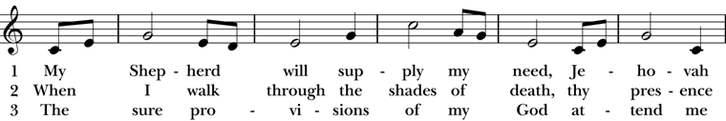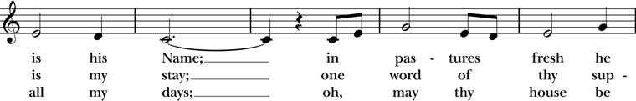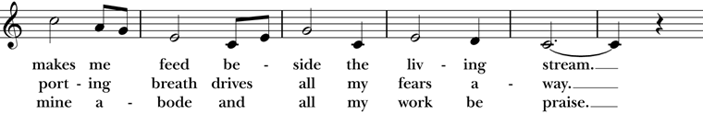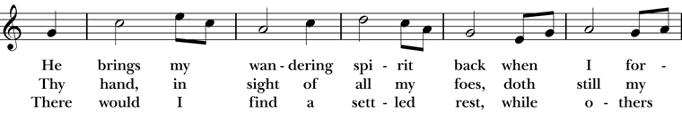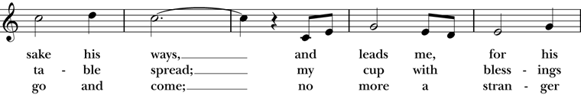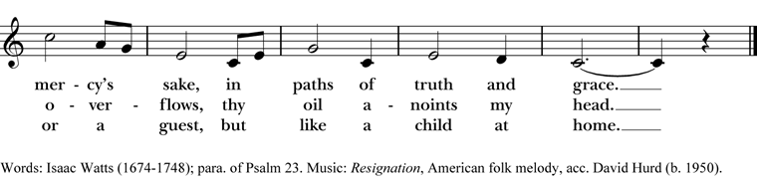

Doxology
The Great Thanksgiving – Eucharistic Prayer B
The people remain standing.
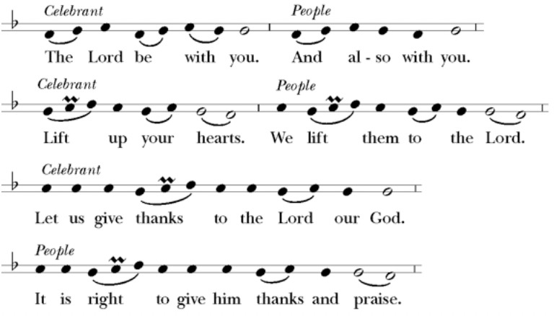
Then, facing the Holy Table, the Celebrant proceeds
It is right, and a good and joyful thing, always and every- where to give thanks to you, Father Almighty, Creator of heaven and earth.
Here a Proper Preface is sung or said on all Sundays, and on other occasions as appointed.
Therefore we praise you, joining our voices with Angels and Archangels and with all the company of heaven, who for ever sing this hymn to proclaim the glory of your Name:
Celebrant and People

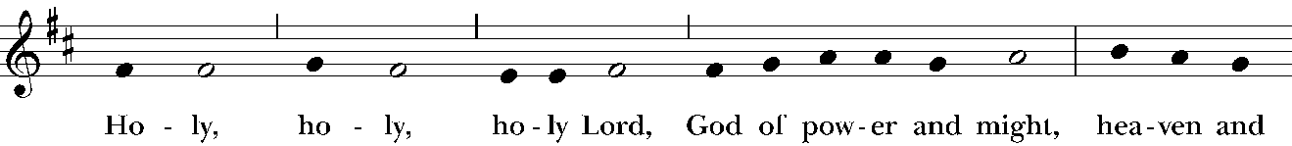

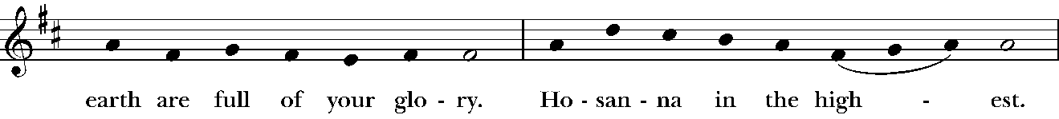

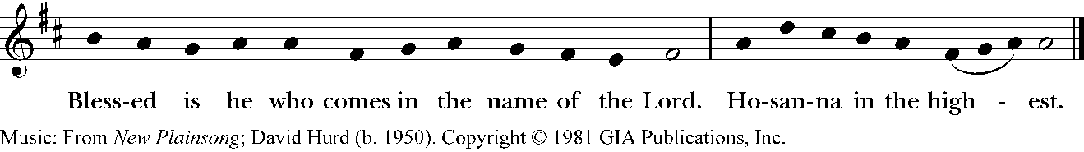

The people stand or kneel.
The Celebrant continues
We give thanks to you, O God, for the goodness and love which you have made known to us in creation; in the calling of Israel to be your people; in your Word spoken through the prophets; and above all in the Word made flesh, Jesus, your Son. For in these last days you sent him to be incarnate from the Virgin Mary, to be the Savior and Redeemer of the world. In him, you have delivered us from evil, and made us worthy to stand before you. In him, you have brought us out of error into truth, out of sin into righteousness, out of death into life.
At the following words concerning the bread, the Celebrant is to hold it, or lay a hand upon it; and at the words concerning the cup, to hold or place a hand upon the cup and any other vessel containing wine to be consecrated.

On the night he was handed over to suffering and death, our Lord Jesus Christ took bread; and when he had given thanks to you, he broke it, and gave it to his disciples, and said, “Take, eat: This is my Body, which is given for you. Do this for the remembrance of me.”

After supper he took the cup of wine; and when he had given thanks, he gave it to them, and said, “Drink this, all of you: This is my Blood of the new Covenant, which is shed for you and for many for the forgiveness of sins. Whenever you drink it, do this for the remembrance of me.”

Therefore, according to his command, O Father,

Celebrant and People

We remember his death,
We proclaim his resurrection,
We await his coming in glory;
The Celebrant continues

And we offer our sacrifice of praise and thanksgiving to you, O Lord of all; presenting to you, from your creation, this bread and this wine.

We pray you, gracious God, to send your Holy Spirit upon these gifts that they may be the Sacrament of the Body of Christ and his Blood of the new Covenant. Unite us to your Son in his sacrifice, that we may be acceptable through him, being sanctified by the Holy Spirit. In the fullness of time, put all things in subjection under your Christ, and bring us to that heavenly country where, with all your saints, we may enter the everlasting heritage of your sons and daughters; through Jesus Christ our Lord, the firstborn of all creation, the head of the Church, and the author of our salvation.

By him, and with him, and in him, in the unity of the Holy Spirit all honor and glory is yours, Almighty Father, now and for ever.

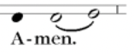
Celebrant
And now, as our Savior
Christ has taught us,
we are bold to say,
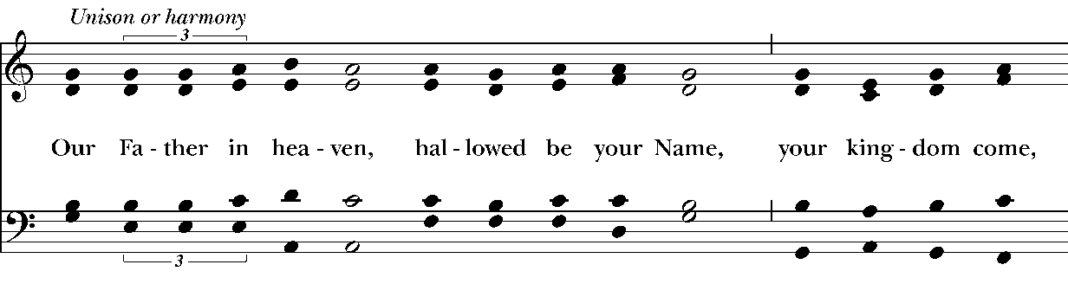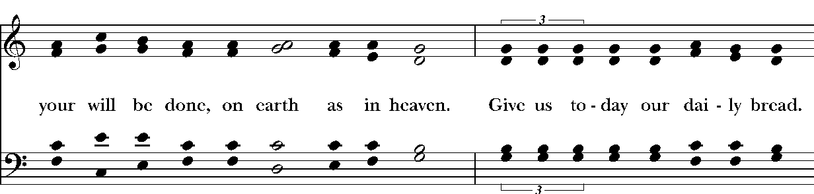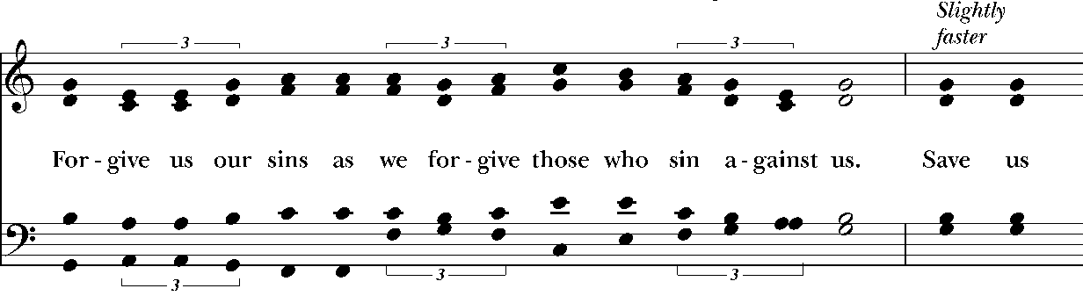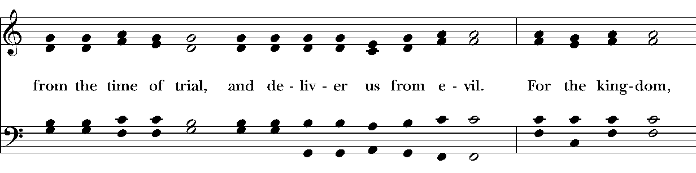
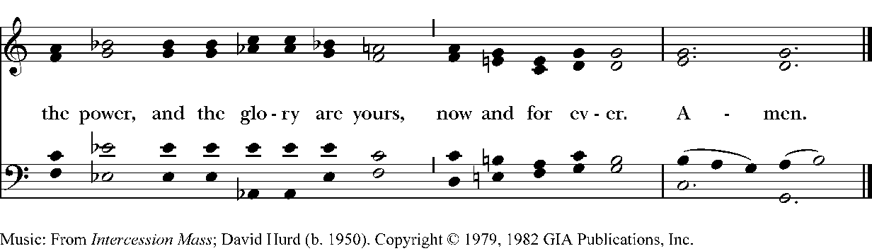
The Breaking of the Bread

The Celebrant breaks the consecrated Bread.

A period of silence is kept.

Then may be sung or said
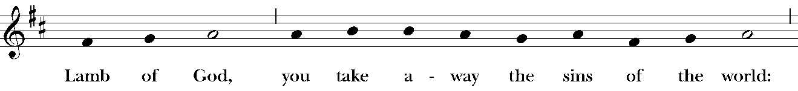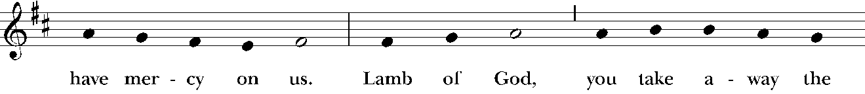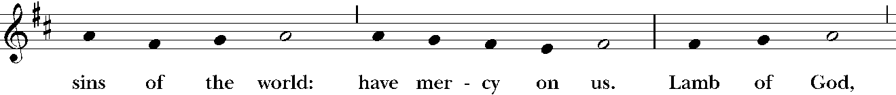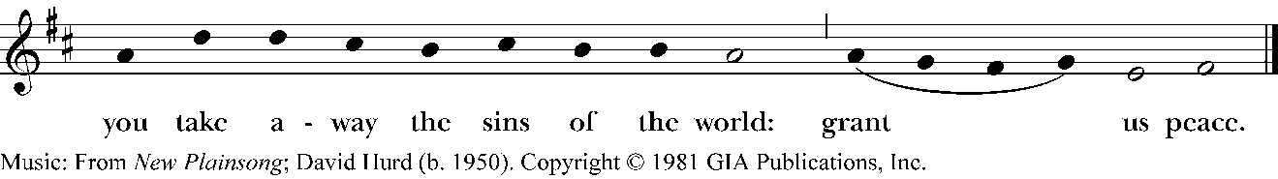
Facing the people, the Celebrant says the following Invitation
The Gifts of God for the People of God.
and may add Take them in remembrance that Christ died for
you, and feed on him in your hearts by faith,
with thanksgiving.
The ministers immediately deliver the Sacrament to the people.
The Sacrament is given to the communicants with these words
The Body of Christ, the bread of heaven. [Amen.]
The Blood of Christ, the cup of salvation. [Amen.]
Hymn 645 – The King of love my shepherd is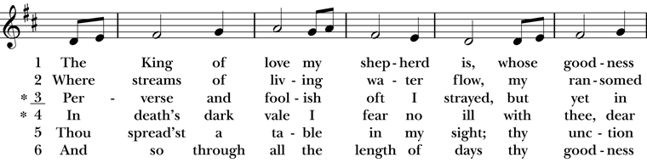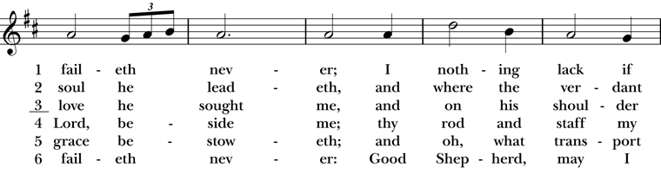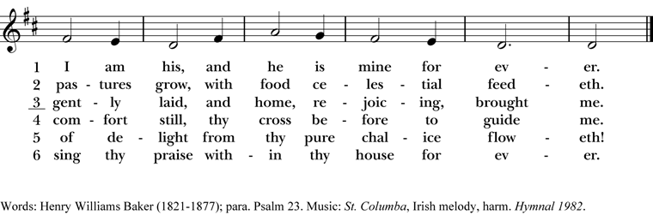

After communion the Celebrant says
Let us pray.
Celebrant and People
Eternal God, heavenly Father,
you have graciously accepted us as living members
of your Son our Savior Jesus Christ,
and you have fed us with spiritual food
in the Sacrament of his Body and Blood.
Send us now into the world in peace,
and grant us strength and courage
to love and serve you
with gladness and singleness of heart;
through Christ our Lord. Amen.
The Celebrant may bless the people.

Hymnal 429 – I’ll praise my Maker while I’ve breath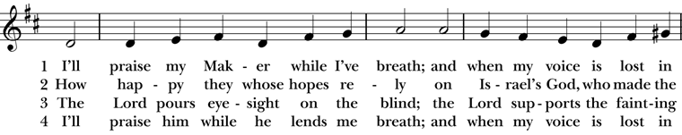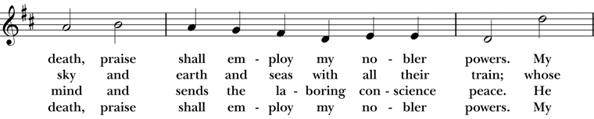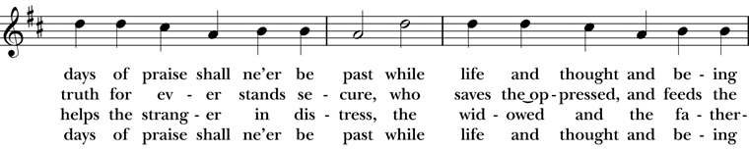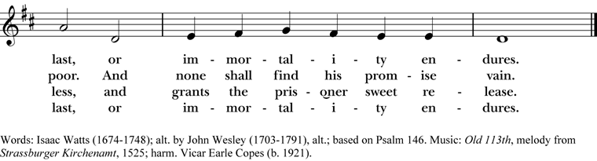

Deacon Let us go forth in the name of Christ.
People Thanks be to God.
Postlude

Announcements
Lenten Soup Supper and Program
Our Lenten Soup Supper and Program will continue for the next two Wednesday evenings of Lent at 6pm. We, as before, will begin with a simple meal followed by an opportunity for learning and formation.
This year’s program is an exploration of spiritual practices that deepen one’s life journey. The remaining topics are: Service, and Meditation. A signup sheet is in the Parish Hall to bring food items: Soup, Bread, and Fruit.
Please join us. It should be an enjoyable and informative experience.
Fellowship Book Group
Please join us for fellowship and lively discussion. We start with fellowship at 6:00 pm and discussion starts at 6:30 pm. We’d love to have you join us. The next meeting will be on our usual meeting day, (4th Monday of the month) March 23, 2026 via zoom.
The Zoom link and passcode are:
Meeting ID: 82826550583
Passcode: 121698
The book for March will be "You Better Be Lightning", by Andrea Gibson. (Available for order at various used bookstores, Audible, or possibly at your local library)
You Better Be Lightning ranges from close examination of the deeply personal to the vastness of the world, exploring the expansiveness of the human experience from love to illness, from space to climate change, and so much more in between. One of the most celebrated poets and performers of the last two decades, Andrea Gibson's trademark honesty and vulnerability are on full display, welcoming and inviting listeners to be just as they are.
We are providing the title of the book chosen for the next month, so readers will have time to get on library wait lists or plan for any ordering backlog. The book for April will be “Remarkably Bright Creatures”, by Shelby Van Pelt.
Questions? Speak with any of the following: Shelly Fairbanks, DeeDee Fournier, Jen Killion, Melinda Jackson
Soup Kitchen
Susan Myers and Deacon Linda
Thank you to the volunteers for providing the food: Steve A. for providing fruit; Rick B., Calvin S., and Steve A. for serving; Susan M. for assisting in the kitchen; Lynn S. and Patti M. for serving at the Hospitality Table.
This week's totals:

People served: 10
Bus passes given out: 15
How many picked up mail: 4
Toiletries given out: 9
Socks given away: 4
Laundry packets given out: 13
We need volunteers to provide soup, fruit, bread or dessert for the next two Wednesdays in March. Please sign up on the Soup Kitchen form on the Communications Board in the parish hall.
Food donations can be bought on Sunday mornings or on Wednesdays before 10:00 am. Just mark them “Soup Kitchen”.
Items we are in need of for the health care basket are deodorant, shampoo, hair conditioner, and body lotion. Most of these items are available and affordable at the Dollar Tree.
1 Peter 4:10 As each has received a gift, use it to serve one another, as good stewards of God's varied grace.

Puyallup Food Bank Donations
Since this month has St. Patrick's Day, let's think about items we can give to the Food Bank that might help people mark the holiday? Here are just a couple ideas:

- Green Jello
- Green tea
- Green beans
- Other shelf stable items that are green anything you would like to donate 🙂

As always, any monies you would like to donate, can be put in the collection plate or mailed to the church office. Please mark it for the food bank. That way the office knows where the money belongs.
Thank you for bringing a spark of hope and help to our neighbors! 💖
Maria Haack, Vestry Outreach
Sock Drive on Palm Sunday March 29
Deacon Linda
Luke 19:36: As he rode along, the crowds spread out their garments on the road ahead of him.
Instead of garments we are asking the crowds for socks. Everyone should have access to new, clean socks year-round for all ailments and conditions they may have. Lack of new, clean socks is the plight of the homeless, the poor and anyone in need, and the health issues they have often due to poor podiatric hygiene because they lack something as basic as a pair of new, clean socks.
How can you help? Donate socks. (Right now Christ Church is completely out of socks.) Please bring a pair of new, clean socks to donate to those in need on Palm Sunday, March 29 at both services. Volunteers will stand at the entry door into the sanctuary. There will be baskets available to put

the new socks in. The socks will be distributed through Christ Church's Wednesday Hospitality Table to those in need.
Thank you for considering helping others.
Readers Needed For Stations of the Cross
On Wednesday, April 1, at noon and 6:30 pm, make your pilgrimage to the Stations of the Cross. Christians have been making the pilgrimage to Jerusalem for centuries to walk the Stations of the Cross and follow Jesus’ footsteps.
Very early on in Christianity people went around the city and marked the places that they believed Jesus had walked on his way to the cross. This became the Stations of the Cross. Christ Church's Stations of the Cross are meant to assist us as we attempt to grasp the significance of Jesus walking towards the cross and dying so that the world could be redeemed. These stations are particularly powerful as we become one with Jesus on this reflective day.
Readers are needed on Wednesday, April 1 at both services to read at each of the 14 stations. Please sign up on the clipboard on the table just outside the Sanctuary door.
Maundy Thursday Agape Supper Sign Up
As is traditional for the day, there will be an Agape Supper on Maundy Thursday, April 3, after the 6:30 pm service.
Volunteers are needed to provide Pita bread, Eastern cheeses (Feta, Provolone, etc.) Dried Fruit (Apricots, Prunes, Raisins, Dates, etc.), olives, sparkling cider, set up and clean up.
﻿Please check the sign-up sheet on the table in the parish hall to help.

Maundy Thursday to Good Friday Prayer Vigil
What is a Vigil?
To be on a vigil is to be wakeful for a purpose. This Holy Week Christ Church will have a Prayer Vigil following our Maundy Thursday liturgy (Agapé meal, washing of feet, and stripping of the altar) on Thursday, Apri 2. This will be a vigil until the start of the Good Friday noon church service on April 3. The vigil can occur in your homes during the night.
The Words of Jesus
“Could you not keep awake one hour?” were the words of Jesus in reproach to his followers. We are now the ones who get an opportunity to stay awake and pray.
You are welcome to use your favorite book of prayers, read any of the Psalms, or any of the Gospels of the readings for Holy Week. It is a time to be in conversation with God. While it may be a challenge, it can be a wonder-filled, grace-filled blessing.
Gospels of Holy Week: John 12:1-11, John 12:20-36, John 13:21-32, John 13:1-17, 31b-35, John 18:1-19:42, Matthew 27:57-66, John 19:38-42.
Please sign up on the Night Watch Prayer Vigil list and indicate where you will be doing the night watch either at home or at the church at the Meditation space in the parish hall. If you plan to come to the church on Friday morning to pray, please write that on the sign up list so we can have someone to let you into the church. Any questions? Contact Deacon Linda

Easter Flower Donations
If you would like to donate flowers for our Easter church services, please look for the Easter Flower Form inserted into the Sunday Bulletins. Fill out the form for any thanksgiving or if the flowers are to be in memory of someone. On the memo line of your check mark "Easter Flowers" and place the check and your form in the Offering Plate. Please return the form by Sunday, March 29. Names and dedications will be included in the Easter Bulletins.

Sermon Notes

Today’s Ministers of Worship

Celebrant: The Rev. Mike Mayor
Deacon: The Rev. Linda Potter
Lectors: DeeDee Fournier, Jen Killion
Acolyte: Jeremy Duplissey
Eucharistic Minister: Christine Scholer
Livestream Coordinator: Rolin Stone
Nursery Attendants: Barb Johnsey, Melinda Jackson
Pianist: Vicki Melton
Usher: Tanya Elder
Greeters: Carla Golden, DeeDee Fournier, Helen Godwin, Christine Scholer, Tiffany Richards
Closer: Barry O'Brien
Altar Guild: Lisa Chatterton, Sydney Walczak
Music permission through OneLicense #A-706918


Scan to give online. All payments are processed through Paypal.
Christ Episcopal Church
A congregation of the Episcopal Diocese of Olympia
Bishop – The Rt. Rev. Philip N. LaBelle
Rector – The Rev. Mike Mayor
Vestry
Sr. Warden – Shelly Fairbanks
Jr. Warden for Property – Jeremy Duplissey
Jr. Warden for Communication – Barry O’Brien
Treasurer – Melinda Jackson
Clerk – Tanya Elder
Member – Steve Angelo
Member – Roddi Barton
Member – Maria Haack
Member – Susan Myers
Member – Dave Steere
Member – Rolin Stone
210 5th St. SW | Puyallup, WA | 98371
253-848-2323 | office@episcopallup.com
www.episcopallup.com

